VistA Scheduling Enhancements (VSE)

VS GUI  
User Guide



January 2018

Department of Veterans Affairs

Office of Information and Technology (OI&T)

Version 1.11.3

Revision History

|  |  |  |  |
| --- | --- | --- | --- |
| Date | Revision | Description | Author |
| 01/05/18 | 1.11.3 | Updated for Release 1.4 | S. Cox  E. Vanderwall |
| 11/07/17 | 1.10.2 | Updated patch description and contacts in Sections 1 and 2 | E. Vanderwall |
| 11/06/17 | 1.9 | Reviewed and incorporated Health Product Support comments | E. Vanderwall |
| 8/31/2017 | 1.8 | Updated per the requirements associated with release 1.3.2 | M. Habic  M. Massiah-King |
| 06/23/2017 | 1.7 | Addressed Business User comments and updated for Build 1.3 Release 1; provided technical edits for format and consistency | M. Habic |
| 01/27/2017 | 1.6 | Addressed VA comments; added Section 5.1.8 Viewing/Editing Patient-Centered Scheduling Request; added alternate text to all figures and tables; added sections for acronyms and hot keys | M. Woehrle  C. Kron  E. Phelps |
| 01/18/2017 | 1.5 | Performed internal peer review; removed *Welcome to VA* references; updated Section 2; added VSE Additional Enhancements description | M. Woehrle  L. Masucci  E. Phelps |
| 01/08/2017 | 1.4 | Incorporated user acceptance testing updates: pages 7, 9, 11, 15, 22, 23, 25, 27, 35-37, 46-48, 50, 52, 55, 57-58,60,63,69,71, 74,76,79,81,84,86,89-91,93,96-109,117-118,120-121, 123, 125, 127-130,132-147,166,181-195; provided technical edits for format and consistency | C. Kron  E. Stuck  C. Zavala E. Phelps |
| 12/21/2016 | 1.3 | Updated table of contents and footers for pages 161-211; provided technical edits – fixed figure captions, added table list, added queries for author | C. Kron E. Phelps |
| 12/7/2016 | 1.2 | Updates to Clinic Grid (pages 31,37-38,72,91) | C. Kron |
| 11/21/2016 | 1.1 | Updates from CIT/ST: pages 6-13,16-21,23-24,27-95,97,99-104,123-124,127,129-131,133,135-137,139-145,157-161,168-171,173-174,176,184 | C. Kron |
| 05/02/2016 | 1.0 | Initial baseline | D. Reed |

Table of Contents

1 Introduction 1

1.1 Purpose 1

1.2 Overview 1

1.3 Project References 1

1.3.1 Information 1

1.3.2 Coordination 2

1.3.3 Help Desk 2

1.3.4 Organization of the User Guide 3

2 System Summary 4

2.1 User Access Levels 5

3 Getting Started 6

3.1 Logging On 6

3.2 Two Factor Authentication Using PIV Cards 7

3.3 New Return to Clinic Orders (RTC Orders) 8

3.4 Logging Off 8

3.5 VS GUI Tabs 9

3.5.1 Tasks Tab 9

3.5.2 System Tab Action Areas 10

3.5.3 Reports Tab Action Areas 10

3.6 Searching 11

3.6.1 Search for Patient 11

3.7 Filtering 12

3.7.1 Filtering Lists 12

3.7.2 Paging Through Records 14

3.7.3 Filtering by Facility or Clinic 15

3.7.4 Filtering by Time Period 15

3.8 Sorting 15

3.8.1 Sorting by Column 16

3.9 Printing and Exporting a Request Management Grid 17

3.9.1 Printing a Request Management Grid 17

3.9.2 Exporting a Grid 18

3.10 Viewing 18

3.10.1 View Only Mode 18

3.10.2 Viewing Requests by Request Type 19

3.10.3 Viewing Requests by Patient 20

3.10.4 Schedule View 21

4 Ribbon Bar 21

4.1 Patients Demographics 21

4.1.1 Finding a Patient 21

4.1.2 Viewing Patient Demographics in the Ribbon Bar 22

4.1.3 Patient Eligibility Information 24

4.1.4 Updating Patient Demographics 25

4.1.5 Editing Permanent Address 27

4.1.6 Adding a Temporary Address 28

4.1.7 Bad Address 29

4.2 Actions 31

4.2.1 New Request 31

4.3 Pending Appointment Window 31

4.4 Special Needs/Preferences 34

4.4.1 Adding/Removing Special Needs/Preferences from Requests 34

4.5 Patient Flags 36

4.6 Tools 37

4.6.1 Print 37

4.6.2 Export 37

4.6.3 Refresh 38

4.6.4 Query 38

4.7 Settings – User Preferences 41

5 Request Management 43

5.1 Request Management Procedures 43

5.1.1 Viewing a Patient’s Existing Requests 43

5.1.2 Adding Appointment Request 48

5.1.3 Viewing/Editing Appointment Request 51

5.1.4 Disposition or Removing an Appointment Request 53

5.1.5 Transfer to EWL Request for a Patient 54

5.1.6 Disposition or Removing a Patient from the EWL 56

5.1.7 Adding Patient-Centered Scheduling Request 57

5.1.8 Viewing/Editing Patient-Centered Scheduling Request 58

5.1.9 Disposition or Remove Patient-Centered Scheduling Request 63

5.2 Contacting a Patient 65

5.2.1 New Contact Attempt 65

6 Appointment Management 70

6.1 Adding Appointments 70

6.1.1 Add Appointment for Appointment Request 70

6.1.2 Add Appointment for EWL Request 75

6.1.3 Add Appointment for Patient-Centered Scheduling Request 81

6.1.4 Add Appointment for Consult Request 86

6.1.5 Add Appointment from Return to Clinic request (RTC) 90

6.2 Disposition Appointments 91

6.2.1 Edit Appointment Information 91

6.2.2 View Appointment Information 93

6.2.3 Cancelling an Appointment 95

6.2.4 Mark as No Show Appointment 98

6.2.5 Undo No-Show Appointment 101

6.2.6 Checking In a Patient 102

6.2.7 Undo a Patient Check In 104

6.2.8 Check Out a Patient 106

6.2.9 Undo a Patient Check Out 109

6.2.10 Rescheduling an Appointment 110

6.3 Multiple Appointment Requests and Appointments 112

6.3.1 Multiple Appointment Request 112

6.3.1.1 Note Regarding Parent and Child Appointment Requests 113

6.3.2 Adding Multiple Appointments from Find Appointment Dialog 114

6.4 Overbooking Appointments 119

6.4.1 Overbooking Appointments with SDMOB Security Key 119

6.4.2 Overbooking Appointments with SDOB Security Key 123

6.5 Variable Length (VL) APPT 128

6.5.1 Identifying a VL Clinic: 128

6.5.2 Add a VL APPT 130

6.6 Compensation and Pension (C&P) APPTs 133

6.6.1 Add a C&P APPT Request 133

6.6.2 Add a C&P APPT for Pending 2507 Request NOT Previously Linked to Appointment 133

6.6.3 Add a C&P APPT for Pending 2507 Request Already Linked to APPT NOT Due to Cancellation 135

6.6.4 Add a C&P APPT for Pending 2507 Request due to Clinic Cancellation 137

6.6.5 Add C&P APPT for Pending 2507 Request due to Veteran Cancellation/No Show 140

6.6.6 Disposition APPT Linked to Pending 2507 Request 143

6.7 VA Online Scheduling (formerly VAR) 144

7 Clinics 145

7.1 Tasks Tab 145

7.1.1 Viewing Clinic Schedule Availability 145

7.1.2 Viewing Clinic’s Availability Cancellation 148

7.1.3 Viewing the Clinic’s Length of APPT and Max OB 149

7.1.4 Viewing the Clinic’s VL Indicator 149

7.1.5 Viewing the Clinic’s Special Instructions 149

7.1.6 Viewing Clinic’s Available Slots 150

7.1.7 The Time Slot Viewer 151

7.1.8 Viewing Provider Availability 155

7.1.9 Viewing Clinic Group Availability 157

7.2 System Tab 158

7.2.1 Viewing Clinic Availability Information 158

7.2.2 Adding and Removing Privileged Users 160

7.2.2.1 Add A Privileged User 160

7.2.2.2 Remove Privileged User 161

7.2.3 Creating Clinic Groups 162

7.2.4 Removing a Resource from a Clinic Group 164

8 Reports 165

8.1 The Audit Activity Report – UPDATE: Working as designed in v2.0.0.14 165

8.1.1 Generating an Audit Activity Report for an Individual Scheduler 165

8.1.2 Generating an Audit Activity Report for All Schedulers 166

8.1.3 Working with Audit Activity Report Data 167

8.1.3.1 Sorting by Column Header 167

8.1.3.2 Filtering by Column Data 168

8.1.4 Export an Audit Activity Report for Individual or All Schedulers 169

8.2 Clinics Report 170

8.2.1 Clinic Activity Report – Individual Clinic 170

8.2.2 Working with the Clinic Activity Report 170

8.2.2.1 Sorting by Column Headers 170

8.2.2.2 Filtering Data by Column 172

8.2.3 Exporting a Clinic Report 173

9 Trash Queue Cleanup 175

9.1 Compile List of Re-Opened REQUEST Records that Can Be Closed 175

9.2 Commit Records to Be Closed from Compiled List 177

9.2.1.1 Systems Manager 179

9.3 View Unresolved APPT Requests Reopened by the SDCANCEL Option 181

10 VistA Scheduling 508 Compliance 182

10.1 The Tasks Tab 182

10.1.1 The Ribbon Bar 182

10.1.2 Request Type Dialog 183

10.1.3 Appointment Request 183

10.2 Systems Tab 187

10.2.1 Systems Tab Ribbon Bar 187

10.2.2 Scheduling Management 187

10.2.2.1 Clinics and Users Tab 187

10.2.2.2 Clinic Groups Tab 189

10.2.3 Availability Selection 190

10.3 The Reports Tab 190

10.3.1 Reports Tab Ribbon Bar 190

10.3.2 Audit Activity 191

10.3.3 Clinic Activity 192

11 Troubleshooting 192

11.1 Changing User ID and Password 192

11.2 Special Instructions for Error Correction 193

12 Acronyms and Abbreviations 194

13 Keyboard Shortcuts Quick List 196

List of Figures

Figure 1: User Login 7

Figure 2: Main Screen with Test Environment Displayed 7

Figure 3: Linking PIV to VistA Account 8

Figure 4: User Logoff 9

Figure 5: VS GUI Tabs 9

Figure 6: Tasks Tab Display 10

Figure 7: System Tab 10

Figure 8: Reports Tab 11

Figure 9: Patient Search 12

Figure 10: Filtering Lists 13

Figure 11: Paging Through Records 14

Figure 12: Filtering by Facility/Clinic 15

Figure 13: Filtering by Time Period 15

Figure 14: Sorting by Column 16

Figure 15: Selecting the Print Option 17

Figure 16: Selecting a Printer 17

Figure 17: Exporting a Grid 18

Figure 18: Request Type Column 19

Figure 19: Select Patient 20

Figure 20: Request Type 20

Figure 21: Patient Pending Requests and Booked Appointments 21

Figure 23: Changing View of a Specific Schedule 21

Figure 24: Search Patient 22

Figure 25: Patient Demographics in the Ribbon Bar 23

Figure 26: Patient Inquiry Detail 24

Figure 27: Patient's Eligibility Information 25

Figure 28: Request Type–APPT 25

Figure 29: Patient Information Dialog 26

Figure 30: Patient is Being Edited Warning Pop-up 27

Figure 31: Patient Info Dialog–Permanent Address 28

Figure 32: Patient Info Dialog – Temporary Address 29

Figure 33: Select Patient 29

Figure 34: Request Type 30

Figure 35: Appointment Request Dialog—Bad Address Selection 30

Figure 36: Actions Pane 31

Figure 37: Request Type – APPT 31

Figure 38: Pending Appointment Window – Past Appointment Date 32

Figure 39: Pending Appointment Window – Current less than Three Days in Future 32

Figure 40: Pending Appointment Window – Future Appointment Dates 33

Figure 41: Request Type – APPT 34

Figure 42: Patient Info Dialog – Special Needs/Preferences Section 35

Figure 43: Ribbon Bar – Special Needs/Preferences 35

Figure 44: Patient Record Flags Dialog 36

Figure 45: Patient Record Flags 37

Figure 46: Refresh Button in Tools Pane 38

Figure 47: Request Query 39

Figure 48: Query Rule Validation 39

Figure 49: Request Query Rule Confirmation 39

Figure 50: Settings – User Preferences 42

Figure 51: Settings – Save as Default View 43

Figure 52: Request Type 44

Figure 53: Request Grid and Pending Appointments 44

Figure 54: Request Grid Displaying Expand Entry Block 45

Figure 55: Appointment Demographics 46

Figure 56: Appointment Event Log 46

Figure 57: Appointment Wait Time 47

Figure 58: Patient Information 47

Figure 59: Encounter Information 48

Figure 60: Request Type - APPT 48

Figure 61: Actions Pane—New Req. Selection 49

Figure 62: Appointment Request Dialog – Request Information Section 49

Figure 63: Special Needs/Preferences Section from Patient Info Dialog 50

Figure 64: Appointment Request Dialog 51

Figure 65: View Request (Read Only) 52

Figure 66: Edit Request (Request Information Only) 53

Figure 67: APPT/Veteran Disposition Options 54

Figure 68: EWL Request Dialog 56

Figure 69: Request Type–PATIENT-CENTERED SCHEDULING 57

Figure 70: Patient-Centered Scheduling APPT Request Dialog 58

Figure 71: Patient-Centered Scheduling Disposition Dialog 59

Figure 72: Patient-Centered Scheduling Appointment View Request Dialog 60

Figure 73: Patient-Centered Scheduling Disposition Dialog 61

Figure 74: Patient-Centered Scheduling Appointment Edit Request Dialog 62

Figure 75: Patient-Centered Scheduling Disposition Options 63

Figure 76: PtCSch Comment Dialog Box 64

Figure 77: Warning Pop-Up If Business Rules Were Not Met 64

Figure 78: Request Type/Dispositions/Contact Message Reference 65

Figure 79: Contact Attempts 66

Figure 80: Patient Contact Dialog 67

Figure 81: New Contact Attempt Submitted and Displayed 67

Figure 82: Displaying Name of Person Entering Contacts 68

Figure 83: Appointment Canceled 68

Figure 84: New Contact Attempt After Cancellation 69

Figure 85: Request Type 70

Figure 86: Select APPT Request – Clinic Schedule Grid Display 71

Figure 87: Select Time Slot 71

Figure 88: Right-click Options – Add Appointment 72

Figure 89: New Appointment Dialog 73

Figure 90: Print Letter? Dialog 73

Figure 91: Closing Request Dialog 74

Figure 92: Clinic Schedule Grid – Past Appointment Display 74

Figure 93: Clinic Schedule Grid – Current Appointment Display 75

Figure 94: Clinic Schedule Grid – Future Appointment Display 75

Figure 95: Request Type 76

Figure 96: Select EWL Request 77

Figure 97: Select Time Slot 77

Figure 98: Right-click Options – Add Appointment 78

Figure 99: New Appointment Dialog 78

Figure 100: Print Letter? Dialog 78

Figure 101: Print to VistA Device Printer to place address in correct position 79

Figure 102: Closing Request Dialog 79

Figure 103: EWL Appointment Past Date Display 80

Figure 104: EWL Appointment Current Date 80

Figure 105: EWL Appointment Future Date Display 81

Figure 106: Request Type 81

Figure 107: Select Patient-Centered Scheduling Request 82

Figure 108: Select Time Slot 82

Figure 109: Right-click Options – Add Appointment 82

Figure 110: New Appointment Dialog 83

Figure 111: Print Letter? Dialog 83

Figure 112: Closing Request Dialog 84

Figure 113: Clinic Schedule Display – Past Date Appointment 84

Figure 114: Clinic Schedule Display – Current Date Appointment 85

Figure 115: Clinic Schedule Display – Future Date Appointment 85

Figure 116: Request Type 86

Figure 117: Select Consult Request 86

Figure 118: Clinic Schedules 87

Figure 119: Select Time Slot 87

Figure 120: Right-click Options – Add Appointment 87

Figure 121: New Appointment Dialog 88

Figure 122: Print Letter? Dialog 88

Figure 123: Clinic Schedule Display – Consult Past Appointment Date 89

Figure 124: Clinic Schedule Display – Consult with Current Date 90

Figure 125: Clinic Schedule Display – Consult Future Appointment Date 90

Figure 126: Request Type 90

Figure 127: Appointment Right-click Options – Edit Appointment 92

Figure 128: Edit Appointment Dialog 93

Figure 129: Hover Box Displaying Appointment Details 94

Figure 130: Appointment Right-click Options – View Appointment 94

Figure 131: View Appointment Dialog 95

Figure 132: Appointment Right-click Options – Cancel Appointment 96

Figure 133: Cancel Appointment Dialog 97

Figure 134: Pending Appointment Window – Appointment Status Cancelled by Clinic 97

Figure 135: Pending Appointment Window – Appointment Status Cancelled by Patient 98

Figure 136: APPT Request – Time Slot Count Increase 98

Figure 137: Appointment Right-click Options – Mark as No Show 99

Figure 138: Mark as No Show Dialog 99

Figure 139: Clinic Schedule Display – No-Show Red 100

Figure 140: Pending Appointment Window – Appointment Status No-Show 100

Figure 141: No-Show Warning Message 100

Figure 142: Appointment Right-click Options – Undo No-show 101

Figure 143: Appointment Clinic Schedule Display – Undo No-show as Purple 102

Figure 144: Undo No-show – Appointment Status No Action Taken 102

Figure 145: Appointment Right-click Options – Check In Patient 103

Figure 146: Appointment Check In Dialog 103

Figure 147: Clinic Schedule Display – Check In Yellow 104

Figure 148: Pending Appointment Window – Status ACT REQ/CHECKED IN 104

Figure 149: Appointment Right-click Options – Undo Check In Patient 105

Figure 150: Clinic Schedule Display – Undo Check In Patient Purple 105

Figure 151: Pending Appointment Window – Appointment Status No Action Taken 106

Figure 152: Appointment Right-click Option – Check Out Patient 107

Figure 153: Appointment Check Out Dialog 108

Figure 154: Clinic Schedule Display – Check Out Patient Orange 108

Figure 155: Pending Appointment Window – Status ACT REQ/CHECKED OUT 108

Figure 156: Appointment Right-click Options – Undo Check Out Patient 109

Figure 157: Clinic Schedule Display – Undo Check Out Patient Yellow 109

Figure 158: Pending Appointment Window – Status ACT REQ/CHECKED IN 110

Figure 159: MRTC Interval/Appt. # Dialog 113

Figure 160: MRTC Requests displayed in Request Management Grid 114

Figure 161: Find Appointment Dialog 116

Figure 162: Find Appointment Dialog and MRTC Booking Status Dialog 117

Figure 163: Future Clinic Inactivation Date 118

Figure 164: Request Type 119

Figure 165: Clinic Schedule Display – APPT Request Future CID/Preferred Date 120

Figure 166: Max Overbook Limit 120

Figure 167: Appointment Right-click Options – Add Appointment 121

Figure 168: View Appointment Dialog – Appointments 122

Figure 169: Print Letter? Dialog 122

Figure 170: Closing Request Dialog 123

Figure 171: Clinic Schedule Display – Overbook Appointment 123

Figure 172: Request Type 124

Figure 173: Clinic Schedule Display – APPT Request Future CID/Preferred Date 125

Figure 174: Overbook After Hours Time Slot 125

Figure 175: Appointment Right-click Options – Add Appointment 126

Figure 176: Overbook Confirmation Dialog 126

Figure 177: New Appointment Dialog 127

Figure 178: Print Letter? Dialog 127

Figure 179: Closing Request Dialog 127

Figure 180: Clinic Schedule Display – Overbook Appointment After Hours 128

Figure 181: Clinic Schedules – Clinic Search 129

Figure 182: Clinic Schedule Grid 129

Figure 183: VL Indicator 129

Figure 184: New Appointment Dialog 130

Figure 185: Clinic Schedule Display – Multiple Time Slot Selected 131

Figure 186: New Appointment Dialog – VL APPT Duration 132

Figure 187: Clinic Schedule Display – Appointment Length Extended 133

Figure 188: TRACKING Record Updated 134

Figure 189: C&P Appointment for Patient with No Pending 2507 Request 134

Figure 190: C&P Requests Dialog 136

Figure 191: C&P Request Due to Cancellation Dialog 136

Figure 192: AMIE C&P EXAM TRACKING Record Updated 136

Figure 193: C&P Requests Dialog 138

Figure 194: C&P Request Due to Cancellation Dialog 138

Figure 195: C&P Request APPT Links Dialog 139

Figure 196: C&P APPT Links Due to Veteran Cancellation or No Show 139

Figure 197: C&P APPT Links Due to Cancellation Dialog 139

Figure 198: C&P APPT Links Adjustment Dialog 140

Figure 199: C&P Requests Dialog 141

Figure 200: C&P Request Due to Cancellation Dialog 141

Figure 201: C&P Request APPT Links Dialog 142

Figure 202: C&P Canceled APPT Links Dialog Warning 142

Figure 203: C&P APPT Links Due to Veteran Cancellation or No Show 142

Figure 204: AMIE C&P EXAM TRACKING Record Updated 143

Figure 205: C&P Cancel APPT Associated 2507 Request Updated 144

Figure 206: C&P Cancel APPT NOT Linked to Pending 2507 Request 144

Figure 207: Clinic Schedules Search 146

Figure 208: Clinic Schedules Display – Available and Unavailable 146

Figure 209: Clinic Schedules Display – Hours of Operation 147

Figure 210: Clinic Schedules Display – Holiday Bookable 147

Figure 211: Clinic Schedules Display – Holiday Unbookable 148

Figure 212: Clinic Schedule Display – No Availability Defined 148

Figure 213: Clinic Schedule Display – Whole and Partial Day Cancel Availability 148

Figure 214: APPT Length and Max OB Allowed 149

Figure 215: VL Indicator 149

Figure 216: Special Instructions Indicator 150

Figure 217: Time Slot Count 150

Figure 218: Overbook Time Slot Count 151

Figure 219: Minimized Time Slot Viewer 152

Figure 220: Expanded Time Slot Viewer 152

Figure 221: Time Slot Viewer Displays Slot Details 152

Figure 221: Time Slot Viewer Right-click–Edit, View, Cancel 153

Figure 224: Time Slot Viewer – Check In Patient 154

Figure 225: Time Slot Viewer – Check Out Patient 154

Figure 226: Time Slot Viewer – Mark as No Show 155

Figure 227: Provider Schedules 155

Figure 228: Provider Schedules Selection List 156

Figure 229: Provider Schedule Display 156

Figure 230: Provider Schedules Booked APPTs 156

Figure 231: Clinic Groups 157

Figure 232: Clinic Groups Search Result List 157

Figure 233: Clinic Groups Schedule Display 158

Figure 234: Clinic Availability Search 159

Figure 235: Clinic Availability 160

Figure 236: Clinics and Users 160

Figure 237: Add Privileged User 161

Figure 238: Remove Privileged User 162

Figure 239: Create New Clinic Group 162

Figure 240: Find Resource 163

Figure 241: Add Resource to Clinic Group 164

Figure 242: Remove Resource from Clinic Group 164

Figure 243: Reports Tab Selections 165

Figure 244: Audit Activity Report – Individual Scheduler 165

Figure 245: Audit Activity Report – All Schedulers 167

Figure 246: Audit Activity Sort – Ascending 168

Figure 247: Audit Activity Sort – Descending 168

Figure 248: Audit Activity Report – Filtered 169

Figure 249: Audit Activity Report – Multiple Filters 169

Figure 250: Clinic Activity Report Sort – Ascending Order 172

Figure 251: Clinic Activity Report Sort – Descending Order 172

Figure 252: Clinic Activity Report – Filtered 173

Figure 253: Clinic Activity Report – Multiple Filters 173

Figure 254: Clinic Activity 174

Figure 255: Save As 174

List of Tables

Table 1: Clinic Schedule Availability 145

Table 2: Keyboard Shortcuts for Ribbon Bar Components 183

Table 3: Keyboard Shortcuts for Request Type 183

Table 4: Keyboard shortcuts for the Appointment Request 184

Table 5: Keyboard Shortcuts for the Systems Tab Ribbon Bar 187

Table 6: Keyboard Shortcuts for Scheduling Management 189

Table 7: Keyboard Shortcuts for the Clinic Groups Tab 189

Table 8: Keyboard Shortcuts for the Availability Selection 190

Table 9: Keyboard Shortcuts for the Reports Tab Ribbon Bar 191

Table 10: Keyboard Shortcuts for Audit Activity 191

Table 11 Keyboard Shortcuts for Clinic Activity 192

Table 12: Warning Messages 193

# Introduction

Department of Veterans Affairs (VA) Veterans Health Information Systems and Technology Architecture (VistA) Scheduling (VS) Graphical User Interface (GUI) module is the Windows GUI version of the Patient Information Management System (PIMS) Scheduling module. It provides appointment management functions included in PIMS Scheduling, but with the added convenience and usability of a GUI.

## Purpose

The Veterans Health Administration (VHA) Office of Veterans Access to Care (OVAC) requested an enterprise enhancement for the VS package. The enhancement reduces operating costs for VHA and improves operational efficiencies, resulting in patient-centered access to care, coordinated care, increased customer satisfaction, and the reduction of excessive cycle/wait time for scheduling patients.

## Overview

VS GUI is a software module that allows schedulers to make appointments quickly by viewing multiple appointment request types and multiple clinics in one screen. A scheduler can easily view patient requests for service, find the next available open appointment, view the provider’s availability in multiple clinics, and track a patient’s appointment process. Refer to Section 2 for a more detailed description of VS GUI functionality.

## Project References

### Information

The VS GUI points of contact (POCs) include:

* OVAC VSE Project Manager – Ms. Erin Vanderwall, [Erin.Vanderwall@va.gov](mailto:erin.vanderwall@va.gov)
* OVAC Program Office – [VHAVSEProgramOffice@va.gov](mailto:VHAVSEProgramOffice@va.gov)
* OIT VSE Project Manager – Mr. Shannon Ayers, [Shannon.Ayers@va.gov](mailto:Shannon.Ayers@va.gov)

**Note:** The VSE project SharePoint site can be accessed via the following link: <http://vaww.oed.portal.va.gov/pm/iehr/vista_evolution/enhancements/SitePages/Home.aspx>

VSE Pulse pages:

* Scheduler: <https://www.vapulse.net/community/vista-scheduling-enhancements-vse>
* Super User: <https://www.vapulse.net/groups/vse-super-users>
* National Return to Clinic Order Implementation: <https://www.vapulse.net/groups/return-to-clinic-rtc>
* Frequently Asked Questions/Known Issues document: <https://www.vapulse.net/docs/DOC-107042>

### Coordination

Coordination between the project and its specific support functions (e.g., installation coordination, security, etc.) for VS GUI is the same as those for VistA.

### Help Desk

Refer to Section 11 for additional information.

### Organization of the User Guide

This user guide is comprised of 11 sections, as follows:

* **Introduction:** Addresses general project information
* **System Summary:** Contains system configuration, data flows, and user access level information
* **Getting Started:** Contains procedures for logging on and off of the system, instructions on how to print and export schedules, and information on VS GUI tab displays, basic functions for searching, sorting, filtering, and viewing
* **Ribbon Bar:** Contains procedures for using the Schedule Manager Ribbon Bar and details on features, such as patient demographics, new request actions, pending appointments, print, export, refresh, query tool, user preferences, and patient preferences
* **Request Management:** Outlines features and procedures for using the Request Management Grid (where patient’s pending requests are displayed 25 at a time) and the Pending Appointments window (where booked appointments are displayed in the in the Ribbon Bar of the Tasks tab)
* **Appointment Management:** Provides details describing how to manage an appointment – after selecting a patient, the option appears to schedule a new appointment (APPT) or Patient-Centered Scheduling (PtCSch); a list of recent and upcoming appointments is displayed in the Ribbon Bar
* **Clinics:** Provides an overview of clinic and administrator views and actions
* **Reports:** Provides an overview of viewing and printing reports, and procedures for generating audit and clinic reports; a list of warnings is also included
* **Trash Queue Cleanup:** Defines this task and provides instructions for use
* **VistA Scheduling 508 Compliance**: Outlines processes for executing VistA Scheduling application functionality from the keyboard
* **Troubleshooting:** Provides contact information for the Help Desk regarding any problems with the VS GUI module

# System Summary

The VSE project delivers a series of enhancements to legacy VistA Scheduling Version 5.3 via the VS GUI application.

The current nationally released version 1.3.2 includes VS GUI 2.0.0.13 and VistA M patch SD*5.3*671. Install compliance date was Dec 19, 2017. This update includes the following:

* Computerized Patient Record System (CPRS) national Return to Clinic (RTC) orders now transfer to VS GUI as actionable requests, auto-populating the Patient Indicated Date (PID) from the new national RTC order. Sites must implement the national RTC order in the new CPRS version 31A before schedulers will see the RTC requests in VS GUI.
* Prevents overwriting of appointments in VistA Appointment Management [SDAM APPT MGT] that resulted in mismatched grids. Post install task job cleaned the database of existing mismatches.
* No longer displays inactive patient flags.
* Check out and Undo Check Out in VS GUI are now tied to the SD SUPERVISOR VistA key. Undo check out appointment removed encounter information and previously did not require the SD SUPERVISOR key. The Check Out’s follow up feature was not functioning as designed. We do not encourage any users to use these two functions in VS GUI in the short term.
* Users can now edit existing appointment comments.

Note: Patch SD*5.3*671 (VS GUI) and OR*3*434 (CPRS 31A) are independent patches. As the patches share functionality, it is recommended that they be installed and configured together. Before implementing national RTC orders, it is recommended that staff are trained and competent in VS GUI functionality as the workflow for national RTC requests are designed to be processed in VS GUI.

The next nationally released version 1.4 includes VS GUI 2.0.0.14 and VistA M patch SD*5.3*672. Install period is tentatively February 8, 2018 at time of publishing. This update includes the following:

* Provides the capability for VSE users to authenticate via Personal Identity Verification (PIV)
* Clinic Group will display for second patient without searching for a different clinic group first. (Users should put curser in the clinic group field and click Enter to refresh.) Ticket I10959194FY17
* Electronic Wait List (EWL) can now be consistently dispositioned from the Resource Management (RM) Grid. Ticket I11259063FY17
* Scheduling grid no longer allows overbooks in the evenings after a FULL DAY availability cancellation. The visual display does not extend the cancellation hash marks to midnight, but it will not allow the user to book, and presents an appropriate error message to user. Ticket I12362398FY17
* Drag and drop rescheduling within the current calendar view (including clinic groups and provider search calendar views) is now available for most existing appointments. Consult linked appointments and appointments in the past cannot drag and drop as they have other linkages that still require manual cancellation. Ticket I12487403FY17
* Slot tallies no longer move as the calendar view is scrolled down. Ticket I12529073FY17
* Schedulers cannot add new request or appointments in VS GUI after a patient is listed as deceased in VistA. Ticket I12602010FY17
* Cancel by Clinic no longer allows PID to be changed by switching between Cancel by Clinic and Cancel by Patient. Ticket I12748395FY17
* VS GUI Audit Report now reports accurate counts of actions within VS GUI for both individual and all schedulers. Tickets I12871937FY17
* Checking out appointment “Follow-up Needed” now works better than it did in former versions, however we continue to keep it tied to the SD SUPERVISOR key until we can completely separate the administrative check out function in VS GUI from any ties to the encounter files. We do not recommend use of check out at this time. Ticket I13233499FY17
* Appointments scheduled in VS GUI with a past date will now show in CPRS cover sheet and visit location lists. Ticket I13212697FY17
* SDRR CLINIC LETTER REPORT will now run properly (was hanging on bad data in previous versions). Ticket R14380532FY17

## User Access Levels

The VS GUI module uses three access levels:

**Provider and Non-Scheduler (View Only)** can view patient appointments, clinics, and provider’s availability in VS GUI via:

* **View** patient appointments, clinics, and provider’s availability
* **Find Available Appointments** slots in a clinic or group of clinics
* **Appointment Schedule** displayed by clinic, provider or clinic group
* **Request Management Query Tool** to produce a list of patients waiting for an appointment
* **Expand Entry** on existing appointments to view details of when the appointment was created, encounter information (if available), and other appointment audit fields
* **VistA Account Requirements:** VistA option CLINICAL SCHEDULING PROCEDURE CALLS [SDECRPC] and VistA key SDECZVIEW. Please note, SDECZVIEW blocks all other SDEC keys the user may hold

**Scheduler** can make appointments quickly by viewing multiple clinics in one screen. The user can easily find open appointments, view the provider’s availability in multiple clinics, and track a patient’s appointment process in VS GUI via:

* **Find Appointments** to specify the dates to view only available appointments in a clinic or list of clinics
* **Resource Schedules** to display clinic schedules
* **Appointment Schedule** to display appointment schedules for a clinic and be able to view a provider’s schedule for the day, week, or month
* **Request Management Queue** to display a list of patients waiting for an appointment or a consolidated list of a particular patient’s unfulfilled appointment needs
* **Ribbon Bar** for a view that shows individual patient information after a patient is selected (demographics, pending appointments, etc.), as well as system functions like print, export, query tool and user preferences.
* **VistA Account Requirements:** VistA option CLINICAL SCHEDULING PROCEDURE CALLS [SDECRPC] and VistA key SDECZMENU. Please note, SDECZVIEW blocks all other SDEC keys the user may hold.

**Administrator** can performall VS GUI Scheduler functions with the Task tab, with the addition of two additional tabs:

* **System** **Tab** to add/delete privileged users from a prohibited clinic and setup clinic groups.
* **Reports Tab** to view and export reports for clinic profile and user action audit reports
* **VistA Account Requirements:** VistA option CLINICAL SCHEDULING PROCEDURE CALLS [SDECRPC] and VistA keys SDECZMENU and SDECZMGR. Please note, SDECZVIEW blocks all other SDEC keys the user may hold.

# Getting Started

This section provides a general walkthrough of the system from initiation through exit. The logical arrangement of the information shall enable the user to understand the sequence and flow of the system.

## Logging On

VistA User Access and Verify codes are required to log on to the VS GUI. The user must have VistA options and keys according to their role (listed above).

VA Identification Cards (PIV)-enabled log in is introduced in this version. It is now the primary method of log in, but the user must have an active VistA account to access VS GUI, regardless of the method used to log in.

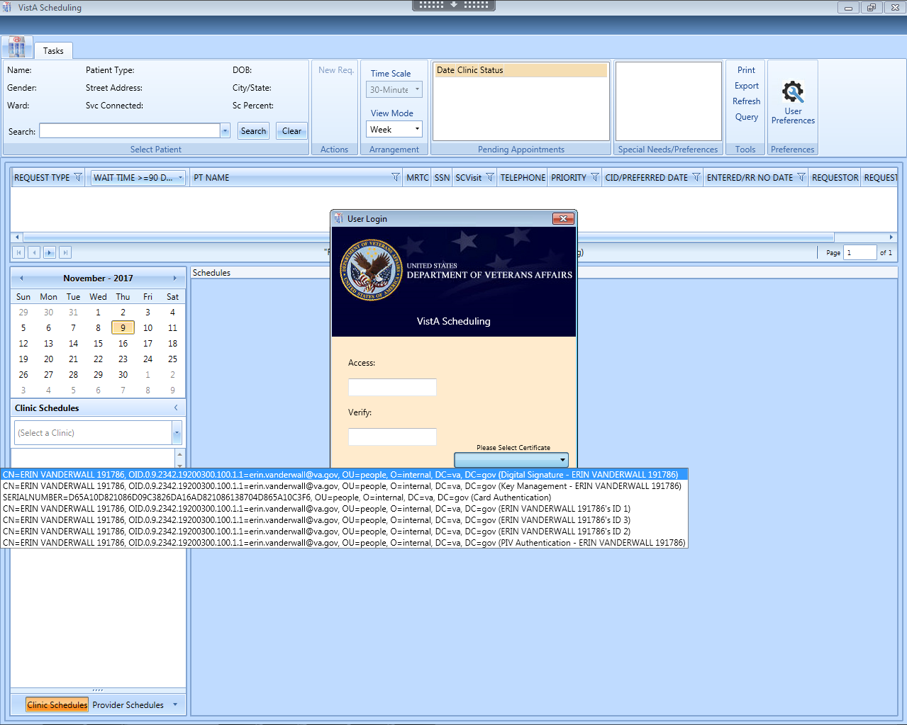

VistA Access Verify Codes are available as a back up log in method

PIV log in is preferred. Highlight the certificate that contains “PIV Authentication” and your name, then click OK.

Figure : User Login

**Note:** The main screen of the application informs users whether they are logged into the test or production environment. The environment to which the user is logged in will be displayed in the top right corner of the main screen page.

Figure : Main Screen with Test Environment Displayed

## Two Factor Authentication Using PIV Cards

After the Version 1.4 update, you will be prompted to access VS GUI using your PIV card and Personal Identification Number (PIN). In order to do this, you must have taken the one-time action of linking your PIV card to your Vista account. If you have already linked your account when CPRS began PIV log in, you will not need to do it again for VS GUI. However, if you move to a different station/VistA instance, you may need to re-link to add your new VistA account to your PIV card.

If you have not already linked your account, you can do so by following this link <http://go.va.gov/qugx>**.** If you experience any issues or are unable to complete the linking/binding process, please contact the **Enterprise Service Desk at (855) 673-4357, Option 3, or by email to** ESDOtherSupport@va.gov**.**

**Note:** After selecting IAM Provisioning Service Link VistA to User you can tell if you’re already linked or there is no link by looking at the Vista Instances.

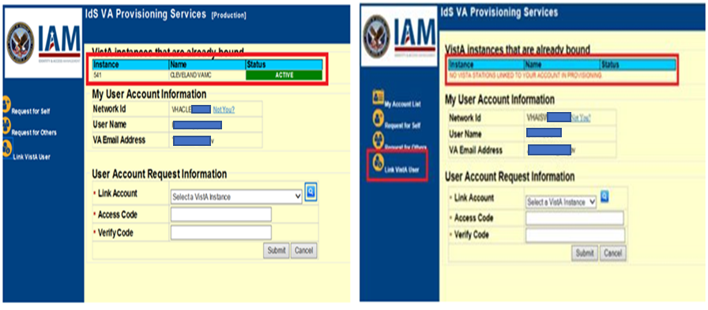

Figure : Linking PIV to VistA Account

If you are not able to log in with your PIV for any reason, you will be able to bypass the PIV logon on the log in pop up by inserting your Access code/Verify Code on the log in pop up box, but it is expected that a security mandate will **require** you to use two factor authentications in the future, so it is highly recommended that you link your account to avoid access problems in the future.

If you have used your PIV card in another capacity (logged into your computer, for instance) in the last few minutes, VS GUI may recognize that PIV activity, and automatically take you into the application without re-entering your PIV PIN.

Note: If the PIV authentication service itself is having problems authenticating, the user may get an error, even if they select the correct certificate. These are usually widespread outages affecting several applications. If the PIV service is going to be down for an extended time, the national PIV will remove PIV completely, and the user will see a message to use VistA login credentials. Either way, VistA credentials are the contingency and can be used whether or not PIV authentication is working.

## New Return to Clinic Orders (RTC Orders)

A nationally developed Return To Clinic (RTC) order dialog is included in CPRS version 31A. This order will allow VistA to transfer the national RTC orders to VS GUI as RTC requests. This will make it easier to transfer a providers RTC order information seamlessly into an appointment with minimal human error in data transfer. All facilities have received upgrades to both CPRS and VS GUI to allow this to happen, however implementation and use of the national RTC order may not be immediate, and in some sites, will take significant planning and coordination. Once clinical staff begin using the national RTC orders in CPRS, the resulting requests should be processed in VS GUI.

## Logging Off

To log off when you are finished scheduling appointments, click the close button (**X**) in the upper right corner of the VS GUI.

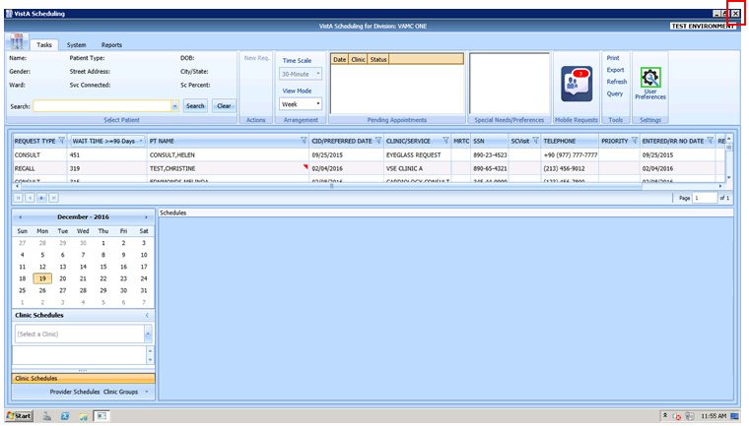

Figure : User Logoff

## VS GUI Tabs

The VS GUI provides the following tabs:

* **Tasks:** Allows the scheduler to search for patient requests, view clinic resources, and make appointments.
* **System:** Allows an administrator (with the SDECZMGR security key) to add/delete privileged users from a prohibited clinic and set up clinic groups.
* **Reports:** Allows for various reports to be generated by users holding the SDECZMGR security key.

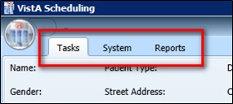

Figure : VS GUI Tabs

### Tasks Tab

The **Tasks** tab Ribbon Bar includes the following sections:

* **Select Patient:** Search for and view information about a selected patient
* **Actions:** Allows the sscheduler to initiate new APPT or Patient-Centered Scheduling requests
* **Arrangement:** Time Scale (slot length) displayed. Note: in this version View Mode does not change the view of the calendar. Use the Day, Week, Month and Timeline buttons above the calendar itself to change the display.
* **Pending Appointments**: Date, clinic, and status of any pending appointments, past appointments (365 days back), and future appointments (365 days forward) for the selected patient
* **Special Needs/Preferences:** Identified special needs and/or preferences for the selected patient missing the Patient Record Flags (PRFs)
* **Tools:** Options include print, export, refresh, and queries.
* **Settings:** Access to User Preferences.

The **Tasks** tab Resource area includes the following sections:

* Calendar to choose a desired appointment date and to search for and access **Clinic Schedules**, **Provider Schedules**, and **Clinic Groups**
* **Schedules:** View single or multiple clinic schedules in one screen

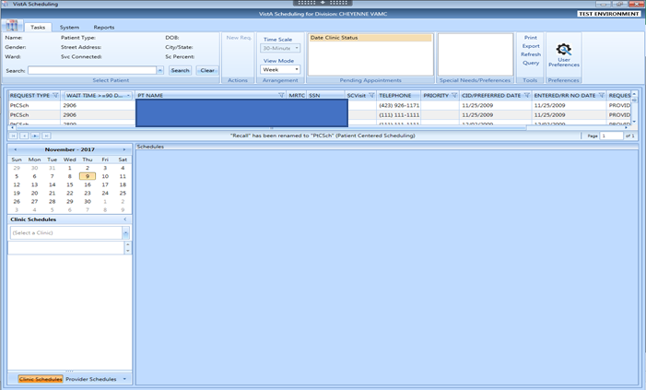

Figure : Tasks Tab Display

### System Tab Action Areas

The System tab includes the following sections:

* **Resource Management:** **Scheduling Management** allows for management of privileged users within Prohibited and Clinic Groups as well as the creation and management of clinic groups.
* **Resource Schedules** **Availability** allows for search of clinic, provider or clinic group by name.
* **Selected Clinic** provides a quick view of the selected clinic’s Primary Provider, Overbook Limit, Inactive Date, and ReactiveDate.

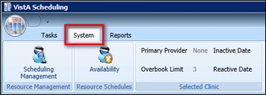

Figure : System Tab

### Reports Tab Action Areas

The **Reports** tab allows for viewing and exporting of **Audit Activity** and **Clinics** setup information. Please note: Audit Activity Report is now working. See details in 8.1

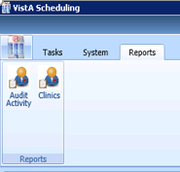

Figure : Reports Tab

## Searching

The search feature enables a scheduler to:

* View and search clinic profiles to view appointments resources by clinic, provider, or by clinic groups
* View and search patient requests by request type
* Sort the request queue by any column in ascending or descending order and filter.
* Sort results and save the search into various outputs, such as Microsoft Excel or Adobe PDF and print to a network printer.

### Search for Patient

1. Log into VS GUI.
2. From the **Tasks** tab, in the **Search** text box, type the search criteria for the patient. Click **Search**, and then select the requested patient’s name. Click **Search/Choose patient from the resulting list**.
3. In the Search field, the following options are available for searching for a patient:

* Last name,First name (no space between comma and first name)
* Full SSN
* First initial of the last name + last four of the SSN (ex. T0170)
* Last four of SSN (0170)
* Last name only (three-character minimum)
* Spacebar + Search will bring the last patient used in VistA, CPRS and VS GUI into the search drop down.

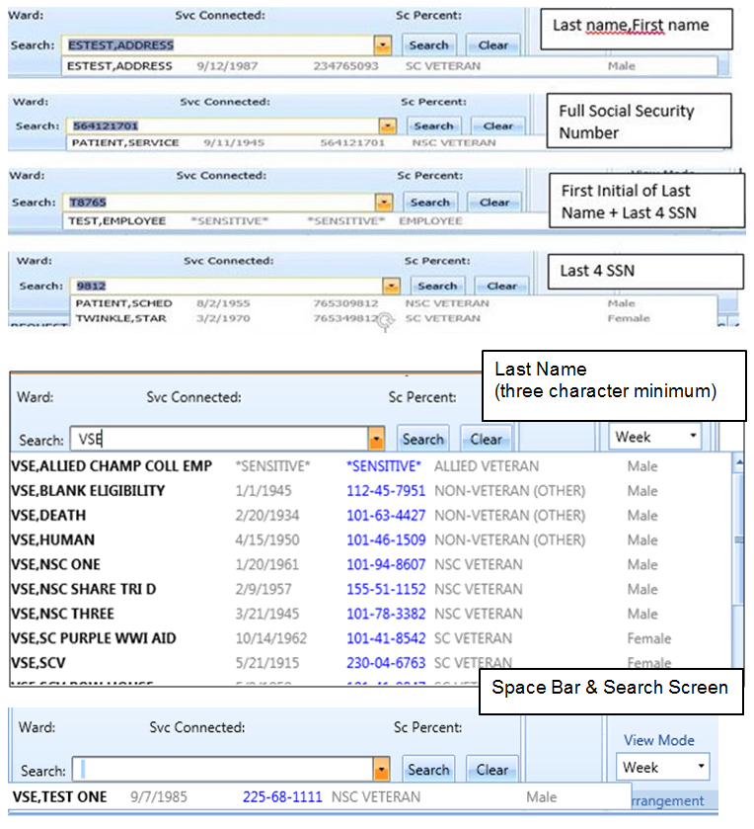

Figure : Patient Search

## Filtering

Filtering can be accomplished in several areas of the VS GUI. Items that can be filtered are:

* Lists
* Time Period
* Facility

The following sections describe basic filtering.

### Filtering Lists

You can filter any column on the request grid to narrow the type of information that you want to view.

1. In the request grid, click any column that shows a filter icon.
2. Select a filter option.
3. Please note: Return to Clinic (RTC) are a sub-type of APPT Requests, and will be included if you check APPT.

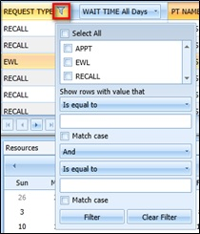

Figure : Filtering Lists

### Paging Through Records

Filtered results are retrieved from the database and displayed in 25 row increments.

To view additional records, use the arrow key located below the list to page through the records.

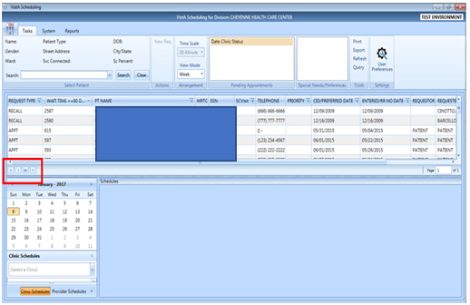

Figure : Paging Through Records

### Filtering by Facility or Clinic

1. To filter by facility or clinic, in the Clinic Schedules pane, type in the name of the desired clinic (six-character minimum when searching by clinic name; four-character minimum when searching by clinic abbreviation),
2. Click the name of the clinic from the list to view the desired clinic.

VS GUI Filtering by Facility or Clinic window

Figure : Filtering by Facility/Clinic

### Filtering by Time Period

1. To filter by time period, in the Resources pane, search for and select a desired clinic.
2. From the calendar, select a month and day for viewing appointments.

Click the back and forward buttons to go to the previous or the next month.

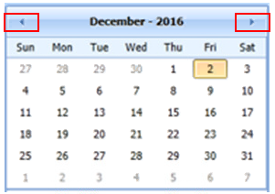

Figure : Filtering by Time Period

## Sorting

You can sort the consolidated list of requests in the request grid in different ways to isolate the information that you need to see.

### Sorting by Column

You can sort the consolidated list of requests in ascending or descending order. The default sort is by Priority Group, Service Connected priority, Preferred Appointment date, and Date entered (Request date).

**To sort by column:**

1. Log on to VS GUI.
2. Click any of the column headers to change the sort order.

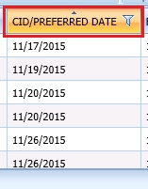

Figure : Sorting by Column

1. Click on the column header again to return to the default sort order.

## Printing and Exporting a Request Management Grid

### Printing a Request Management Grid

The VS GUI also allows for printing of a Request Management Grid. Use the following procedure to print a request grid.

**Note:** Only requests downloaded on the Request Management Grid will print.

1. On the Ribbon Bar, in the Tools section, select the **Print** option.

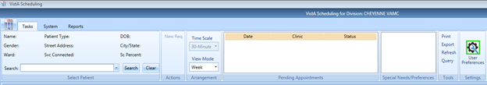

Figure : Selecting the Print Option

1. Select the desired printer, and then click **Print**.

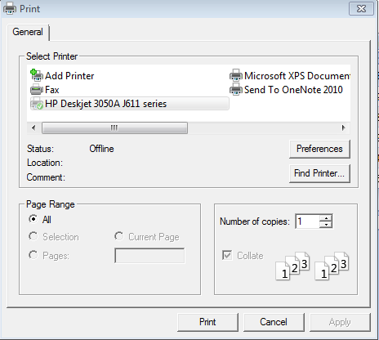

Figure : Selecting a Printer

### Exporting a Grid

The VS GUI also allows for exporting of a Request Management Grid in Microsoft Excel format.

**To export a schedule:**

1. On the Ribbon Bar, in the Tools section, select the **Export** option.

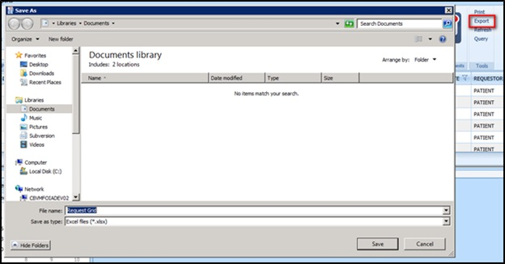

Figure : Exporting a Grid

1. In the **Save As** dialog box, type a file name, select a file type, browse to the location where you want to save the information, and then click **Save**.
2. Open the file and review the contents. All data displayed in the Request Management Grid is saved.

**Note:** Only data that was loaded on screen at the time of export will be exported to the file. Users may need to load more screens to see all the data.

## Viewing

### View Only Mode

A View Only mode is available for non-scheduling personnel. To provide this mode to a user, you will need the option SDECRPC, and the SDECVIEW security key must be assigned to the user. This mode allows users to view data in VS GUI but no changes or edits will be allowed. This key overrides other VS GUI keys and assigns the user to View Only of the Task Tab.

Information available for viewing includes:

* All Pending Requests
* Previously scheduled appointments
* Clinic with appointments scheduled
* Provider with appointments scheduled
* Clinic Group with appointments scheduled
* Patient demographics and special needs/preferences
* Expanded Entry to display appointment audit details such as create date/time
* Query Tool to display a custom list of open requests

### Viewing Requests by Request Type

A Scheduler can view requests for Veteran Appointments (APPT) requests—Consults, Procedure, Veteran, Patient-Centered Scheduling reminders, or EWL reminders. The default view is for requests that are 90 days or older. Users can change the view for a particular session or change the default view by changing their user preferences (refer to Section 4.9).

Requests display 25 records at a time. Additional requests can be viewed by going to the next page.

**To view requests by request type:**

1. Log on to VS GUI.
2. View the request grid. Consult, APPT, EWL, Procedure, and Patient-Centered Scheduling requests that have a wait time of 90 days or more will appear in the grid. The preferred date for the patient request type is shown in the **Clinically Indicated Date (CID)/Preferred Date** column.

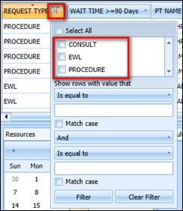

Figure : Request Type Column

1. Click the **Request Type** column to filter specific requests. Only request types that are in the current request grid display in the filter tool.
2. Select **EWL** to view the Electronic Wait List requests.
3. Select **APPT** to view appointment requests (and RTC requests if the category does not appear on its own.)
4. Select **RTC** to view Return to Clinic requests (may be included in APPT for some views including the query tool)
5. Select **Patient-Centered Scheduling** to view Patient-Centered Scheduling requests.
6. Select **Procedure** to view procedure requests.
7. Select **Consult** to view consultation requests.
8. Or you can use any combination of the above.

### Viewing Requests by Patient

**To view requests by patient:**

1. Log on to VS GUI.
2. From the **Tasks** tab, in the **Search** text box, type the patient’s last name or the patient’s first initial of the last name and last four of the SSN (e.g. S1234), Click **Search**, and then select the requested patient’s name.

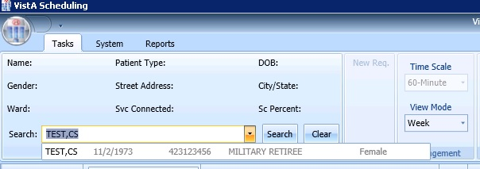

Figure : Select Patient

1. In the **Request Type** dialog box select either **APPT** or **PATIENT-CENTERED SCHEDULING,** and then click **OK** or click **Cancel to see the existing open requests**.
2. When a **New Patient** is searched, please select **CANCEL** when the **Request Type** box pops up. This will allow searching for existing requests before creating anything new.

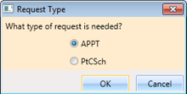

Figure : Request Type

The patient’s pending requests are displayed in the Request Management Grid, 25 records at a time. Booked appointments are displayed in the Pending Appointments window on the Ribbon Bar of the **Tasks** tab.

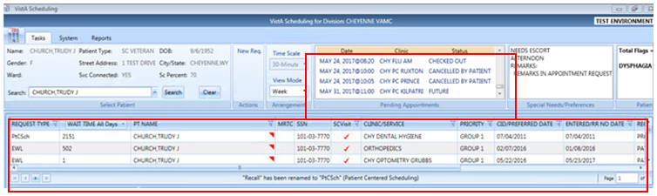

Figure : Patient Pending Requests and Booked Appointments

### Schedule View

The buttons across the top of the calendar are the only working method to change the view the schedule.

The default schedule view displays the clinic schedule by week. but the view can be changed to day or month view for ease of scheduling. To change the schedule view:

1. Log on to VS GUI.
2. Search and select a Clinic to open.
3. To change a view for a specific schedule, at the top of the Schedules section, click the tab of your choice. The available views from the schedule include:

* Day
* Week
* Month
* Timeline

See the week view display below.

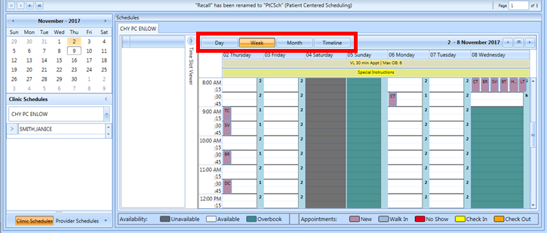

Figure : Changing View of a Specific Schedule

# Ribbon Bar

The following section outlines the features available in the Ribbon Bar of Schedule Manager.

## Patients Demographics

### Finding a Patient

1. Log on to VS GUI.
2. From the **Tasks** tab, in the **Search** text box, type the patient’s last name or the patient’s first initial of the last name and last four of the SSN (e.g. S1234). Click **Search**, and then select the requested patient’s name.
3. Select the requested patient’s name from the list.

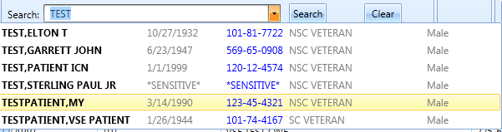

Figure : Search Patient

### Viewing Patient Demographics in the Ribbon Bar

You can view basic patient demographic information in the Ribbon Bar; it provides a limited amount of patient information, but you can choose to display more patient details. To view patient demographics in the Ribbon Bar:

1. Log on to VS GUI.
2. From the **Tasks** tab, in the **Search** text box, type the patient’s last name or the patient’s first initial of the last name and last four of the SSN (e.g. S1234). Click **Search**, and then select the requested patient’s name.
3. In **Request Type** dialog box, click **Cancel**.

View the patient demographics in the Ribbon Bar. The following patient demographics are available:

* **Name:** Last name, First name
* Patient Type: VA patient type
* **DOB:** Date of birth in mm/dd/yyyy format
* **Gender:** Male (M) or female (F)
* **Street Address:** Patient’s street address
* **City/State:** Patient’s address city and state
* **Ward:** For inpatients, current ward location display
* **Svc Connected:** Is the patient service connected (YES or NO)
* **SC Percent:** Percent of service connected disability

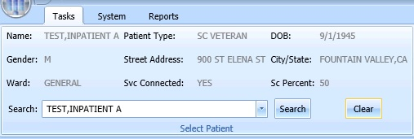

Figure : Patient Demographics in the Ribbon Bar

1. Click anywhere in the Select Patient section of the screen to view the Patient Inquiry Detail screen. This allows for viewing of additional patient information, including the patients Primary Care team and provider, if applicable.

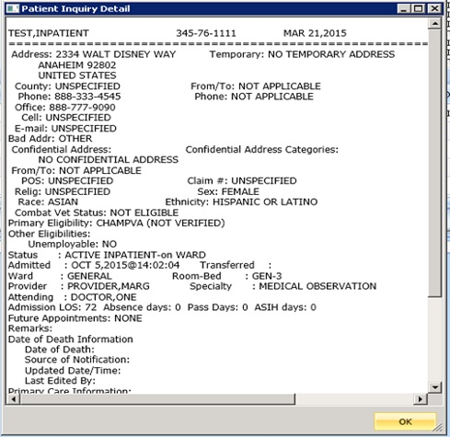

Figure : Patient Inquiry Detail

### Patient Eligibility Information

When adding a new Patient-Centered Scheduling or APPT request, the **Patient’s Eligibility Information** window displays along with the **New Appointment** dialog box. The user can move the **Patient’s Eligibility Information** window around the screen, for convenience. Changes to eligibility may take 5 to 20 minutes to show in VS GUI as there are task jobs running to verify the change before it is fully posted to the patient’s file. Please refresh if you know the patient had a recent change in eligibility.

The window includes:

* SC Percent
* Current Disabilities
* Primary and Secondary Eligibility Codes

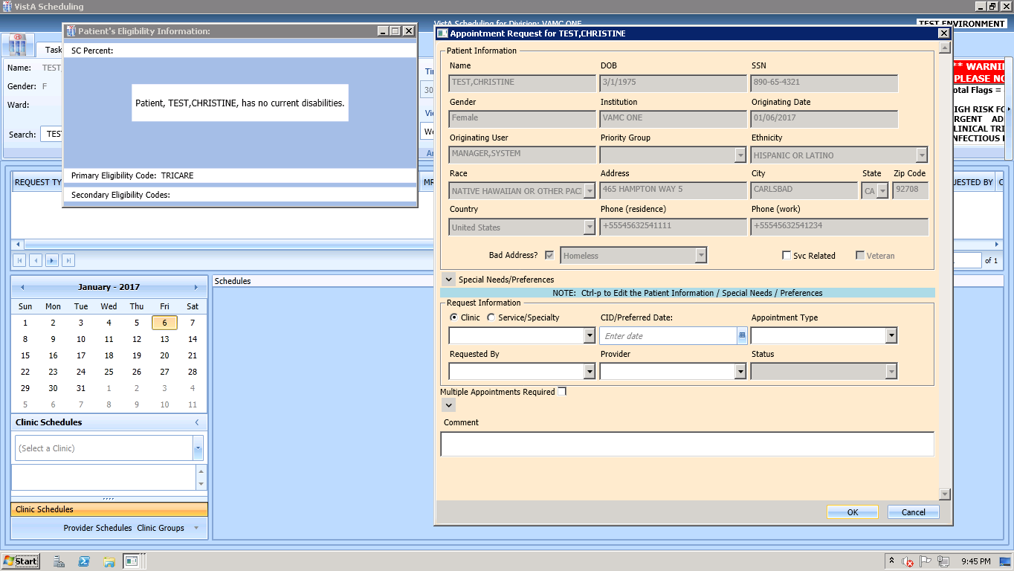

Figure : Patient's Eligibility Information

When the **New Appointment** dialog box is closed, the **Patient Eligibility Information** window closes automatically.

### Updating Patient Demographics

Patient demographic information, such as ethnicity, race, address, state, ZIP code, country, or phone numbers that were not defined during registration, can be updated at any time during the process. Perform the following procedure to update patient demographic data.

1. Log on to VS GUI as a Scheduler.
2. From the **Tasks** tab, in the **Search** text box, type the patient’s last name or the patient’s first initial of the last name and last four of the SSN (e.g. S1234). Click **Search,** and then select the requested patient’s name. Click **Search**.
3. In the **Request Type** dialog box, click **Cancel**.



Figure : Request Type–APPT

1. Press CTRL+P to open the Patient Info screen. Alternatively, right click in the patient demographics box or the patient preferences box.

Patient demographic information can now be displayed and edited at any point in the process. Undefined patient demographic information displays in lists and text fields, on the Patient Information window.

**Note:** Information that appears dimmed cannot be edited.

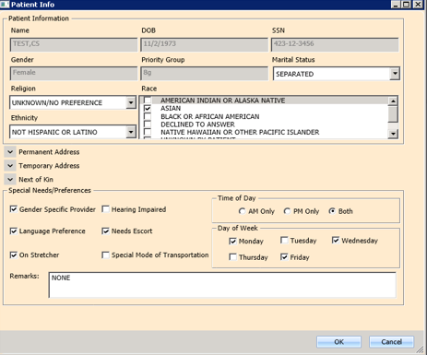

Figure : Patient Information Dialog

1. Click **OK** to update patient demographics. At this point, the updated information displays in the Ribbon Bar.
2. Click **Cancel** to go back to the all patients view.

**Note**: If the patient is being edited in VistA Register a Patient or Load/Edit Patient Data and the user attempts to save edits made to the Patient Info data, a “Patient is being edited” warning message will appear and the user must click OK and Cancel to get out of the Patient Info screen until the VistA Register a Patient or Load/Edit Patient Data option is exited.

Patient is Being Edited Warning Pop-up

Figure : Patient is Being Edited Warning Pop-up

### Editing Permanent Address

The Permanent address for a patient can be edited.

1. Point to the **Patient Info** screen, which is available at any point via the RM Grid.
2. Press **CTRL + P** to view the patient’s information.

A user can update the patient’s address Line 1 and 2, Zip Code, and Phone Numbers.

* Zip Code – five or nine digits (when entered, the system provides choices for Cities that match that zip code and based on that, automatically completes the State and County fields).
* For Phone numbers, VS GUI automatically formats the Patient Work Phone to (xxx) xxx-xxxx if 10 digits are entered. If more than 10 digits are entered, it auto formats to x-xxx-xxx-xxxx x….

Only characters (,), +, -, and X (Except Cell and Pager) are allowed in the Phone Numbers.

1. Click **OK** when complete to save the information.

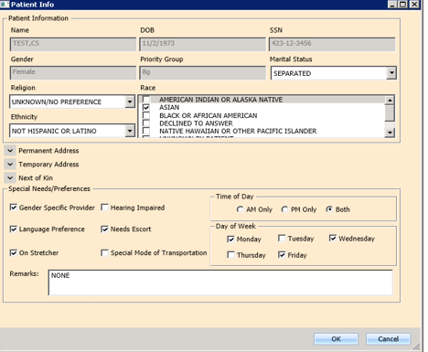

Figure : Patient Info Dialog–Permanent Address

**Note:** Areas highlighted in gray cannot be edited.

### Adding a Temporary Address

A temporary address can be entered for a patient.

1. Point to the **Patient Info** screen.
2. Press **CTRL + P**, which is available at any point in the RM Grid.

**Note:** The Address Active Box should be checked with a Start Date and End Date

A user can update the patient’s address Lines 1 – 2 and Zip Code. Zip Code can be five or nine digits (when entered, the system provides choices for Cities that match that zip code and based on that, automatically completes the State and County fields).

1. Click **OK** when complete to save the information.

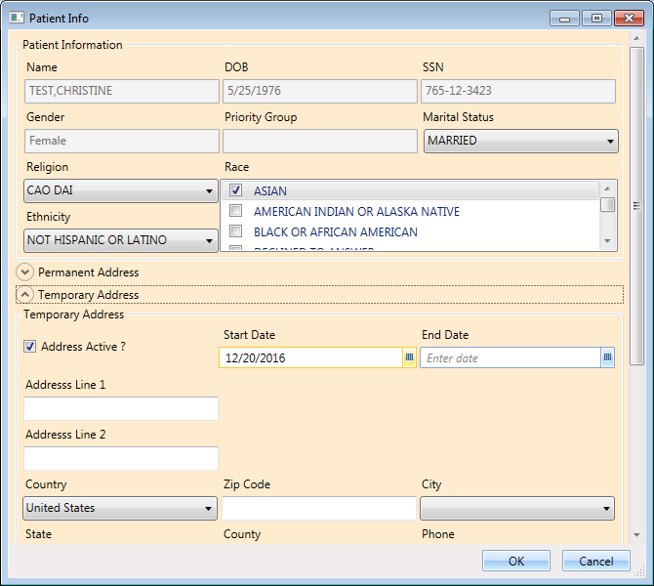

Figure : Patient Info Dialog – Temporary Address

**Note:** Areas highlighted in gray cannot be edited.

### Bad Address

A patient’s address may be incorrect (e.g., mail has been returned as undeliverable, or if the patient is homeless). If you learn that a patient’s address is incorrect, you must indicate that information on the patient’s record so notices are no longer sent. The incorrect address can be indicated while updating the patient’s address information in the Patient Info dialog.

1. Log on to VS GUI as a Scheduler.
2. From the Tasks tab, in the **Search** text box, type the patient’s last name or the patient’s first initial of the last name and last four of the SSN (e.g. S1234). Click **Search**, and then select the requested patient’s name.



Figure : Select Patient

1. In the **Request Type** dialog box, click **Cancel**.



Figure : Request Type

1. Press **CTRL + P** to open the Patient Information dialog screen. Confirm that the patient’s address information is incorrect or missing, and then click to check the Bad Address check box.

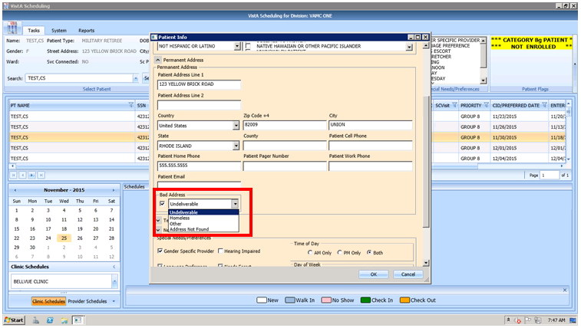

Figure : Appointment Request Dialog—Bad Address Selection

1. Choose the reason for the bad address:
2. Undeliverable
3. Homeless
4. Other
5. Address Not Found
6. Click **OK**.

Note: If a scheduler later obtains a correct address and updates the patient’s record, the scheduler must ensure that the bad address flag is REMOVED manually. If the bad address remains, mail will not resume being sent to the patient.

## Actions

### New Request

After searching for and accessing a specified patient’s demographics and associated pending appointments, the Actions pane allows you to create a new request for the patient. For example, creating a Patient-Centered Scheduling request as a follow-up to an appointment request or creating a new appointment request after looking at only patient information.

**To start a new request for an already selected patient:**

1. Patient demographics and pending appointments appear in the Ribbon Bar. In the Actions pane, select **New Request**.

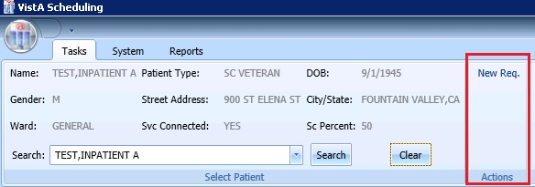

Figure : Actions Pane

The Request Type dialog box opens.



Figure : Request Type – APPT

1. Click the Request Type, and then click OK.

## Pending Appointment Window

The Pending Appointment Window displays a patient’s existing appointments. The appointment view defaults to the current date. The Scheduler can utilize the scroll bar to the right to scroll up to view appointments 365 days in the past. Or, the Scheduler can utilize the scroll bar to scroll down to view appointments 365 days in the future.

Selecting an appointment from the Pending Appointment window in the Ribbon Bar opens the Clinic Schedule Grid. When you select a past appointment, the clinic schedule defaults to the appointment’s date.

Right click on an existing appointment in either the Pending Appointments box or in the calendar to select Expanded Entry. This will show the audit history of that appointment’s creation, check in, etc.

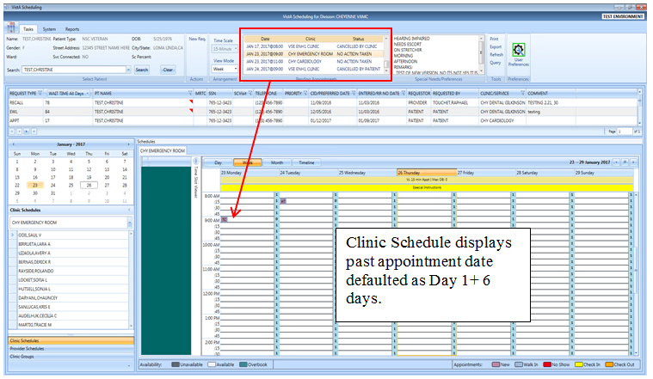

Figure : Pending Appointment Window – Past Appointment Date

The clinic schedule defaults to the current date (today’s date) when you select an appointment dated “today” or less than three days in the future.

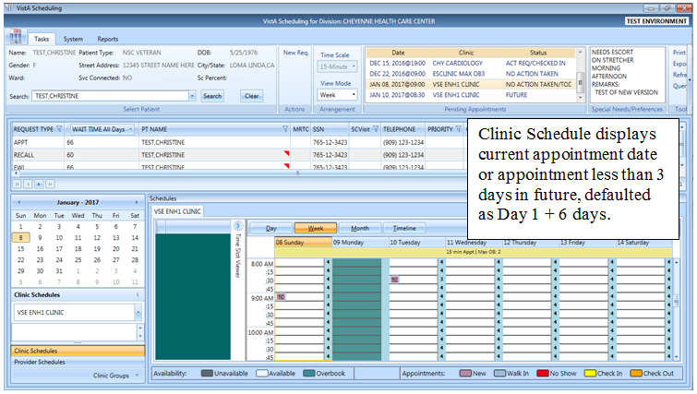

Figure : Pending Appointment Window – Current less than Three Days in Future

The clinic schedule defaults to -/+ three days of the appointment date for future dates.

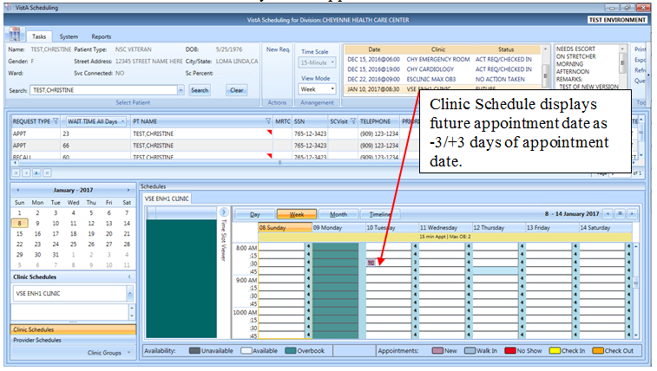

Figure : Pending Appointment Window – Future Appointment Dates

## Special Needs/Preferences

### Adding/Removing Special Needs/Preferences from Requests

Patients visiting the VA may require additional assistance when they arrive for their visit. Some of these special needs/preferences may include issues with hearing, how they are arriving at the VA, Day of the Week or Time of the Day, etc.

**To add Special Needs/Preferences to an appointment request:**

1. Log on to VS GUI
2. From the **Tasks** tab, in the **Search** text box, type the patient’s last name or the patient’s first initial of the last name and last four of the SSN (e.g. S1234). Click **Search**, and then select the requested patient’s name. Click **Search**.
3. In the Request Type dialog box, click **Cancel**.



Figure : Request Type – APPT

1. Press **CTRL + P** to open the Patient Info dialog box.
2. Select the patient’s special needs from the Special Needs/Preferences section of the Patient Info dialog box.
3. Add additional information regarding patient’s Special Needs/Preferences selections in the Remarks field.
4. Please note: If AM/PM preference is selected, it will reset to both the next time patient preferences are edited. This is a known defect in version 2.0.0.14.

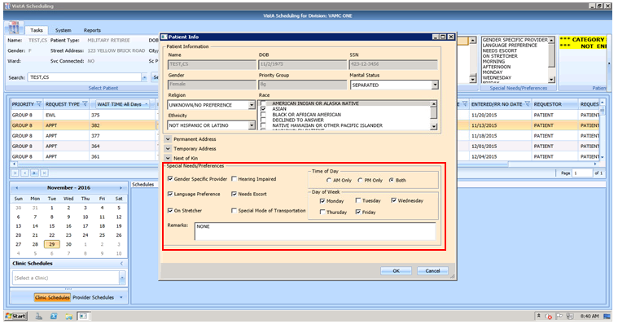

Figure : Patient Info Dialog – Special Needs/Preferences Section

1. Click **OK**. The Special Needs/Preferences entered display in the Ribbon Bar.

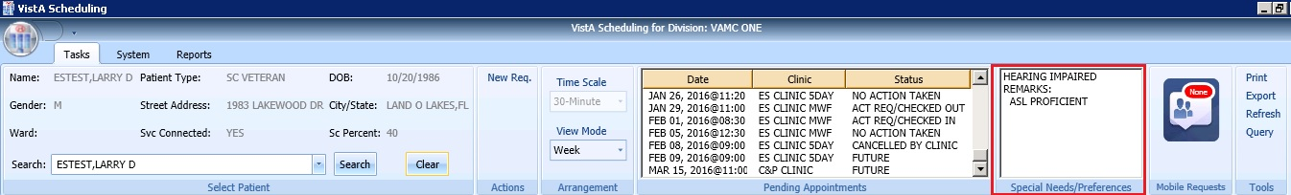

Figure : Ribbon Bar – Special Needs/Preferences

## Patient Flags

PRFs are used to alert VHA medical staff and employees of patients whose behavior and characteristics may pose a threat either to their safety, the safety of other patients, or compromise the delivery of quality health care. PRF assignments are displayed during the patient look-up process.

Each PRF includes a narrative that describes the reason for the flag and may include some suggested actions for users to take when they encounter the patient.

When a patient’s record is flagged, a message window opens with an appropriate action recommended.

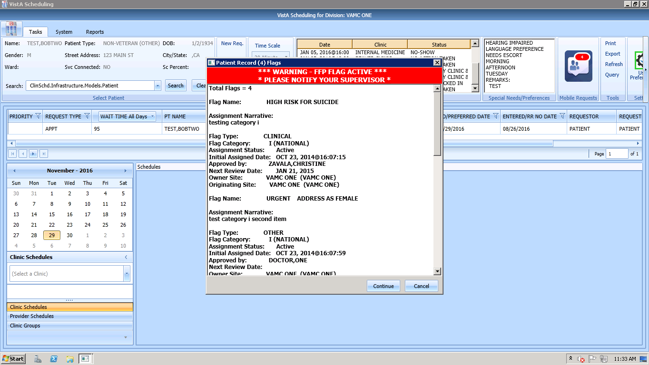

Figure : Patient Record Flags Dialog

1. Select an appropriate action.
2. To continue processing the appointment, click **Continue**; otherwise, click **Cancel**.

Once processing has continued, the PRF continues to show on the Ribbon Bar. If the user clicks on PRF in the flag box in the ribbon bar, the pop up box containing flag details will return.

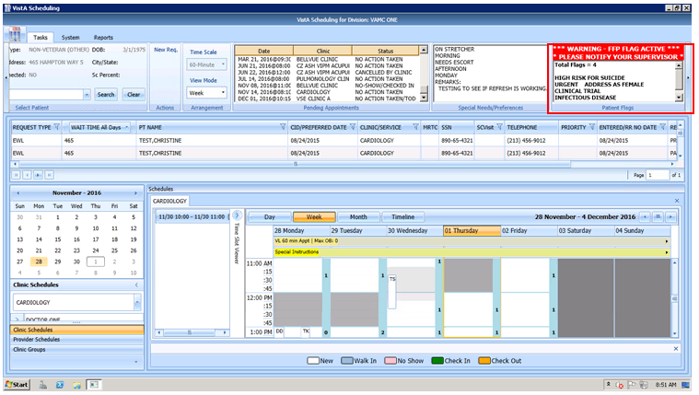

Figure : Patient Record Flags

## Tools

### Print

Refer to Section 3.9.1for details on using the Print functionality in the Tools Pane via a network printer. If you are printing a patient letter using this method, the address will print too high on the page to fit into a windowed envelope.

Refer to Section 6.1.1 for details on printing using an active VistA print device. This method is vastly preferred as it places the address into the correct spot for windowed envelopes and allows schedulers to print to their office printer, centralized printers or other bulk mail devices that are used in VistA for processing outgoing mail.

### Export

Refer to Section 3.9.2for details on exporting the request grid.

### Refresh

After checking a patient’s pending appointments or checking availability for a clinic, you may want to reset the GUI back to the default view from when you first logon to the GUI, clearing all text entered in any fields.

1. To refresh the GUI, go to the Tools pane.
2. Click **Refresh**. The GUI resets to its default logon view.

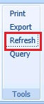

Figure : Refresh Button in Tools Pane

### Query

In order to sift through patient data and only view data of a specific type, the Query tool can be utilized to show only data matching specific criteria. Once the query has been performed, only records matching the query criteria appear in the request grid.

* Patients are in **Group A** and can be used independently or in conjunction with other search criteria.
* Request Type + Clinic/Services are in **Group B**. This group can be used independently or in conjunction with other search criteria.
* Priority, Wait Time, SC Visit, Service Connected, Origination Date, CID/Preferred Date and Urgency are in **Group C**. This group must be combined with other search criteria from either Group A, Group B, or Group A and B to satisfy the Query Tool business rules.

**To perform a query:**

1. Log on to VS GUI.
2. Select **Query** from the **Tools** pane. The **Request Query** window displays.

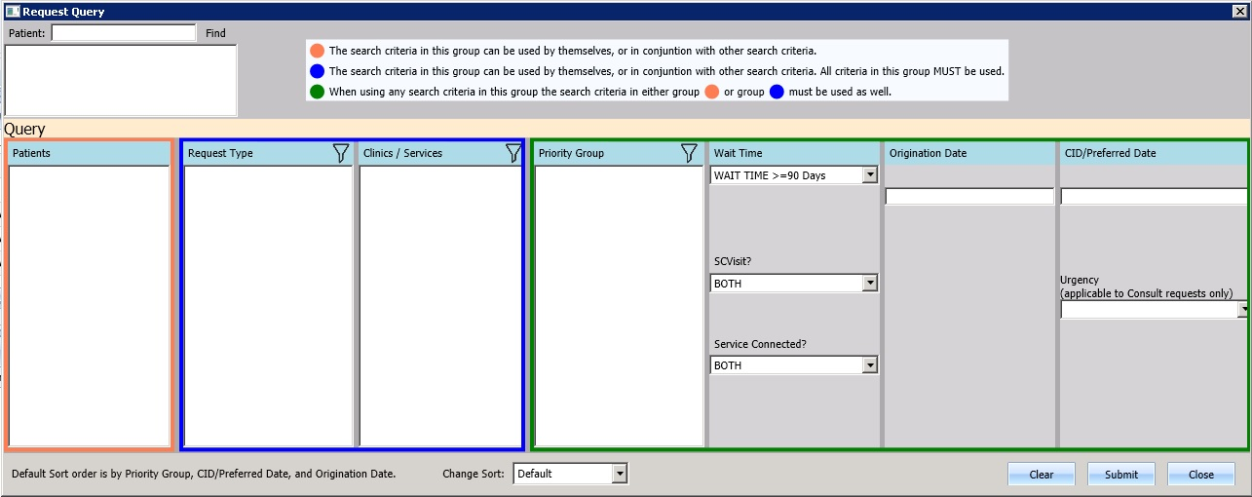

Figure : Request Query

1. Click **Submit**. If the search criteria rules are not satisfied, a **Query Rule Validation** dialog box displays.

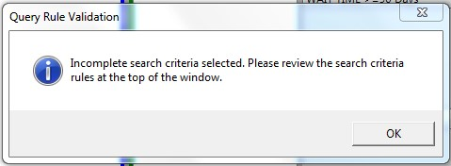

Figure : Query Rule Validation

Once all search criteria has been selected and the results have been returned, a **Request Query Confirmation** dialog box displays the number of records found that satisfied the search criteria.

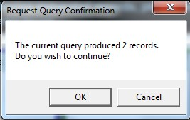

Figure : Request Query Rule Confirmation

1. Click **OK** to display the Query results in the Request Management Grid.
2. Click **Cancel** to remove search criteria and start a new search.

Note: RTC requests are a subtype of Appointment Requests. In version 2.0.0.14, chose Appointment to see both APPT and RTC requests. In addition, the query tool will only return the first 200 entries found in the search. The user will be asked if they want to continue and view the first 200, or go back to limit the search. Once the list displays, page forward until the user reaches the end of the list to sort/filter on the entire list. The query tool will retain the search criteria of the last search in a user’s session to aid the user while they work a list of open requests.

## Settings – User Preferences

Users may now set their own column preferences within a session or as their default view.

From the far right of the Ribbon Bar, select the User Preferences setting icon.

The current column order is:

Request Type;

Wait Time; (Wait time calculated from Create date to today)

Patient (PT) Name;

Multiple Return To Clinic (MRTC);

SSN;

SC Visit;

Telephone;

Priority;

CID/PreferredDate;

Entered/RR No Date;

Requestor;

Requested By;

Clinic/Service; and

Comment

Note: Users can drag and drop columns to reorder them. Save as default and accept to save the order from session to session. Reordered columns do NOT have any effect on log in times, and are highly encouraged as Clinic/Service and CID/PreferredDate are far to the right in the default order.

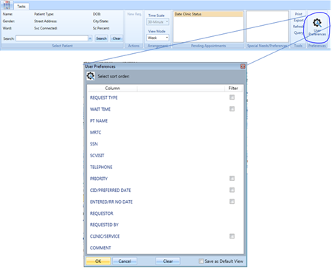

Figure : Settings – User Preferences

Filters on the following fields are also available:

* Request Time
* Wait Time
* CID/Preferred Date
* Clinic/Service
* SC Visit
* Priority
* Entered/RR (Recall Reminder) No Date

NOTE: **Adding filters to user preferences is highly discouraged at this time**. If the user restricts their log in with filters, and the system cannot find any open requests, the log in will take an excessive amount of time. If a user experiences long log in times, clear all preferences.

**To save your user preferences:**

1. Select the sort order or filters to display.

To save the selections as your default view, select “Save as Default View” on the bottom right. If you do not select “Save as Default View,” your selections will only be applicable to your current session.

1. Click OK to save.

**Note:** If you filter the requests to view only Consult requests you will not see the PtCSch requests unless you unfilter the preferences.

The User Preferences Settings icon is highlighted in green indicates the user preferences are stored.

**To remove any existing user preferences for the user’s default view:**

1. Click the User Preferences icon.
2. In the User Preferences window, click **Clear, Save as Default View,** then click **OK** to save.

The User Preferences Settings icon will now display without the green highlight when no user preferences have been stored.

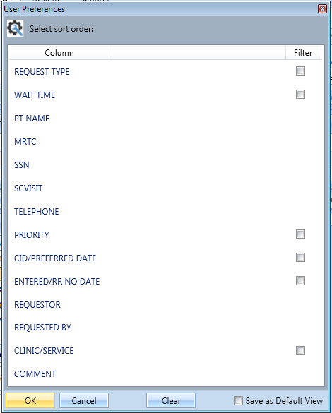

Figure : Settings – Save as Default View

# Request Management

## Request Management Procedures

### Viewing a Patient’s Existing Requests

1. Log on to VS GUI.
2. From the **Tasks** tab, in the **Search** text box, type the patient’s last name or the patient’s first initial of the last name and last four of the SSN (e.g. S1234). Click **Search**, and then select the requested patient’s name.
3. Click Search.
4. Select the requested patient’s name from the list.
5. In the **Request Type** dialog box, click **Cancel**.



Figure : Request Type

In the Request Management grid, view the existing requests for the selected patient.

**Note:** The patient’s booked appointments display in the Pending Appointment Window in the Ribbon Bar. The default is the current date. Schedulers can scroll up or down to view appointments dated -/+365 days of the current date.

1. Click a Request Type entry and the Prerequisites screen opens. **Prerequisites are for RTCs only and the Prerequisite box will open if there is a Prerequisite note. #NLT# will display in the comments if the provider selected “NO LATER THAN” for a priority request.**

* The Prerequisite screen will remain open while the user is on the Request Management Grid.
* If switching to a Request Type with no Prerequisites, then the Prerequisite screen will go away.

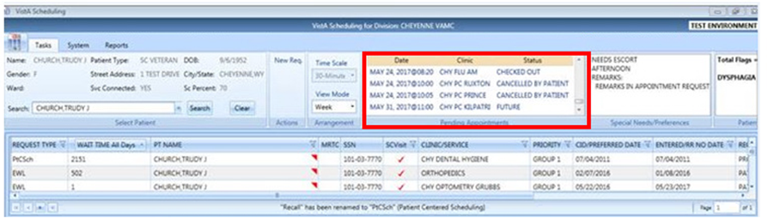

Figure : Request Grid and Pending Appointments

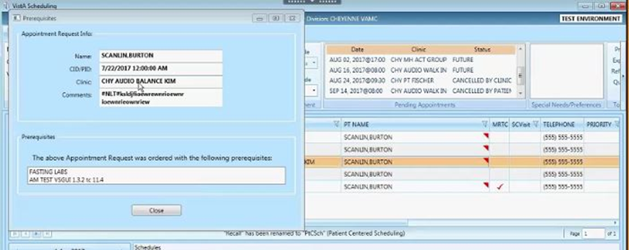

Figure 54: Prerequisite Screen

1. Right-click on an appointment in the Pending Appointments block and the EXPAND ENTRY block opens.

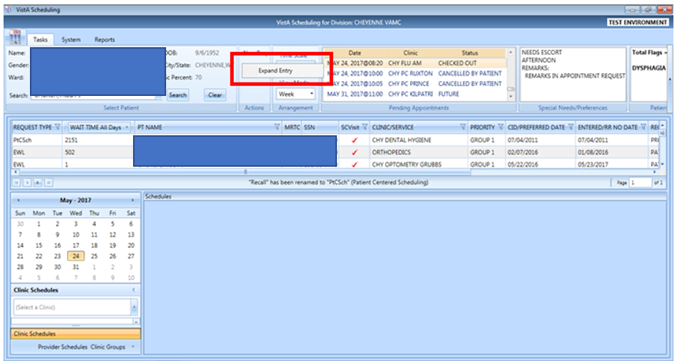

Figure : Request Grid Displaying Expand Entry Block

1. Click the Expand Entry block to see the expanded appointment information.

* Appointment Demographics
* Appointment Event Log
* Appointment Wait Time
* Patient Information
* Encounter Information (this information will only display if the encounter information has been entered for this patient)

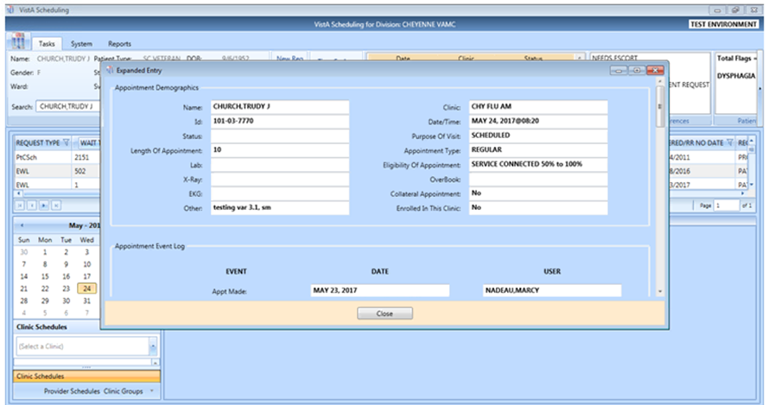

Figure : Appointment Demographics

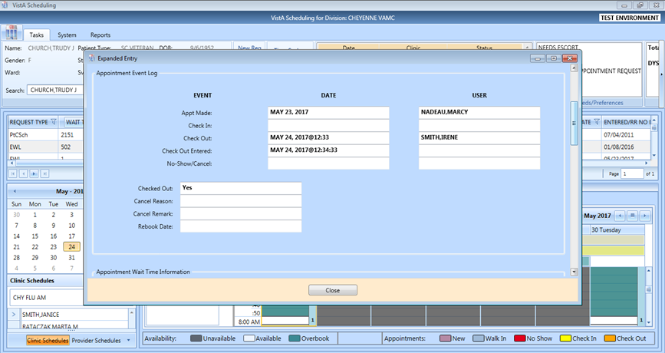

Figure : Appointment Event Log

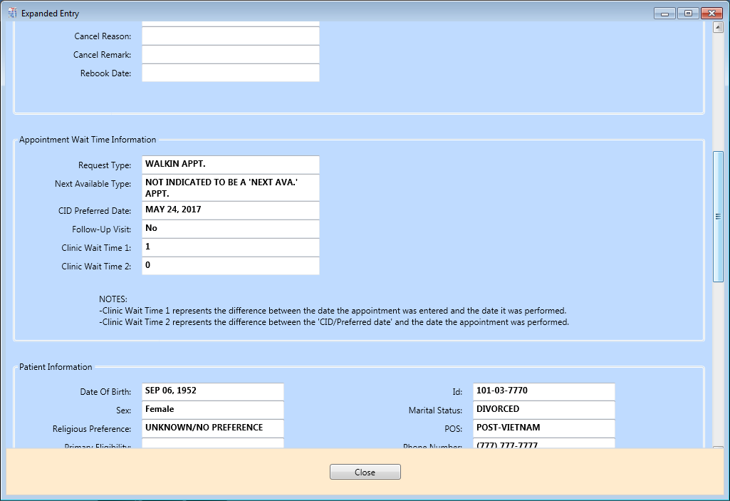

Figure : Appointment Wait Time

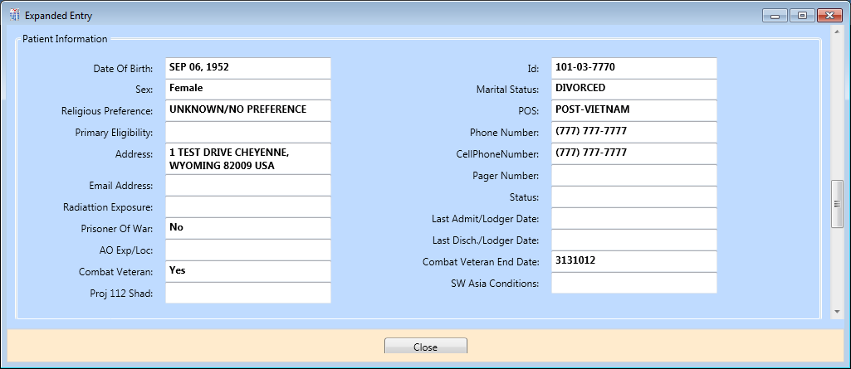

Figure : Patient Information

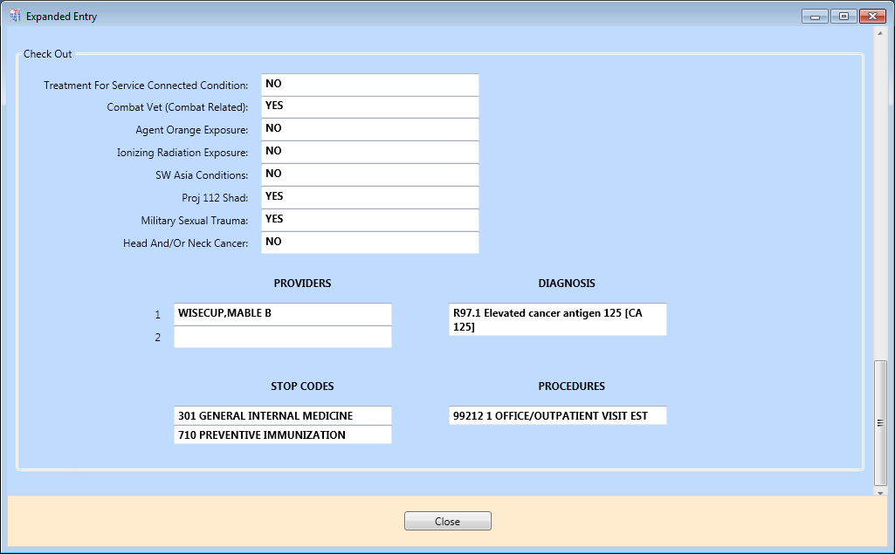

Figure : Encounter Information

**Note:** This information will only display if the encounter information has been entered for this patient.

### Adding Appointment Request

1. To submit an appointment request, from the **Tasks** tab search for the patient using the Search field.
2. Select **APPT** in the **Request Type** dialog box.



Figure : Request Type - APPT

**Note:** If the patient has already been selected, the **Request Type** dialog box can be accessed via **New Req.** in the Actions Pane of the Ribbon Bar.

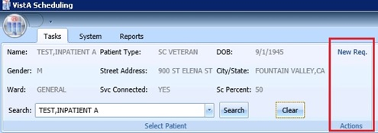

Figure : Actions Pane—New Req. Selection

1. In the **Appointment Request** dialog box, confirm Patient Information details.
2. In the **Appointment Request** dialog box, complete the **Request Information** section.
3. Click the **Clinic** or **Service/Specialty** button. For Clinic, enter clinic name (minimum of six characters) or Clinic abbreviation. For Service/Specialty enter service or specialty (minimum of six characters required).
4. Enter **CID/Preferred Date** for the preferred appointment/Patient-Centered Scheduling date. Enter date directly or select date from Calendar control option. CID/Preferred Date can be past, current, or future.
5. Select **Appointment Type** if not defaulted by patient eligibility and clinic selection then choose from the list.
6. In **Requested By**, select either Provider or Patient.

If **Provider** is selected, then enter the provider name (three-character minimum for the list to populate) and select from the list.   
**Note:** If the Patient was selected from Requested By, then the Provider field appears dimmed and cannot be edited.

* **Status** is automatically populated.

1. Established – The patient has been seen at that clinic in the past 24 months.
2. New – The patient has not been seen at that clinic in the past 24 months.

Refer to Section 6.3.2 for additional instructions regarding Multiple Appointments Requiredcheck box options.

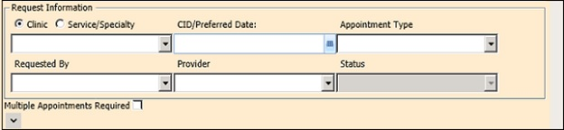

Figure : Appointment Request Dialog – Request Information Section

If needed, users can view existing special needs and preferences in the middle section drop down box. If changes are needed, the user can call the edit special needs and preferences box by **CTRL + P**, complete the **Special Needs/ Preference** section. The **Remark**s field is available to add clarifying information regarding selections made. **Selected Special Needs/Preferences** and **Remarks** display in the Ribbon Bar.

**Note:** Text can be added in the **Remarks** field up to 80 characters to add information regarding the Appointment Request. Text displays in the Request Management Grid under the Comment column.

1. Click **OK**.

Updated demographics display in ribbon bar. The APPT Request appears on the Request Management grid. The Clinic Schedule Grid opens for the clinic specified in the request.

**Note:** APPT Requests with Comments are flagged with a red arrow in the Request Management Grid.

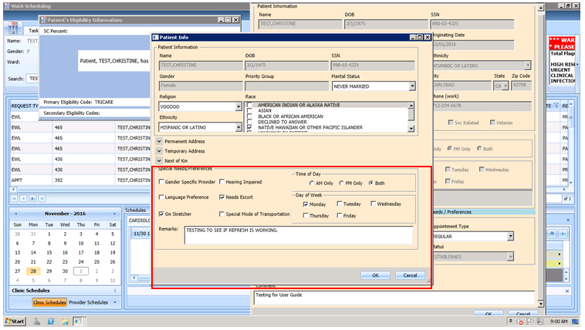

Figure : Special Needs/Preferences Section from Patient Info Dialog

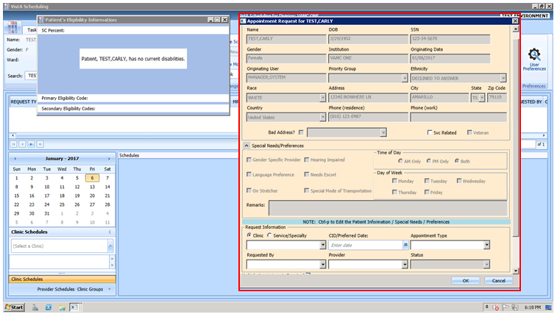

Figure : Appointment Request Dialog

### Viewing/Editing Appointment Request

If a request (APPT, EWL, Veteran) needs to be reviewed or modified before being booked, you can View/Edit the request in the Request Grid:

1. Log on to VS GUI as a Scheduler.
2. From the **Tasks** tab, in the **Search** text box, type the patient’s last name or the patient’s first initial of the last name and the last four of the SSN (e.g. S1234). Click **Search**, and then select the requested patient’s name. Click **Search**.
3. Select the requested patient’s name from the list.

**Note:** When the **Spacebar + Search** is used, the Ribbon Bar and Request Management Grid adjust to that selected patient.

1. In the **Request Type** dialog box, select **Cancel**.
2. In the **Request Management** grid, right-click the applicable **APPT** request.
3. Select APPT/VETERAN Disposition option.

The following options appear for selection:

* View Request
* Edit Request
* Transfer to EWL – refer to Section 5.1.5 for instructions
* Death
* Removed/Non-VA Care
* Removed/Scheduled-Assigned
* Removed/VA Contract Care
* Removed/No longer Necessary
* Entered in Error

1. Select **View Request**. The **Appointment Request** dialog box opens with everything dimmed as the dialog box is Read-Only.

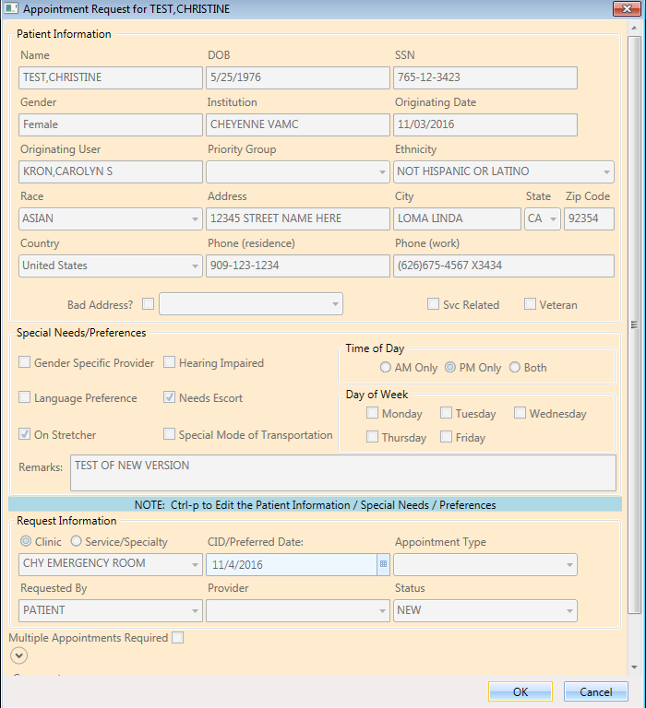

Figure : View Request (Read Only)

1. Click **OK**.

You return to the Request Management Grid.

1. Right-click the applicable **APPT** request.
2. Select the APPT/VETERAN Disposition option.

The following options appear for selection:

* View Request
* Edit Request
* Transfer to EWL. Refer to Section 5.1.5 for instructions
* Death
* Removed/Non-VA Care
* Removed/Scheduled-Assigned
* Removed/VA Contract Care
* Removed/No longer Necessary
* Entered in Error

1. Select Edit Request.

The Appointment Request and Patient’s Eligibility Information dialog display.

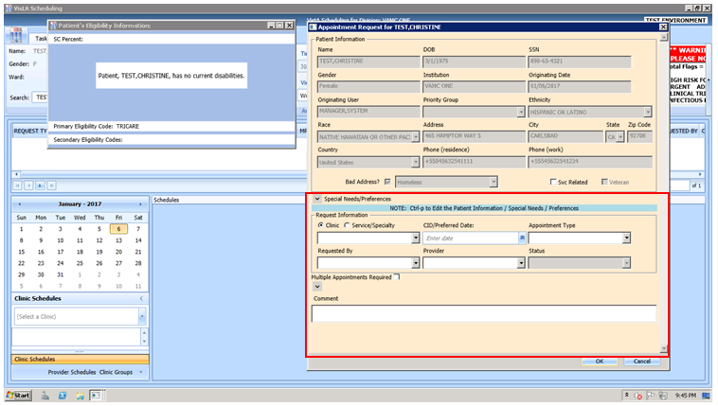

Figure : Edit Request (Request Information Only)

The editable fields are Clinic/Service Specialty; Appointment Type; Requested By; Provider, and Comments. The CID/Preferred Date CANNOT be edited.

1. Click **OK**.

The request returns to the Request Management Grid with the updated information listed.

**Note:** If you change the request for a Clinic to a Service/Specialty request, the **Appointment Type** field can then be edited. Also, changes to the **APPT Request** are tracked by the system in the SDEC APPT REQUEST file.

### Disposition or Removing an Appointment Request

If an APPT request is no longer needed, the Scheduler can remove it from the Request Grid following the steps below.

1. Log on to VS GUI as a Scheduler.
2. From the **Tasks** tab, in the **Search** text box, type the patient’s last name or the patient’s first initial of the last name and last four of the SSN (e.g. S1234). Click **Search**, and then select the requested patient’s name.
3. Click **Search**.
4. Select the requested patient’s name from the list.
5. In the **Request Type** dialog box, click **Cancel**.
6. In the **Request Management** grid, right-click the applicable **APPT** request.
7. Select APPT/VETERAN Disposition option.

The following options appear for selection:

* Transfer to EWL. Refer to Section 5.1.5 for instructions
* Death
* Removed/Non-VA Care
* Removed/Scheduled-Assigned
* Removed/VA Contract Care
* Removed/No longer Necessary
* Entered in Error

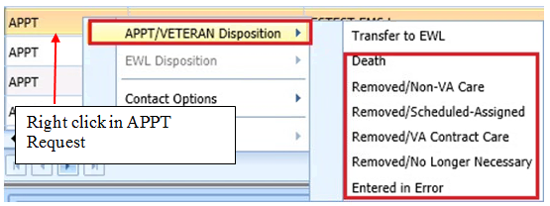

Figure : APPT/Veteran Disposition Options

1. Select the applicable APPT Disposition option. APPT Request is removed from Request Management Grid.

### Transfer to EWL Request for a Patient

If an appointment cannot be scheduled because of limitations, the patient is put on an EWL for future scheduling. Use the following procedures to transfer an APPT Request to an EWL Request.

1. Log on to VS GUI as a Scheduler.
2. From the **Tasks** tab, in the **Search** text box, type the patient’s last name or the patient’s first initial of the last name and last four of the SSN (e.g. S1234). Click **Search**, and then select the requested patient’s name.
3. In the **Request Type** dialog box, click **Cancel**.
4. In the **Request Management** grid, view the open APPT Requests for the patient.
5. Select the **APPT** request that needs transferred to **EWL**.
6. Right-click the APPT request and select **APPT/VETERAN Disposition**.
7. In the APPT/VETERAN Disposition options, select **TRANSFER TO EWL**. The **EWL Request** dialog box displays.  
   **Note:** The Transfer to EWL option is not available for MRTC appointments nor is it available for users who do not have the SDWL MENU Security Key.

Confirm **Clinic** is the default in the dialog box. If not, search for and select the appropriate Wait List Clinic by name. Searching by clinic abbreviation is not supported in the EWL Request dialog.

**Note:** Clinic or Service (stop code) does not default if it is not activated as Wait List Clinics in SD Wait List Parameter (File #409.32).

**CID/Preferred** date and Status are not editable.

**Appointment Type** is the default from APPT Request Clinic. If a patient is a Veteran and the Service Related box is checked, the Appointment type defaults to Service Connected. Also, if the Service Connected disability is greater than or equal to 50%, the Appointment type defaults to Service Connected. This puts the EWL request in a higher priority than other EWL requests.

**Requested By** and **Provider** are populated from the original APPT request but are editable.

Enter **Comments** as appropriate.

1. Click **OK**.

The request grid shows requests of the selected patient. The newly added request is selected. The calendar defaults to the desired date and shows the clinic schedules.

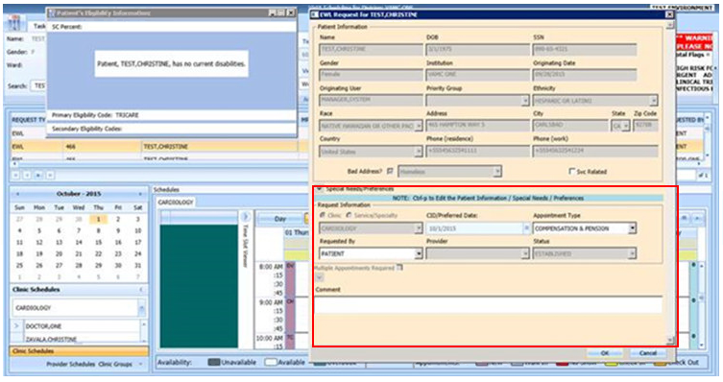

Figure : EWL Request Dialog

### Disposition or Removing a Patient from the EWL

If a patient is on the EWL for an appointment or a consult, and information is received that the patient no longer needs the appointment, the EWL request can be removed and will no longer appear in the Request Management Grid.

**To disposition or remove the EWL Request:**

1. Log on to VS GUI as a Scheduler.
2. From the **Tasks** tab, in the **Search** text box, type the patient’s last name or the patient’s first initial of the last name and last four of the SSN (e.g. S1234). Click **Search**, and then select the requested patient’s name. The patient must have an existing EWL request.
3. In the request grid, right-click the desired EWL request and select the EWL Disposition.

The following EWL Disposition options are available for selection:

* Death
* Removed/Non-VA Care
* Removed/Scheduled-Assigned
* Removed/VA Contract Care
* Removed/No longer Necessary
* Entered in Error
* Transferred

The EWL Request is removed from the Request Management Grid and the next APPT Request is moved up and highlighted.

### Adding Patient-Centered Scheduling Request

**To add a new Patient-Centered Scheduling request for a patient:**

1. Log on to VS GUI as a Scheduler.
2. From the **Tasks** tab, in the **Search** text box, type the patient’s last name or patient’s first initial of the last name and last four of the SSN (e.g. S1234). Click **Search**, and then select the requested patient’s name.
3. In the Request Type dialog box, select PATIENT-CENTERED SCHEDULING (PtSch) and click OK.

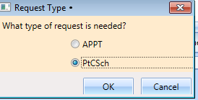

Figure : Request Type–PATIENT-CENTERED SCHEDULING

1. Enter a **Patient-Centered Scheduling Date**. Enter the date the provider requested.
2. Enter a **Patient-Centered Scheduling Date** (per patient). Enter the date the patient prefers.
3. Enter a Patient-Centered Scheduling Appt Type.

* Follow up
* Consultation
* Routine
* Evaluation

Check the box for **Fasting** if the patient needs to fast for the appointment.

1. Enter the Length of the Appointment.
2. Select **Clinic** (the Clinic can be searched by Clinic Name with 6-character minimum or by the Clinic’s abbreviation with a 4-character minimum).

**Note:** The Clinic does not appear for selection if the Patient-Centered Scheduling Reminders Letter is not defined for the clinic.

1. Select Patient-Centered Scheduling Provider (3-character minimum).
2. Enter a **Comment**.
3. Press **Ctrl + P** to view the **Special Needs/Preferences** window for the Patient Info dialog box and add or edit preferences as appropriate.
4. Click **OK**.

The request grid shows requests of the selected patient. The newly added request is selected. The calendar defaults to the desired date and the selected clinic and defaults, and shows the clinic schedules.

View the **Special Needs/Preferences** window in the ribbon bar to confirm it is updated.

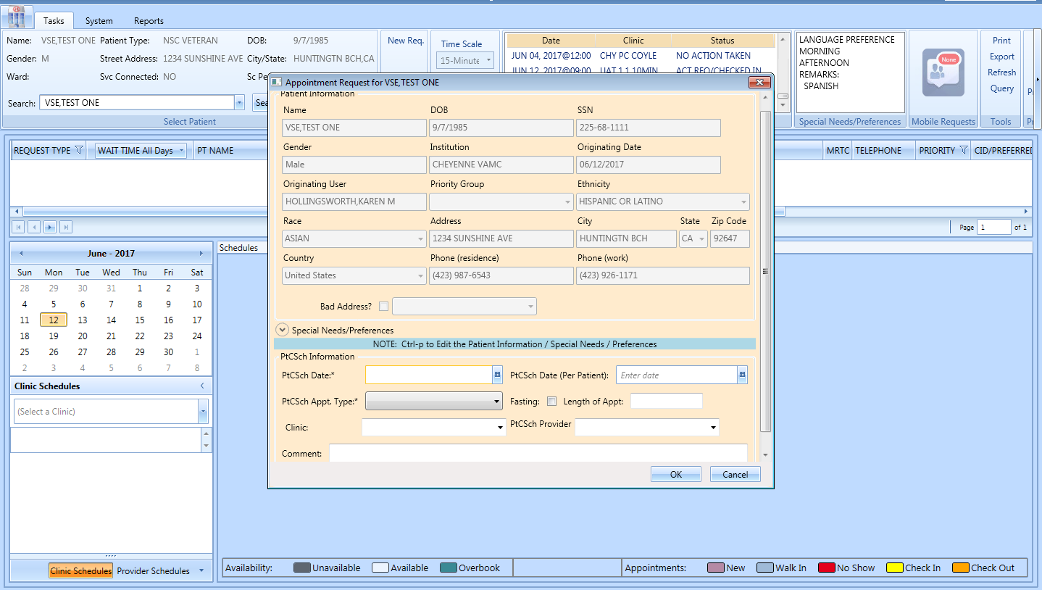

Figure : Patient-Centered Scheduling APPT Request Dialog

### Viewing/Editing Patient-Centered Scheduling Request

If a Patient-Centered Scheduling request needs to be reviewed or modified before being booked, you can View/Edit the request in the Request Grid using the following steps:

1. Log on to VS GUI as a Scheduler.
2. From the **Tasks** tab, in the **Search** text box, type the patient’s last name or the patient’s first initial of the last name and last four of the SSN (e.g. S1234). Click **Search**, and then select the requested patient’s name.

**Note:** When **Spacebar + Search** are used, the Ribbon Bar and Request Management grid adjust to that selected patient.

1. In the **Request Type** dialog box, select **Cancel**.
2. In the **Request Management** grid, right-click the applicable **Patient-Centered Scheduling** request.
3. Select the Patient-Centered Scheduling Disposition option.

The following options appear for selection:

* View Request
* Edit Request
* Failure to respond
* Moved
* Deceased
* Doesn’t want VA services
* Received care at another VA
* Other

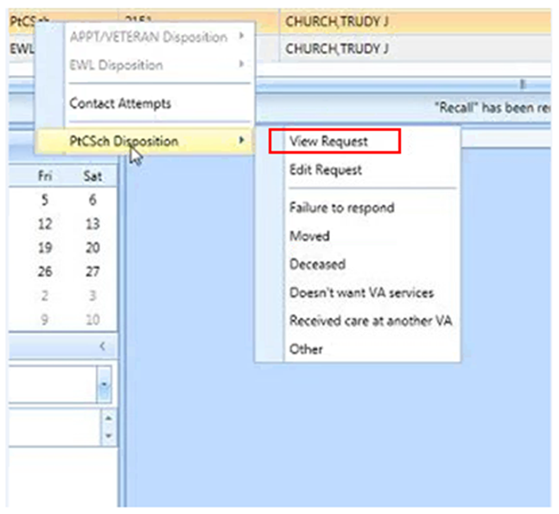

Figure : Patient-Centered Scheduling Disposition Dialog

1. Select **View Request**. The **Patient-Centered Scheduling Request** dialog box appears with the contents dimmed as the dialog box is Read-Only.

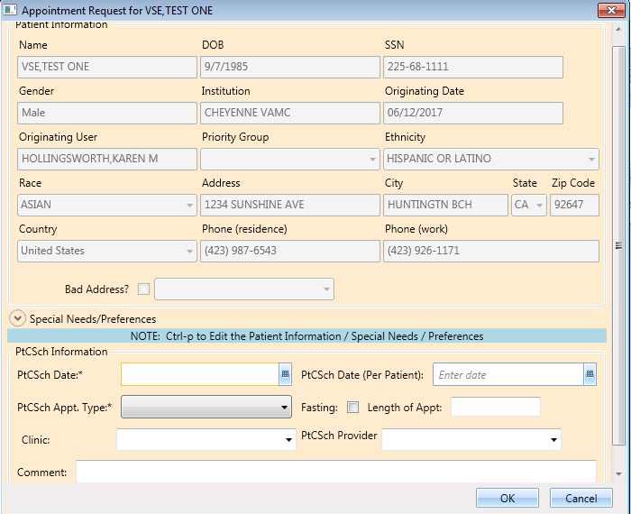

Figure : Patient-Centered Scheduling Appointment View Request Dialog

1. Click **OK**. You return to the Request Management Grid.
2. Right-click the applicable **Patient-Centered Scheduling** request.
3. Select Patient-Centered Scheduling Disposition.

The following options appear for selection:

* View Request
* Edit Request
* Failure to respond
* Moved
* Deceased
* Doesn’t want VA services
* Received care at another VA
* Other

1. Select **Edit Request.** The Patient-Centered Scheduling Request dialog displays.

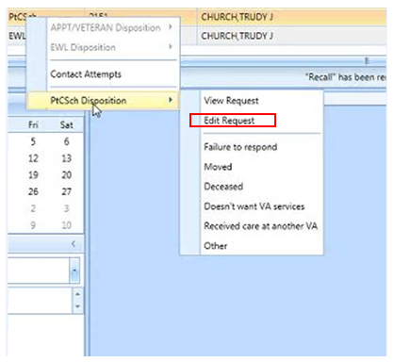

Figure : Patient-Centered Scheduling Disposition Dialog

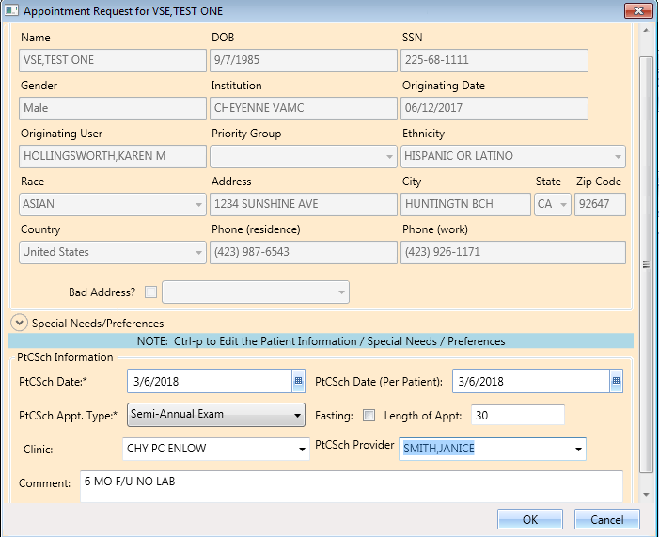

Figure : Patient-Centered Scheduling Appointment Edit Request Dialog

**Note:** The editable fields are PtCSch Appt. Type, Fasting, Length of Appt., Clinic, PtCSch Provider, and Comment. Note the PtCSch Date and PtCSch Date (Per Patient) are not editable.

1. Click **OK**. The request returns to the **Request Grid** with the altered information listed.

### Disposition or Remove Patient-Centered Scheduling Request

To cancel or delete a Patient-Centered Scheduling request:

1. Log on to VS GUI as a Scheduler.
2. From the **Tasks** tab, in the **Search** text box, type the patient’s last name or the patient’s first initial of the last name and last four of the SSN (e.g. S1234). Click **Search**, and then select the requested patient’s name.
3. In the RM Grid, right-click the **Patient-Centered Scheduling** request and select **PtCSch Disposition**. The following dispositions are available for selection:

* Failure to respond
* Moved
* Deceased
* Doesn’t want VA services
* Received care at another VA
* Other

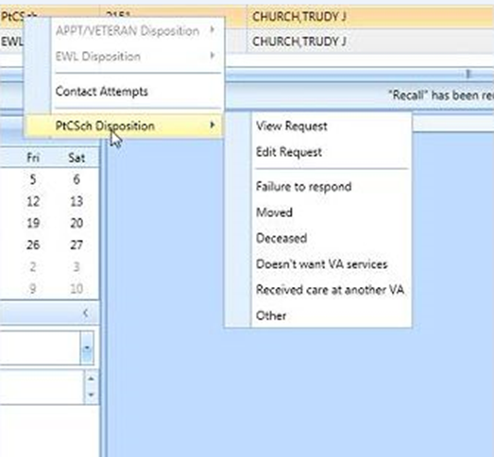

Figure : Patient-Centered Scheduling Disposition Options

1. From the **PtCSch Comment** dialog box, enter comments as necessary. Only the current comment entered is displayed although there is an Audit Log of Uses that created previous comments.

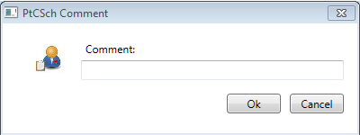

Figure : PtCSch Comment Dialog Box

1. Click **OK**. The patient is removed from the request grid.

Certain dispositions will present a **Patient Contacts** message pop-up if the business rules were not met. To disposition the request, click **Yes** to acknowledge the warning.

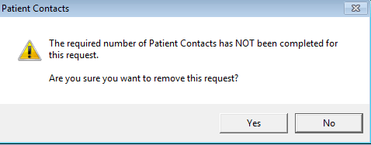

Figure : Warning Pop-Up If Business Rules Were Not Met

**Note** here the Request Type, Dispositions, and Contact Message information.

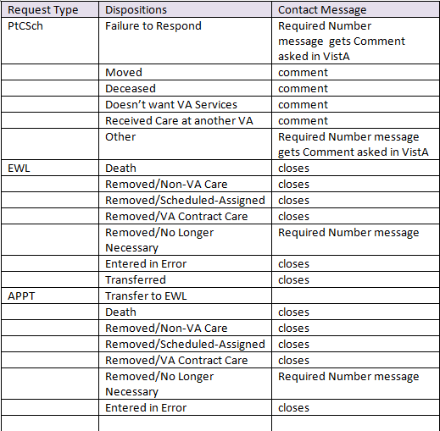

Figure : Request Type/Dispositions/Contact Message Reference

## Contacting a Patient

A patient may need to be contacted by phone or letter to schedule an appointment. Contact efforts can be added to the patient record for APPT and EWL requests. They are viewable in the GUI and are storedin the **SDEC APPT REQUEST file.**

### New Contact Attempt

To document **New Contact Attempt** information:

1. Log on to VS GUI as a Scheduler.
2. From the **Tasks** tab, in the **Search** text box, type the patient’s last name (or the patient’s first initial of the last name) and last four of the SSN (e.g. S1234).
3. Click **Search**.
4. Select the requested patient’s name from the list.
5. In the Request Type dialog box, click Cancel.
6. In the request grid, right-click APPT, PtCSch, or EWL request type, and then select **Contact Attempts**. The following Contact Types are available for selection:

* Call
* Letter

1. Select Call or Letter

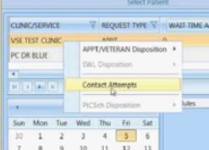

Figure : Contact Attempts

The **New Contact Attempt** dialog box displays showing, Patient Name, Clinic Name, Desired Appt. Date, Request Type, and Patient phone numbers. Select Call or Letter and accept the default contact date/time (which is the time the New Contact Attempt dialog was opened) or change as appropriate. You can change the Date/Time to a past Date/Time to document when the contact attempt was created. Backdating an attempt will still reflect the entry date and time in the far-right column.

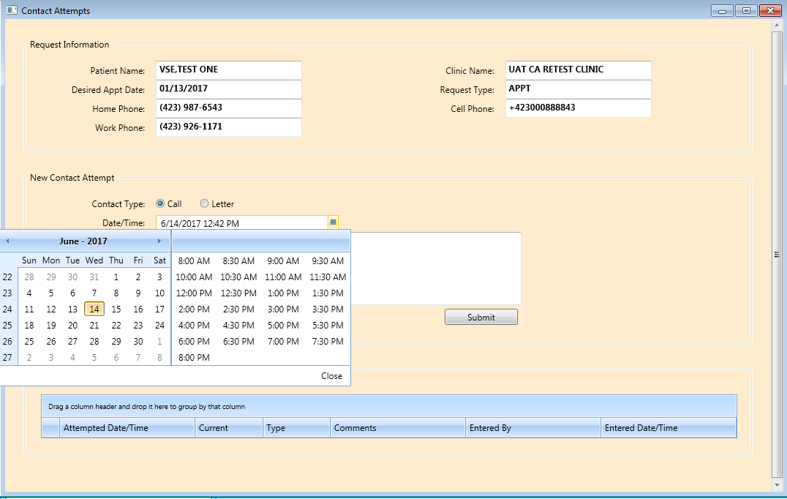

Figure : Patient Contact Dialog

1. Enter the phone number that was contacted, if desired, and provide any appropriate information in the Comments section.
2. Click Submit to enter the Call Attempt details, which will be displayed at the bottom of the New Contact Attempt screen and highlighted in Green.

The above procedures can be repeated as many times as needed to attempt to contact the patient. There is no limit to the number of attempts that can be created.

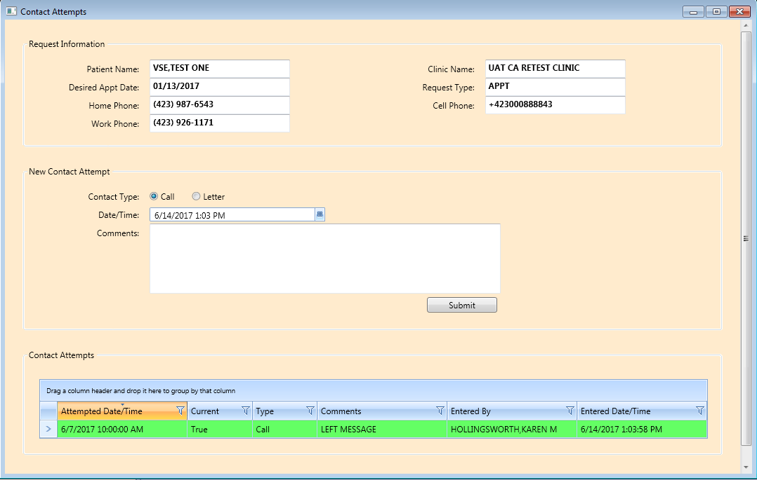

Figure : New Contact Attempt Submitted and Displayed

**Note:** The name of the person entering the contacts, the date the contact was entered, and the attempt date/time are shown.

* For Non-Mental Health appointment contacts, a call and a letter (letter must be at least 14 days old) are required prior to system dispositioning without an appointment.
* Mental Health appointment contacts require 3 calls on different calendar days (ex. Monday, Tuesday, Wednesday). At least one letter is required (letter must be at least 14 days old) and can be on same day as a call attempt.
* Attempting to disposition prior to the above rules being met will result in a warning message of the business rules not being met (See Figure 77). Click Yes to acknowledge the warning and disposition the request or Click No to return to Request Management Grid.

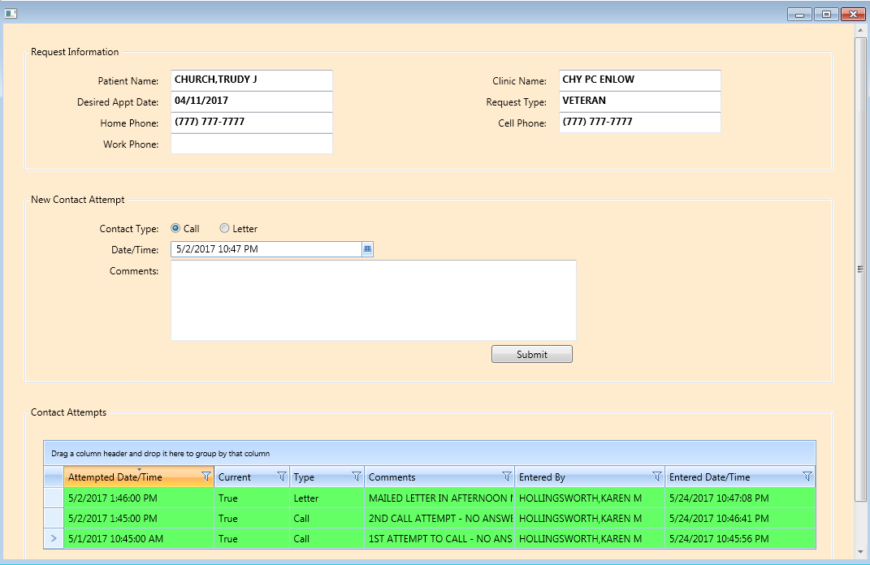

Figure : Displaying Name of Person Entering Contacts

After making an appointment the request is dispositioned and removed from Request Management. If the appointment is cancelled, the request returns to the grid and the current field in **Contact Attempts** changes to false and is a tan color.

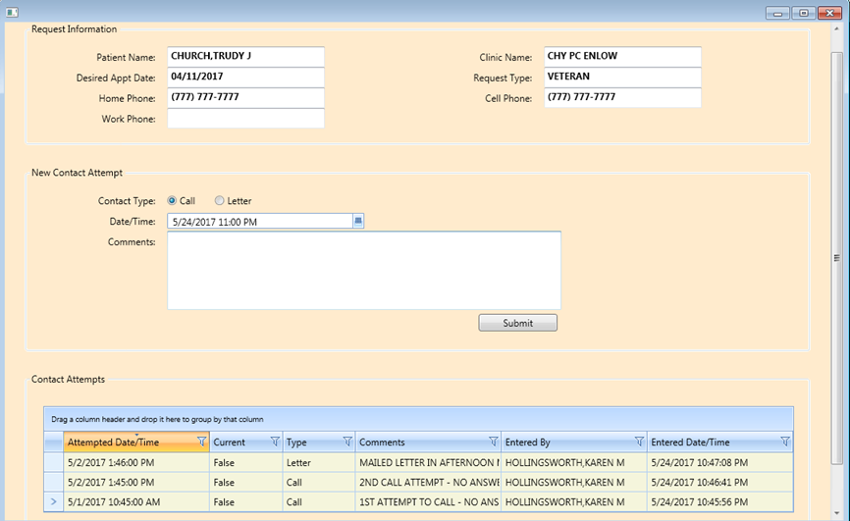

Figure : Appointment Canceled

After making a New Contact Attempt after the cancellation, the new attempt will be green and the **Current** field will be “True”.

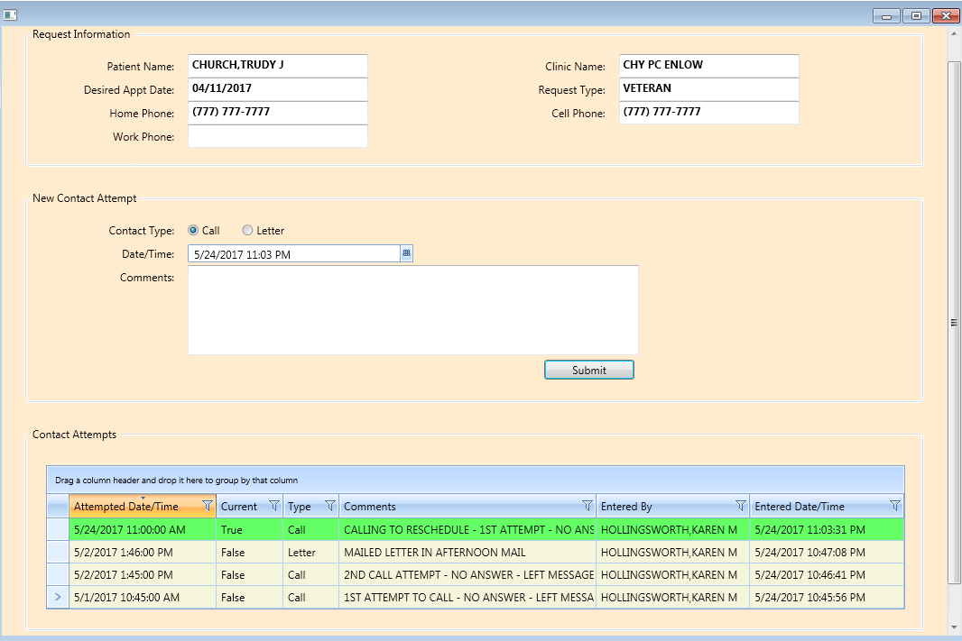

Figure : New Contact Attempt After Cancellation

# Appointment Management

## Adding Appointments

### Add Appointment for Appointment Request

1. Log into VS GUI as a Scheduler.
2. From the Tasks tab, type the patient’s last name and first name in the Search text box. Click Search, and then select the requested patient’s name from the list.
3. In the **Request Type** dialog box, select **Cancel** for existing requests. This is a change from previous versions. With the addition of Return to Clinic requests coming from CPRS, schedulers should always review existing requests before creating a new entry.

**Note:** Refer to Section 5.1.2 for steps on adding a new APPT Request.



Figure : Request Type

1. In the Request Management Grid, select **APPT** request. The Clinic Schedule Grid displays the clinic schedule based upon CID/Preferred date of request. For past dates, the clinic schedule opens defaulted to current date. For current date (or CID/Preferred date less than three days in future), the clinic schedule displays defaulted to current date. For future dates, the clinic schedule displays -/+ three days of CID/Preferred date.

**Note:** For newly created APPT requests, the system automatically highlights the APPT request and the Clinic Schedule displays.

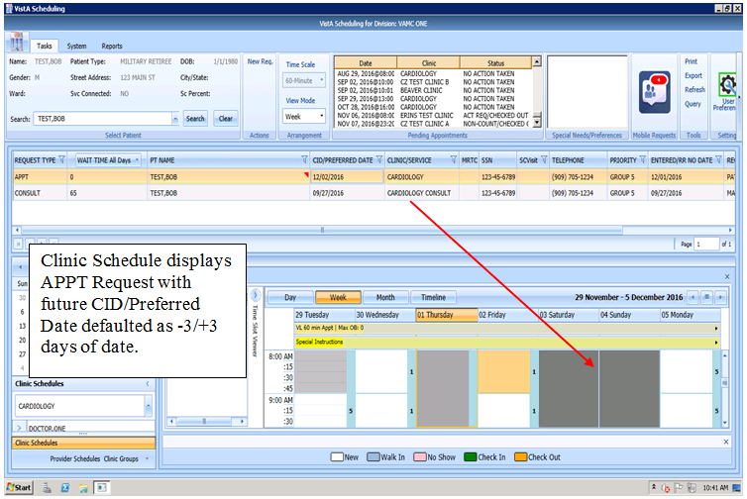

Figure : Select APPT Request – Clinic Schedule Grid Display

1. In the Clinic Schedule Grid, select the available time slot. Time Slot details display in the Time Slot Viewer.

**Note:** Refer to Section 7.1.7 for detailed information on Time Slot Viewer functionality.

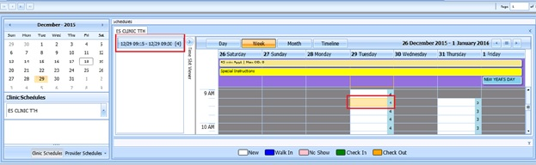

Figure : Select Time Slot

1. Right-click in the time slot. Add **Appointment** option displays. The Create Walk In Appointment option is only available for selection on the current date. It is not available for past or future CID/Preferred dates.

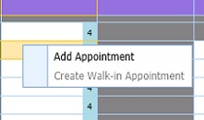

Figure : Right-click Options – Add Appointment

1. Select Add Appointment.

The New Appointment dialog displays as well as the Patient Eligibility dialog box.

* Appointments Tab:
* The **Patient Information** Section displays Name, DOB, SSN, Svc Connected, SC Percent, Global Assessment of Function (score) (GAF) (read only), and the Svc Related check box.
* The **Appointment** information section displays Benefit/Eligibility (provides drop down for patients with multiple eligibility), Start Time, Appt Type, Duration, Clinic and Notes (Appointment Start Time; Duration on for appointments to VL Clinics; and Notes are editable fields). Information can be added pertinent to appointment.
* The **Appointment Conflicts** section displays any appointments already scheduled that potentially conflict with the appointment being added.

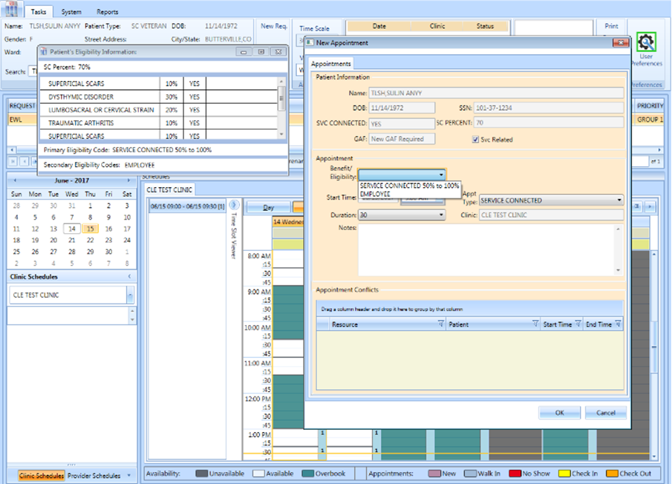

Figure : New Appointment Dialog

1. Add any applicable notes to the appointment. Click **OK**.

The Print Letter? Dialog box displays.

1. Click **OK** to print the Letter to the patient.

Click **Cancel** if you do not want to print the letter.

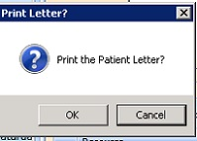

Figure : Print Letter? Dialog

1. To close the Request dialog box, Click **OK**.

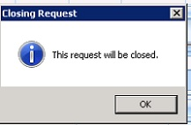

Figure : Closing Request Dialog

The APPT Request is removed from the Patient Request Management Grid. The Next request for patient is moved up and highlighted.

The Clinic Schedule closes and the next appointment clinic schedule opens.

The New appointment displays in the Pending Appointment Window on the Ribbon Bar.

1. Select appointment from the Pending Appointment window to view the appointment in the Clinic Schedule Grid. The clinic schedule opens. For past dates, the clinic schedule opens defaulted to the appointment date. For the current date (or appointment date less than three days in future), the clinic schedule displays defaulted to current date. For future dates, the clinic schedule displays -/+ three days of appointment date.

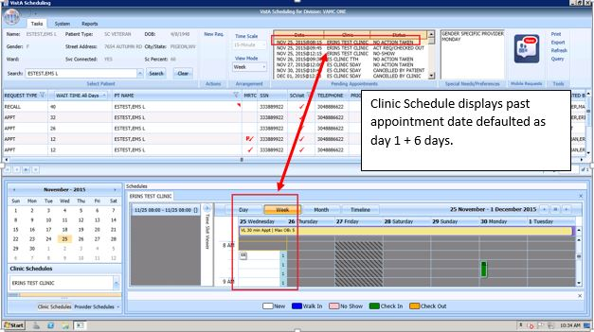

Figure : Clinic Schedule Grid – Past Appointment Display

For current date (or appointment date less than three days in future), the clinic schedule displays defaulted to current date. See below.

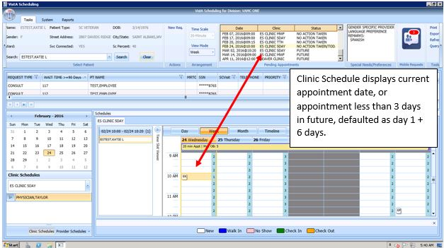

Figure : Clinic Schedule Grid – Current Appointment Display

For future dates, the clinic schedule displays -/+ three days of the appointment date. See below.

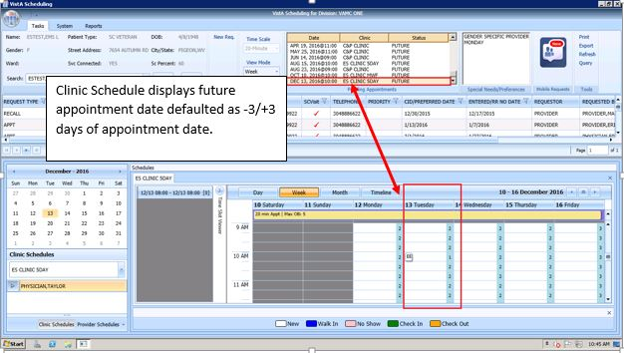

Figure : Clinic Schedule Grid – Future Appointment Display

### Add Appointment for EWL Request

1. Log into VS GUI as a Scheduler.
2. From the Tasks tab, type the patient’s last name and first name in the Search text box. Click **Search**, and then select the requested patient’s name from the list.
3. In the **Request Type** dialog box, **Cancel** to review existing requests.

**Note:** Refer to Section 5.1.5 for steps on transferring the APPT request to the new EWL Request.



Figure : Request Type

1. In the Request **Management** Grid select the **EWL** request.

The Clinic Schedule Grid displays the clinic schedule based upon the CID/Preferred date of the request. For past dates, the clinic schedule opens defaulted to CID/Preferred date. For the current date (or the CID/Preferred date less than three days in future), the clinic schedule displays defaulted to the current date. For future dates, the clinic schedule displays -/+ three days of the CID/Preferred date.

**Note:** For the newly created Patient-Centered Scheduling request the system automatically highlights the APPT request and the Clinic Schedule displays. If the EWL is for a service/specialty, no grid is displayed and the clinic must be searched and selected.

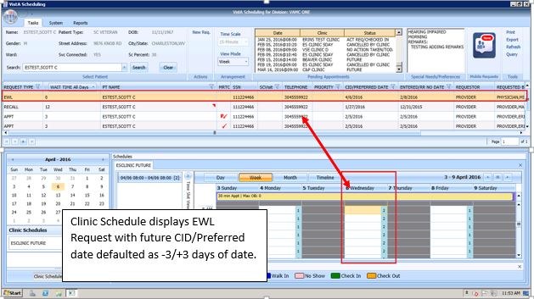

Figure : Select EWL Request

1. In the Clinic Schedule Grid, select the available time slot. Time Slot details display in the Time Slot Viewer.

**Note:** See Section 7.1.7 for detailed information on the Time Slot Viewer functionality.

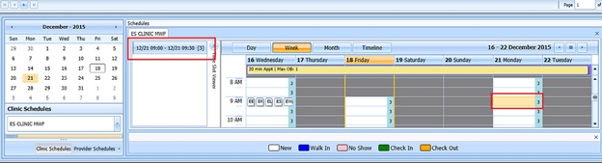

Figure : Select Time Slot

1. Right-click in the time slot. The **Add Appointment** option displays.

**Note: The** Create Walk In Appointment option is only available for selection on the current date. It is not available for past or future CID/Preferred dates.



Figure : Right-click Options – Add Appointment

1. Select Add Appointment.

The New Appointment dialog box contains the following sections:

* **Appointments Tab:**
* The **Patient Information** section displays Name, DOB, SSN, Svc Connected, SC Percent, GAF (read only), and Svc Related check box.
* The **Appointment** information section displays Start Time, Appt Type, Duration, Clinic and Notes (Appointment Start Time; Duration on for appointments to VL Clinics; and Notes are editable fields).
* The **Appointment Conflicts** section displays any appointments already scheduled that conflict with appointment being added.

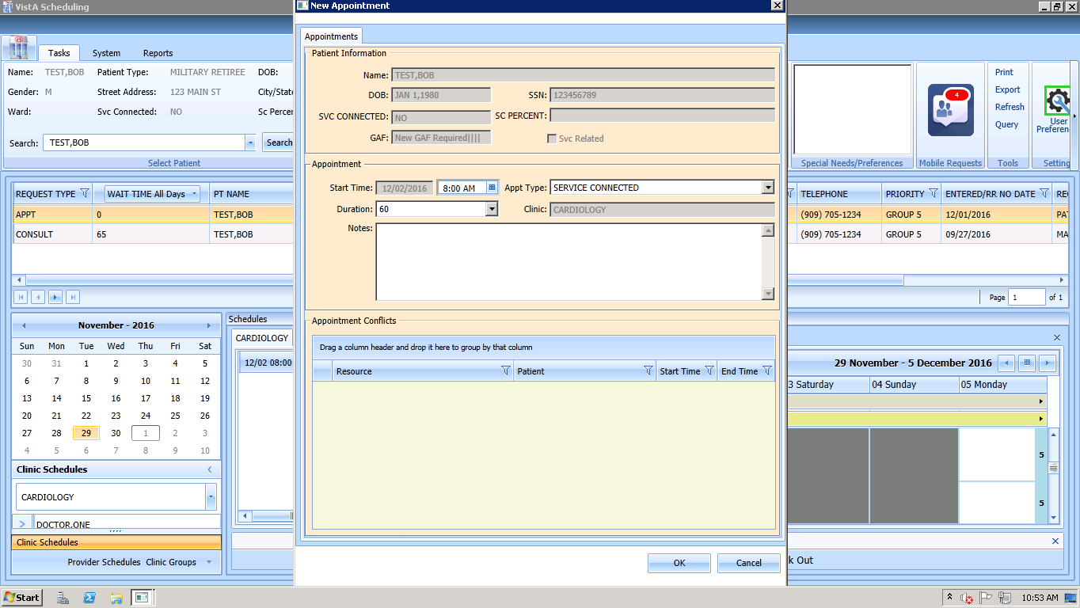

Figure : New Appointment Dialog

1. Add any applicable Notes to the appointment. Click **OK**.

The Print Letter? Dialog box displays.

1. Click **OK** to print the Letter to the patient. Click **Cancel** if you do not want to print the letter.



Figure : Print Letter? Dialog

1. If you do want to print the letter, click OK, and the print dialog box will pop up. If there is no letter in the box, contact your local clinic set up team to place that type of letter into the clinic’s set up. If there is a letter, decide whether to print to a network printer via Print (Local) or a VistA print device via the search box and Print (Server). It is highly recommended to use the Vista method, as that will place the address in the correct position for a windowed envelope.

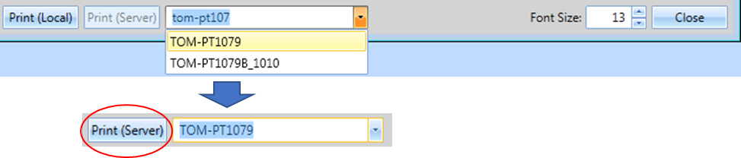

Figure : Print to VistA Device Printer to place address in correct position

1. To close the Request dialog box, click **OK**.



Figure : Closing Request Dialog

* The EWL Request is removed from the Patient Request Management Grid. The EWL request is dispositioned as scheduled.
* The Next request for the patient is moved up and highlighted.
* The Clinic Schedule closes and the clinic for the next request displays.
* The New appointment displays in the Pending Appointment Window on the Ribbon Bar.

1. Select appointment from the Pending Appointment window to view the appointment in the Clinic Schedule Grid. The clinic schedule opens. For past dates, the clinic schedule opens defaulted to appointment date.



Figure : EWL Appointment Past Date Display

For the current date (or the appointment date less than three days in the future), the clinic schedule displays the default, the current date. See below.

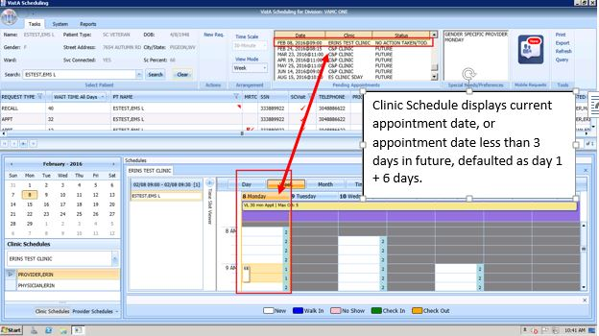

Figure : EWL Appointment Current Date

For future dates, the clinic schedule displays -/+ three days of the appointment date. See below.



Figure : EWL Appointment Future Date Display

### Add Appointment for Patient-Centered Scheduling Request

1. Log into VS GUI as a Scheduler.
2. From the **Tasks** tab, in the **Search** text box, type the patient’s last name or the patient’s first initial of the last name and last four of the SSN (e.g. S1234). Click **Search**, and then select the requested patient’s name.
3. In the Request Type dialog box, select **Patient-Centered Scheduling** (PtSch) and then click **OK** to create a new request or click **Cancel** for the existing request.
4. When a **New Patient** is searched, please select **CANCEL** when the **Request Type** box pops up. This will allow searching for existing requests before creating anything new.

**Note:** Refer to Section 5.1.7 for steps on adding a new Patient-Centered Scheduling Request.



Figure : Request Type

1. In the Request Management Grid select Patient-Centered Scheduling request.

The Clinic Schedule Grid displays the clinic schedule based upon the CID/Preferred date of request. For past dates, the clinic schedule opens defaulted to the CID/Preferred date. For current date (or the CID/Preferred date less than 3 days in future), the clinic schedule displays defaulted to current date. For future dates, the clinic schedule displays -/+3 days of the CID/Preferred date.

**Note:** For a newly created Patient-Centered Scheduling request the system automatically highlights the PATIENT-CENTERED SCHEDULING request in the Request Management Grid and Clinic Schedule.

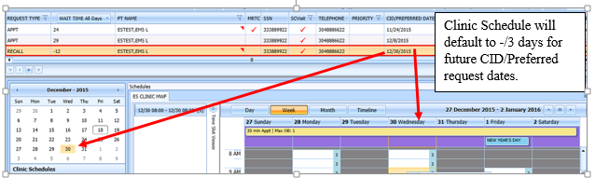

Figure : Select Patient-Centered Scheduling Request

1. In the Clinic Schedule Grid, select the available time slot.

Time Slot details display in the Time Slot Viewer.

**Note:** See Section 7.1.7 for detailed information on Time Slot Viewer functionality.

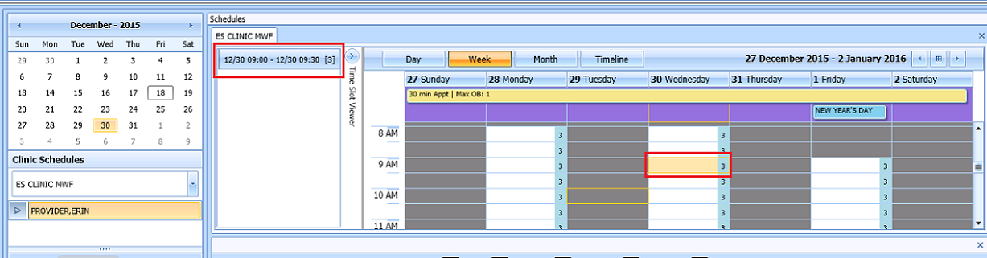

Figure : Select Time Slot

1. Right-click in the time slot.

**Add Appointment** option displays.

**Note:** The **Create Walk In Appointment** option is only available for selection on the current date. It is not available for past or future CID/Preferred dates.

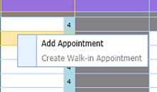

Figure : Right-click Options – Add Appointment

1. Select Add Appointment.

The New Appointment dialog box contains the following sections:

* **Appointments Tab:**
* The **Patient Information Section displays** Name, DOB, SSN, SVC Connected, SC Percent, GAF (read only), and Svc Related check box**.**
* The **Appointment** information section displays Start Time, Appt Type, Duration, Clinic and Notes (Appointment Start Time; Duration on for appointments to VL Clinics; and Notes are editable fields).
* The **Appointment Conflicts** section displays any appointments already scheduled that conflict with the appointment being added.



Figure : New Appointment Dialog

1. Add any applicable Notes to the appointment. Click **OK**.

The Print Letter? Dialog box displays.

1. Click **OK** to print the Letter to patient.

Click **Cancel** if you do not want to print the letter.

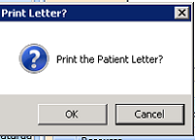

Figure : Print Letter? Dialog

The Closing Request dialog box displays.

1. Click **OK**.

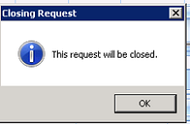

Figure : Closing Request Dialog

**Note:** The Patient-Centered Scheduling request is not immediately removed from the request grid. The request is removed when the task “CLEAN UP CLINIC PATIENT-CENTERED SCHEDULING ENTRIES” has been run and when the appointment is made within the CLEAN UP DAY SETTING in ENTER/EDIT CLINIC PATIENT-CENTERED SCHEDULING SITE PARAMS menu option.

The Clinic Schedule closes and the clinic for the next request displays.

The New appointment displays in Pending Appointment Window on the Ribbon Bar.

1. Select an appointment from the Pending Appointment window to view it in the Clinic Schedule Grid. The clinic schedule opens. For past dates, the clinic schedule displays defaulted to appointment date.



Figure : Clinic Schedule Display – Past Date Appointment

For the current date (or if the appointment date is less than three days in the future), the clinic schedule displays the appointment date as Day 1 + six days to current date.



Figure : Clinic Schedule Display – Current Date Appointment

For future dates, the clinic schedule displays -/+ three days of the appointment date. See below.



Figure : Clinic Schedule Display – Future Date Appointment

### Add Appointment for Consult Request

1. Log into VS GUI as a Scheduler.
2. From the **Tasks** tab, in the **Search** text box, type the patient’s last name or the patient’s first initial of the last name and last four of the SSN (e.g. S1234). Click **Search**, and then select the requested patient’s name.
3. In the **Request Type** dialog box, click **Cancel** and select existing **Consult**.

**Note:** Consult requests are added from CPRS.



Figure : Request Type

1. In the Request Management Grid select ConsultRequest.

**Note:** The Clinic Schedule does NOT display when selecting Consult request, as a consult is directed to an entire service, not a specific clinic. The scheduler should read the consult body in CPRS to determine which specific clinic or clinic group should be used, and then search for that clinic or group in the clinic schedules search box. Consult scheduling can benefit greatly from clinic groups when the specialty has more than one consult clinic that can be grouped and viewed side by side.

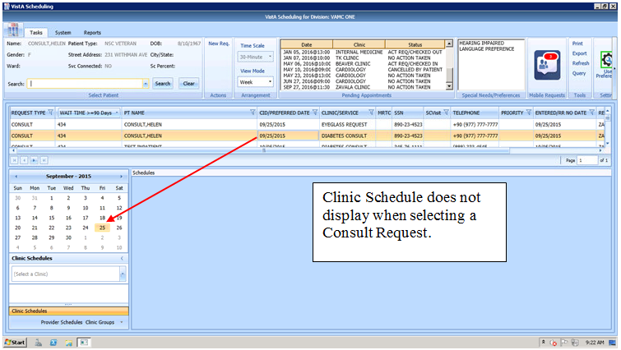

Figure : Select Consult Request

From the Clinic Schedules, enter the clinic name (six-character minimum).

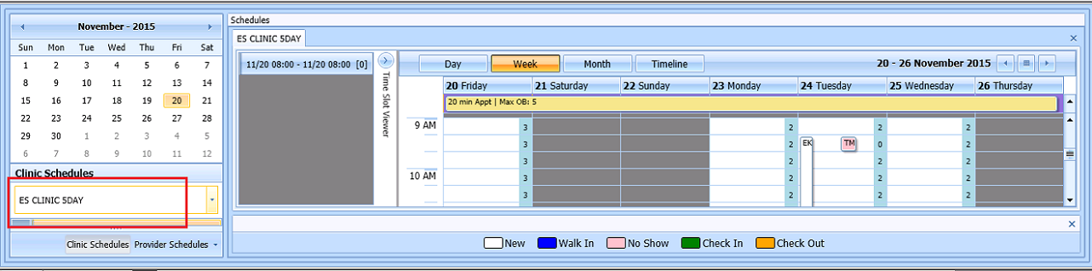

Figure : Clinic Schedules

1. In Clinic Schedule, click the available time slot. Time Slot details display in the Time Slot Viewer.

**Note:** See Section 7.1.7 for detailed information on Time Slot Viewer functionality.

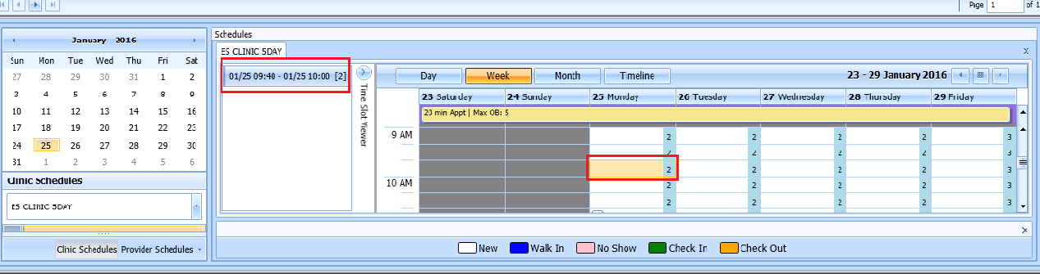

Figure : Select Time Slot

1. Right-click in the time slot.

**Add Appointment** option displays.

**Note:** The **Create Walk-In Appointment** option is only available for selection on current date. It is not available for past or future CID/Preferred dates.



Figure : Right-click Options – Add Appointment

1. Select Add Appointment.

The New Appointment dialog box displays as well as the Patient Eligibility dialog box.

* Appointments Tab:
* The **Patient Information Section displays** Name, DOB, SSN, SVC Connected, SC Percent, GAF (read only), and Svc Related check box**.**
* The **Appointment** information section displays Start Time, Appt Type, Duration, Clinic and Notes (Appointment Start Time; Duration on for appointments to VL Clinics; and Notes are editable fields).
* The **Appointment Conflicts** section displays any appointments already scheduled that conflict with appointment being added.



Figure : New Appointment Dialog

Add any applicable Notes to the appointment.

1. Click **OK**.

The Print Letter? dialog box displays.

1. Click **OK** to print the Letter to the patient.

Click **Cancel** if you do not want to print the letter.



Figure : Print Letter? Dialog

* The Consult Request is removed from the Patient Request Management Grid.
* The next request for the patient is moved up and highlighted.
* The Clinic Schedule closes and the clinic for the next request displays, if applicable.
* The New appointment displays in the Pending Appointment Window on the Ribbon Bar.

1. Select the appointment from the Pending Appointment window to view it in the Clinic Schedule Grid.

The clinic schedule opens. For past dates, the clinic schedule opens to the default appointment date.

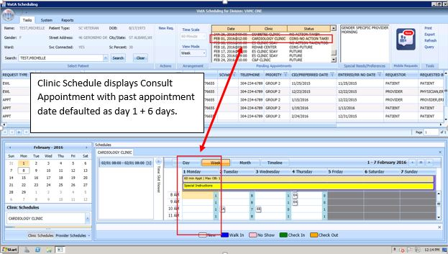

Figure : Clinic Schedule Display – Consult Past Appointment Date

For the current date (or appointment date less than three days in future), the clinic schedule displays the current date as the default. See below.

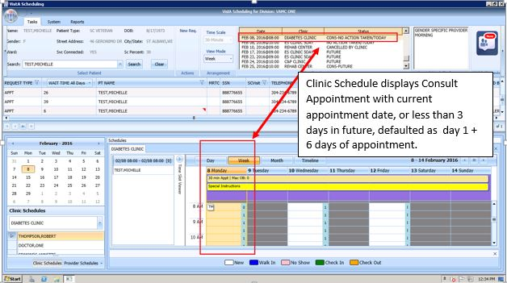

Figure : Clinic Schedule Display – Consult with Current Date

For future dates, the clinic schedule displays -/+ three days of the appointment date. See below.

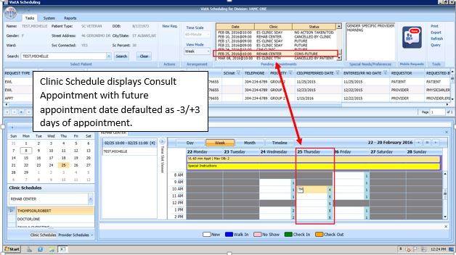

Figure : Clinic Schedule Display – Consult Future Appointment Date

### Add Appointment from Return to Clinic request (RTC)

1. Log into VS GUI as a Scheduler.
2. From the **Tasks** tab, in the **Search** text box, type the patient’s last name or the patient’s first initial of the last name and last four of the SSN (e.g. S1234). Click **Search**, and then select the requested patient’s name.
3. In the **Request Type** dialog box, click **Cancel** and select existing **RTC**.

**Note:** RTC requests are added from CPRS when the clinical staff use the National Return to Clinic Order and sign it.



Figure : Request Type

1. In the Request Management Grid select the RTCRequest and schedule the appointment. Scheduling the appointment while the RTC request is selected (orange) will automatically complete the corresponding order in CPRS.

**Note:** If the RTC is for a single follow up appointment, it will follow the same steps as a Patient Centered Scheduling Request (PtCSch) in Section 6.1.3. If the RTC is for a series of follow up appointments, it will follow the same steps as in the MRTC requests in Section 6.3.1. Contact attempts can be added as appropriate.

1. If a RTC request has prerequisites from the RTC Order in CPRS, it will pop up an extra box with that information. If the prerequisite pop up box is accidently closed, it can be reopened, by clicking on the RTC order in the RM grid again.
2. If a RTC request must be dispositioned without making an appointment, right click on the RTC and select from the disposition drop down. The corresponding National Return to Clinic Order will respond accordingly.

|  |  |
| --- | --- |
| **APPT Request Dispositions** | **RTC Order Disposition** |
| 'D' FOR DEATH | Discontinued – alert to Provider |
| 'NC' FOR REMOVED/NON-VA CARE | Discontinued – alert to Provider |
| 'SA' FOR REMOVED/SCHEDULED-ASSIGNED | Completed |
| 'CC' FOR REMOVED/VA CONTRACT CARE | Discontinued – alert to Provider |
| 'NN' FOR REMOVED/NO LONGER NECESSARY | Discontinued – alert to Provider |
| 'ER' FOR ENTERED IN ERROR | Discontinued – alert to Provider |

## Disposition Appointments

### Edit Appointment Information

Editing appointment information can be done within the VS GUI.

To edit appointment information:

1. Log on to VS GUI as a Scheduler.
2. From the Tasks tab, type the patient’s last name and first name in the Search text box. Click **Search**, and then select the requested patient’s name from the list.
3. In the **Request Type** dialog box, click **Cancel**.
4. Point to the appointment to be edited in the Pending Appointments Window on the Ribbon Bar.

The clinic schedule displays. For past appointment dates, the clinic schedule opens the default appointment date. For the current date (or appointment date less than three days in future), the clinic schedule displays the current date as the default. For future dates, the clinic schedule displays -/+ three days of the appointment date.

1. In the Clinic Schedule Grid, point to the appointment, right-click on the appointment, and then select **Edit Appointment**.

The Edit Appointment dialog box displays.

**Note:** See Section 7.1.7 for detailed information on Time Slot Viewer functionality.

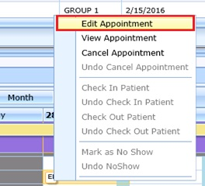

Figure : Appointment Right-click Options – Edit Appointment

The only field that is editable is Notes.

1. Make any necessary edits to the appointment information, and then click OK.

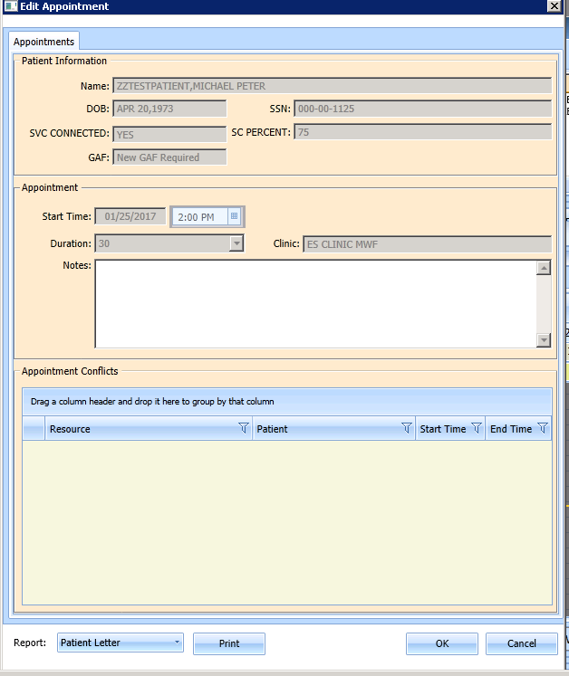

Figure : Edit Appointment Dialog

### View Appointment Information

Viewing appointment information can be done in the Clinic Schedule Grid in the VS GUI.

To view appointment information:

1. Log on to VS GUI.
2. From the **Tasks** tab, in the **Search** text box, type the patient’s last name or the patient’s first initial of the last name and last four of the SSN (e.g. S1234). Click **Search**, and then select the requested patient’s name.
3. In Request Type dialog box, click **Cancel**.
4. Point to the appointment to be viewed in the Pending Appointments Window on the Ribbon Bar.

The clinic schedule displays. For past appointment dates, the clinic schedule defaults to the appointment date as Day 1 + six days. For the current date (or appointment date less than three days in future), the clinic schedule displays the default, the current date as Day 1 + six days. For future dates, the clinic schedule displays -/+ three days of the appointment date.

1. In the Clinic Schedule Grid, point to the appointment, move the pointer over the appointment, and the appointment details display.

**VS GUI Hover Box Displaying Appointment Details window**

Figure : Hover Box Displaying Appointment Details

1. Right-click the appointment.
2. Select View Appointment.

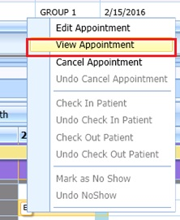

Figure : Appointment Right-click Options – View Appointment

The **View** Appointment dialog box displays. It is in read-only mode. No fields are editable.

1. Click **OK** to close the View Appointment dialog box.

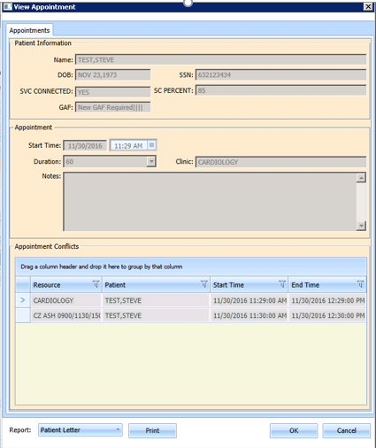

Figure : View Appointment Dialog

### Cancelling an Appointment

You can cancel an appointment without rebooking it.

1. Log on to VS GUI as a Scheduler.
2. From the **Tasks** tab, in the **Search** text box, type the patient’s last name or the patient’s first initial of the last name and last four of the SSN (e.g. S1234). Click **Search**, and then select the requested patient’s name.
3. In the Request Type dialog box, click **Cancel**.
4. Select a scheduled appointment from the Pending Appointment Window on the Ribbon Bar.

The clinic schedule displays. For past appointment dates, the clinic schedule opens the default, the appointment date. For the current date (or appointment date less than three days in future), the clinic schedule displays the default, the current date. For future dates, the clinic schedule displays -/+ three days of the appointment date.

1. Select an appointment from the Clinic Schedule Grid.
2. Right-click and select **Cancel**.

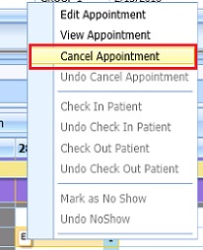

Figure : Appointment Right-click Options – Cancel Appointment

1. In the **Cancel Appointment** dialog box, select a cancellation option:

* **Cancelled by Clinic:** The original CID/Preferred appointment date defaults to the patient desired date. The date cannot be edited.
* **Cancelled by Patient**: The patient CID/Preferred date is available and defaults to original CID/Preferred date request. You can edit the date to change it.

1. Select the **Reason for Cancellation** from the list.

Edit the CID/Preferred dates if applicable.

Add Remarks as needed.

1. Click **OK**.

The appointment is canceled and not rebooked. If the appointment is linked to a consult, the consult status changes to Active.

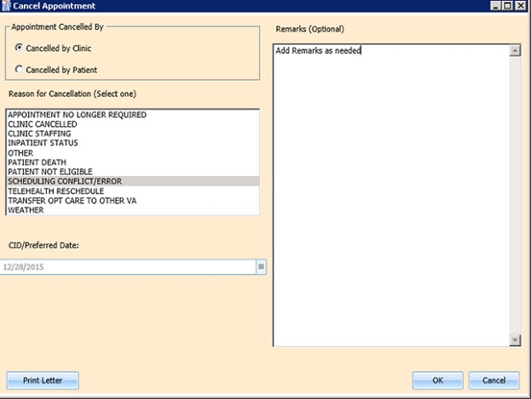

Figure : Cancel Appointment Dialog

The Appointment displays in Pending Appointments with a status of Cancelled by Clinic or Cancelled by Patient (whichever is applicable).

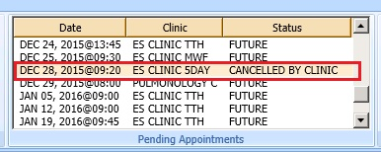

Figure : Pending Appointment Window – Appointment Status Cancelled by Clinic

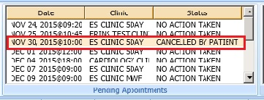

Figure : Pending Appointment Window – Appointment Status Cancelled by Patient

* The Clinic Schedule closes.
* The patient’s appointment request reappears on the APPT Request grid for future rescheduling.

1. Select the **APPT Request** and the Clinic Schedule displays again.

**Note:** The Time Slot count increases when an appointment is canceled.

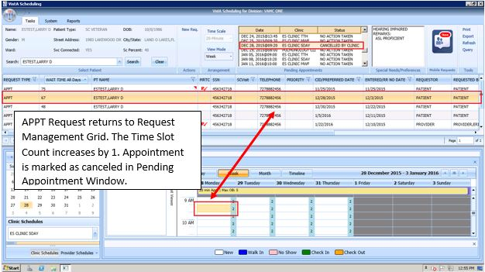

Figure : APPT Request – Time Slot Count Increase

### Mark as No Show Appointment

To record a no show appointment.

1. Log on to VS GUI as a Scheduler.
2. From the Tasks tab, type the patient’s last name and first name in the Search text box. Click **Search**, and then select the requested patient’s name from the list.
3. In the **Request Type** dialog box, click **Cancel**.
4. From the **Pending Appointment** Window select appointment to mark as no show.

The clinic schedule displays.

For past appointment dates, the Clinic Schedule displays the default, the appointment date. For the current date (or appointment date less than 3 days in future), the clinic schedule displays the current default date.

1. Select the appointment from the Clinic Schedule Grid.
2. Right-click the Appointment.
3. Select **Mark as No Show**. The appointment MUST be a past date/time from the current date/time.

**Note: “**Mark as No Show” is not available for future appointments.

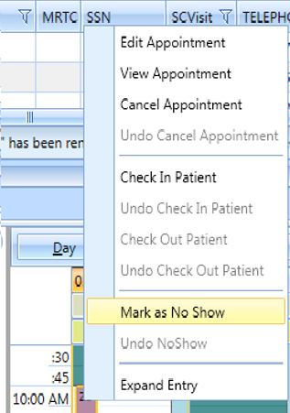

Figure : Appointment Right-click Options – Mark as No Show

The Mark **as No Show** dialog box displays.

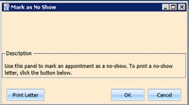

Figure : Mark as No Show Dialog

1. Click **OK**.

The Appointment displays in red in the Clinic Schedule Grid and the Time Slot Viewer.

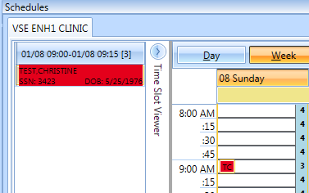

Figure : Clinic Schedule Display – No-Show Red

The Status in the Pending Appointment Window on the Ribbon Bar changes to No-Show.

The Request returns to the Request Management Grid for the patient.

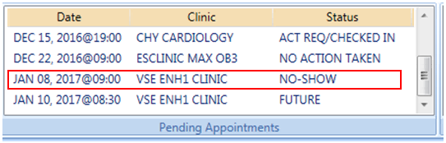

Figure : Pending Appointment Window – Appointment Status No-Show

Inpatient appointments **CANNOT** be dispositioned as a No-Show.

A Not Allowed warning message will display if the user attempts to flag an Inpatient as a No Show.

1. Click OK to close the message and the appointment should not show as a No-Show.

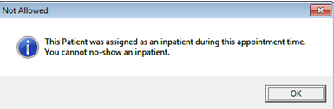

Figure : No-Show Warning Message

### Undo No-Show Appointment

If a patient was previously recorded as a no-show but arrives in time for the current appointment, the previously recorded no show can be undone.

**To undo a no-show appointment:**

1. Log on to VS GUI as a Scheduler.
2. From the **Tasks** tab, in the **Search** text box, type the patient’s last name or the patient’s first initial of the last name and last four of the SSN (e.g. S1234). Click **Search**, and then select the requested patient’s name. Click **Search**.
3. In the Request Type dialog box, click **Cancel**.
4. In the Pending Appointments Window on the Ribbon Bar, point to the No Show appointment to be undone.

The clinic schedule displays.

For past appointment dates, the clinic schedule displays the default appointment date.

For the current date (or appointment date less than 3 days in future), the clinic schedule displays the current default date.

1. Right-click Appointment.
2. Select Undo No-show.

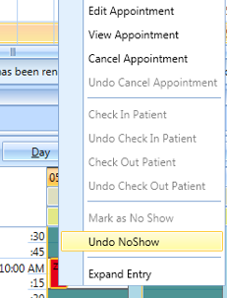

Figure : Appointment Right-click Options – Undo No-show

In the Clinic Schedule Grid, the appointment changes from red to purple.

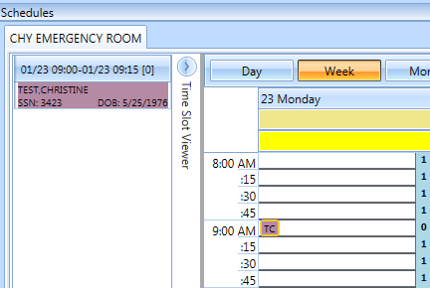

Figure : Appointment Clinic Schedule Display – Undo No-show as Purple

The appointment status in the Pending Appointments Window changes to No Action Taken.

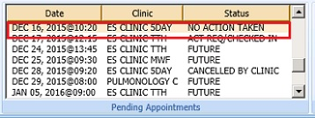

Figure : Undo No-show – Appointment Status No Action Taken

The Request closes and is relinked to the appointment.

### Checking In a Patient

If a clinic location uses VPS Vetlink and/or patient kiosks to check in patients, continue to use VPS Vetlink and kiosks to check in patients. VS GUI is an overlay to VistA, and like a VistA check in, a check in VS GUI will not reflect in Vetlink for patient tracking.

To check in a patient for an appointment:

1. Log on to VS GUI as a Scheduler.
2. From the **Tasks** tab, in the **Search** text box, type the patient’s last name or the patient’s first initial of the last name and last four of the SSN (e.g. S1234). Click **Search**, and then select the requested patient’s name.
3. In the Request Type dialog box, click **Cancel**.
4. In the Pending Appointments Window on the Ribbon Bar, point to the appointment to be checked in.

The clinic schedule displays. For past appointment dates, the clinic schedule Clinic Schedule opens defaulted to appointment date. For the current date (or appointment date less than three days in future), the clinic schedule displays the current default date.

1. Right-click Appointment**.**
2. Select Check In Patient.

**Note:** Check In is not available for appointments with future dates.

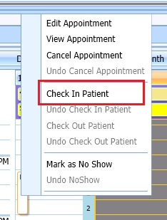

Figure : Appointment Right-click Options – Check In Patient

The Appointment **Check In** dialog box opens. You can change the check in date and time as needed.

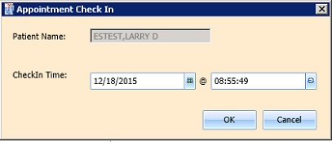

Figure : Appointment Check In Dialog

1. Click **OK**.

The appointment color changes to yellow, which indicates the patient has checked in for the appointment.

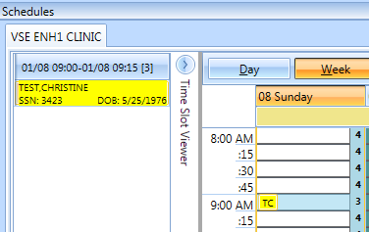

Figure : Clinic Schedule Display – Check In Yellow

In the **Pending Appointment Window** on the Ribbon Bar, the appointment status changes to ACT REQ/CHECKED IN.

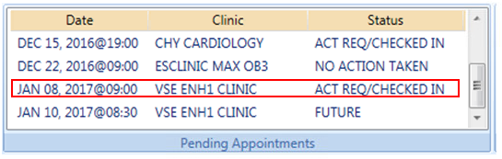

Figure : Pending Appointment Window – Status ACT REQ/CHECKED IN

### Undo a Patient Check In

If a patient is checked in by mistake, the check in can be undone.

To undo a patient check in:

1. Log on to VS GUI as a Scheduler.
2. On the Clinic Schedule Grid, select the patient check in that needs to be undone.
3. Right-click and then select Undo **Check In Patient**.

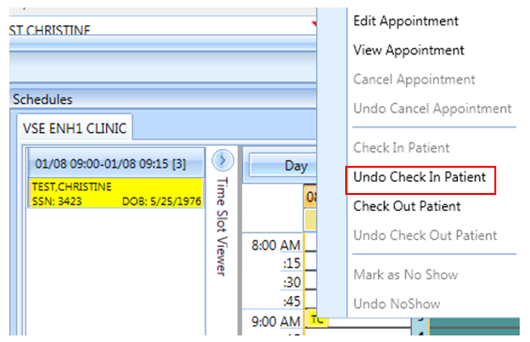

Figure : Appointment Right-click Options – Undo Check In Patient

The Appointment changes color from yellow to purple.

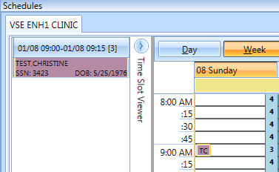

Figure : Clinic Schedule Display – Undo Check In Patient Purple

On the Pending Appointment Window, appointment status changes to No Action Taken.

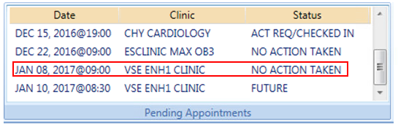

Figure : Pending Appointment Window – Appointment Status No Action Taken

### Check Out a Patient

To check out a patient:

1. Requires the SD SUPERVISOR key in VistA. Please note: The check out follow-up function is now working in version 2.0.0.14, but is still tied to the encounter. Until we can make the VS GUI’s Check Out purely administrative, **we highly discourage the use of Check Out in VS GUI**.
2. Log on to VS GUI as a Scheduler.
3. From the **Tasks** tab, in the **Search** text box, type the patient’s last name or the patient’s first initial of the last name and last four of the SSN (e.g. S1234). Click **Search**, and then select the requested patient’s name.
4. In the Request Type dialog box click **Cancel**.
5. In the Pending Appointments Window on the Ribbon Bar, point to the appointment to be checked out.

The Clinic Schedule displays.

* For a past appointment date, the Clinic Schedule opens on the default appointment date.
* For the current date (or appointment date less than three days in future), the schedule displays the current default date.
* For future dates, the schedule displays -/+ three days of the appointment date.

1. Right-click and select Check **Out Patient**.

**Note:** Check Out is not available to select if Check In has not been performed.

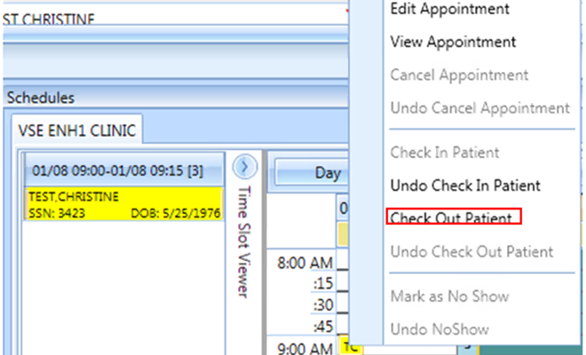

Figure : Appointment Right-click Option – Check Out Patient

1. Update the **Appointment Check Out** dialog box.
2. Confirm the date and time. Edit as needed.

**Note:** Check Out must be at least one minute after Check In.

1. Click **OK**.

The appointment status is changed to ACT REQ/**Checked Out** in the Pending Appointment Window and the color changes to orange in Clinic Schedule.

**Note:** When the Scheduler clicks OK, if Follow-up Needed was checked, then the new APPT Request dialog box opens. This APPT Request dialog box needs to be completed before Patient Check Out is complete.

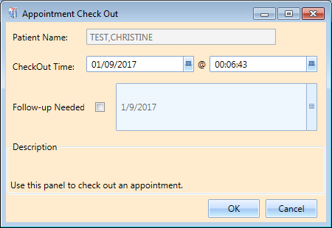

Figure : Appointment Check Out Dialog

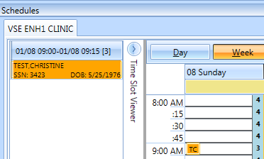

Figure : Clinic Schedule Display – Check Out Patient Orange

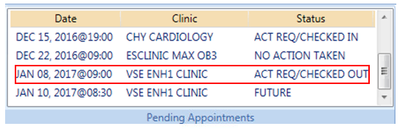

Figure : Pending Appointment Window – Status ACT REQ/CHECKED OUT

### Undo a Patient Check Out

If a patient is checked out by mistake, the checkout can be undone.

To check out a patient:

1. Requires the SD SUPERVISOR key in VistA. **Please note: The Undo Check Out function is not working as designed and should not be used in this version.** It will remove any encounter information associated with this visit.
2. Log on to VS GUI as a Scheduler.
3. On the Clinic Schedule Grid, select the patient check in that needs to be undone.
4. Right-click and select **Undo Check Out Patient**.

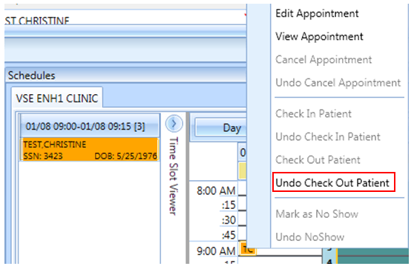

Figure : Appointment Right-click Options – Undo Check Out Patient

The Appointment changes color from orange to yellow.

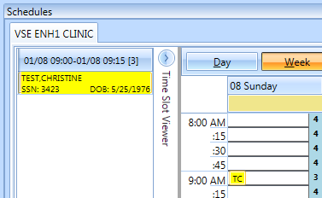

Figure : Clinic Schedule Display – Undo Check Out Patient Yellow

From the Pending Appointment Window, the appointment status changes to ACT REQ/CHECKED IN.

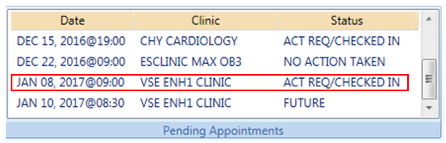

Figure : Pending Appointment Window – Status ACT REQ/CHECKED IN

**Note:** Undoing the checkout will also delete all the unnecessary information that has been entered up to this point.

### Rescheduling an Appointment

You can cancel an appointment and reschedule it for another time.

1. Log on to VS GUI as a Scheduler.
2. From the Tasks tab, in the **Search** text box, type the patient’s last name or the patient’s first initial of the last name and last four of the SSN (e.g. S1234). Click **Search**, and then select the requested patient’s name.
3. In the Request Type dialog box, click **Cancel**.
4. In the **Pending Appointments** Window on the Ribbon Bar, point to and select the appointment to be rescheduled.

The Clinic Schedule displays.

For a past appointment date, the Clinic Schedule opens to the default appointment date.

For the current date (or appointment date less than three days in the future), the schedule displays the current default date.

For future dates, the schedule displays -/+ three days of an appointment date.

1. On the Clinic Schedule Grid, select the scheduled appointment, and cancel per section 6.2.3 Cancelling An Appointment.
2. Add the new appointment per section 6.1 Adding Appointments.

The box opens.

1. Click OK to move the appointment or click cancel if you do not want to move the appointment.

## Multiple Appointment Requests and Appointments

Multiple Appointment Requests allow the scheduler to create requests and book a series of appointments at one time for a patient.

### Multiple Appointment Request

1. Log into VS GUI as a Scheduler.
2. From the Tasks tab, in the **Search** text box, type the patient’s last name or the patient’s first initial of the last name and last four of the SSN (e.g. S1234). Click **Search**, and then select the requested patient’s name. Click **Search**.
3. In the Request Type dialog box, select APPT to create a new request.

The Patient’s Eligibility Information dialog box opens.

1. In the **Appointment Request** dialog box confirm Patient Information details and complete the Request Information section.

* Select the **Clinic** or **Service/Specialty** button. For Clinic, enter the name of the clinic (minimum of six characters required). For Service/Specialty, enter the service or specialty (minimum of six characters required).
* Enter the **CID/Preferred Date** for the preferred appointment date. The scheduler can enter the date directly or select the date from the Calendar control option.
* Select the **Appointment Type** (if not defaulted by patient eligibility and clinic selection) then choose from the list.
* In **Request By**, select either Provider or Patient.
* For you select **Provider,** enter the provider’s name (three character minimum) and select from list. If you select Patient , then the Provider field is dimmed and you cannot be edit that field.
* The **Status** is automatically populated.

1. Established – This indicates that the patient has been seen at that clinic in the past 24 months
2. New – This indicates that the patient has not been seen at that clinic in the past 24 months

The Multiple **Appointments Required** check box is enabled.

1. Click the box to enter a check mark.

* The **Number of Appointments Required** list is visible. Up to 60 appointments can be requested at one time.
* The **Interval Between Appointments** (In days) list is visible. Up to 30 days between appointments can be requested at one time.

**Note:** The combination of Number of Appointments Required and Interval Between Appointments cannot exceed 24 months. If the selected combination exceeds 24 months to complete, when the scheduler selects OK to complete the Appointment Request, the MRTC Interval/Appt.# Dialog displays the message: “The combination of requested appointments and the interval between appointments exceeds 24 months. Adjust the number of requested appointments and/or the interval between appointments so that the combined duration is less than 24 months.” The adjustment must be made before the Multiple Appointment Request can be completed.

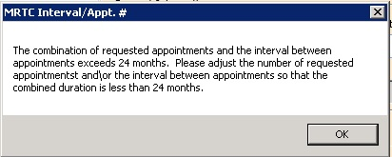

Figure : MRTC Interval/Appt. # Dialog

* Text can be added in the **Comment** field up to 80 characters to add information regarding the Appointment Request. For MRTC Requests, the text displays in the Request Management Grid under the Comment column after the {Day, Interval} information.
* Only the current comment entered is displayed although there is an Audit Log of Uses that created previous comments.

1. Click **OK.**

The **Find Appointment** dialog box opens to allow the scheduler to book Multiple Appointments at one time. See Section 0 for booking appointments from the Find Appointment Dialog.

#### Note Regarding Parent and Child Appointment Requests

When booking Multiple Appointment Requests, the scheduler can click **Close** in the Find Appointment dialog. If this is done prior to the first appointment in the series being booked the Parent MRTC Request is placed in the Request Grid with a “P” and a check mark in MRTC Column. The {Day, Interval} requested in the Appointment Request displays in the Comment column. Any text entered into the Comment field of the Appointment Request dialog displays in the Comment column after the {Day, Interval} information. The MRTC APPT Requests with Comments are flagged with a red arrow in the Request Management Grid.

If the scheduler books the first appointment in the series and then clicks CLOSE in the Find Appointment Dialog box, the Parent Request displays in the Request Grid. Additionally, the remaining unbooked appointments display as individual Child MRTC Requests in the Request Grid with a check mark, not a “P” in the MRTC Column. The appointment placement in the series as well as the number of total appointments requested display in the Comments column. Any comments entered in the original MRTC Appointment Request dialog box display in each individual Child Request after the {Day, Interval} information.

Selecting the Parent MRTC Request launches the **Find Appointment** dialog box and the scheduler can continue booking all remaining appointments for the series from Find Appointment. However, selecting a Child MRTC Request opens the Clinic Schedule and the scheduler can only book the individual appointment following the same steps as adding an appointment for an APPT Request (refer to Section 6.1.1). The Parent MRTC Request is not removed from the Request Grid until all appointments in the series have been booked. A Child MRTC Request is removed from the Request Grid at the time the appointment is booked.

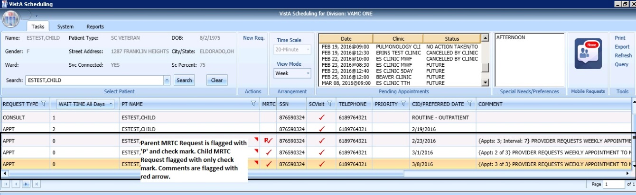

Figure : MRTC Requests displayed in Request Management Grid

### Adding Multiple Appointments from Find Appointment Dialog

When the scheduler clicks **OK** in the **Appointment Request Dialog** with **Multiple Appointments Required** checked**,** the **Find Appointment** dialog box displays to allow the scheduler to book Multiple Appointments at one time.

In the Find Appointment dialog box, the following information is displayed:

* **Calendar** in upper left corner. The CID/Preferred date entered in Appointment Request is highlighted.
* The **Clinic** is the default on the list from the Appointment Request in the Resources Section in the upper middle pane of the Find Appointment dialog box. This field is editable and Clinics can be switched between appointments as needed.
* Patient’s **Time of Day** and **Day of Week** preferences are the default in the upper right pane of the Find Appointment dialog box. These can be edited/adjusted as needed.
* The CID/Preferred date entered in Appointment Request is displayed under the Time of Day and Day of Week preferences in the Find Appointment dialog box with the label **Original CID:**. This data is not editable.
* **Search** is available if the availability needs to be recalculated due to date or clinic changes.
* The Multiple **Appointments Required** information is the default from the Appointment Request in the middle of the Find Appointment dialog box. This information is not editable.
* **CID** displays a list of unbooked appointment dates. These dates are calculated based upon the original CID/Preferred Date + the Number of Appointments + the Interval Between Appointments.
* For clinics with special instructions defined, **Special Instructions**  displays in the Search Results section of the Find Appointment dialog box. When clicked, a Special Instructions dialog box displays with the defined information available to review.
* The clinic’s **appointment length, variable length, and Max Overbook** settings display in the label in the Search Results section.

In the **Search Results** section, availability results display -/+ three Days of the CID date for future dates. For current CID dates availability display Day 1 + six days in Search Results field.

**Note:** Time of Day and Day of Week preferences limit availability results.

* Book Column allows the scheduler to select the time slot for booking an appointment.
* Start Time Column displays the start time of time slot.
* End Time Column displays the end time of time slot.
* Resource Column displays the name of the Clinic currently selected.
* Slots Column displays available time slot count. Slots available for overbooking display based upon the Scheduler’s security key allowances.

**Note:** Time Slots do not display if no availability is defined for that time period for the clinic or overbooking has been reached beyond the scheduler’s security key allowances.

* **Number of Available Slots**: The count displays at the bottom of the Find Appointment dialog box notifying the scheduler how many slots are available for the selected CID date.
* **Next** and **Book** buttons are disabled until first Time Slot(s) is selected for booking.

1. Select a time slot in the Booking Column. If the clinic is Variable Length, schedulers can select multiple appointment slots in the view to lengthen the appointment time. The additional slots must all be adjacent to each other (stop time of first = start time of second).

**Note:** If Clinic DISPLAY INCREMENTS PER HOUR is defined for a count less than the defined LENGTH OF APP'T, then multiple Time Slots may need to be selected to satisfy the Appointment Booking Requirements and enable the Book Button.

1. Click **Book**.

**Note:** If the selected time slot has reached its defined slot count and the scheduler has the appropriate security keys to overbook, then a dialog box displays a message alerting the scheduler that continuing with scheduling the appointment will result in overbooking the selected time slot. The Scheduler can click **OK** to confirm overbooking and continue to the New Appointment dialog box.

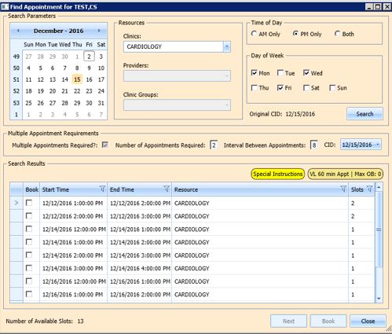

Figure : Find Appointment Dialog

The New Appointment dialog box opens. The New Appointment dialog box has one tab:

* **Appointments Tab**:
* **Patient Information Section displays** Name, DOB, SSN, SVC Connected, SC Percent, GAF (read only), and Svc Related check box**.**
* **Appointment** information section displays Start Time, Appt Type, Duration, Clinic and Notes (Appointment Start Time; Duration on for appointments to VL Clinics; and Notes are editable fields).
* **Appointment Conflicts** section displays any appointments already scheduled that conflict with the appointment being added.

1. Confirm information in the New Appointment dialog box and add any applicable text to the Notes section. Click **OK**.

The Print Letter? Dialog box displays.

1. Click **OK** to Print the Patient Letter.
2. Click **Cancel** to close dialog box and not print the Patient Letter.

The Closing Request dialog box displays “This request will be closed.”

1. Click **OK**.

The First MRTC Appointment is booked. The CID date in the Find Appointment dialog box changes to the next appointment date in the series. The MRTC Booking Status dialog box displays appointments as they are booked. An arrow points to date in MRTC Series that is being booked and automatically updates as appointments are completed.

The following information displays in the MRTC Booking Status dialog box:

* CID Date—Calculated by first booked appointment date and Interval Requested.
* Appointment Date—the date selected when booking appointments.
* Resource—the Clinic name where the appointment was booked.

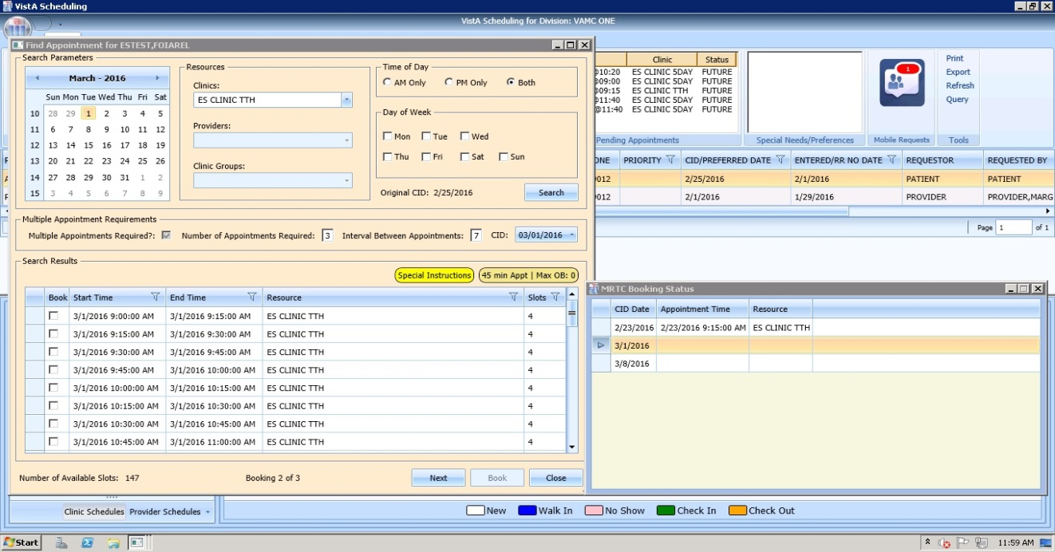

Figure : Find Appointment Dialog and MRTC Booking Status Dialog

**To book a second MRTC appointment:**

1. Select a time slot for the second MRTC appointment in the series.
2. Click **Book**.

The New Appointment dialog box displays.

1. Confirm information in the New Appointment dialog box. Add any applicable text to the Notes section, and then click **OK**.

The Print Letter? Dialog box displays.

1. Click **OK** to Print the Patient letter.

Click **Cancel** to close dialog and not print the Patient Letter.

The Closing Request dialog box displays a message “This request will be closed.”

1. Click **OK**.

The Second MRTC Appointment is booked. The CID date in the Find Appointment dialog box changes to the next appointment date in the series. The Appointment date is added in the MRTC Booking Status dialog box for the second appointment and the arrow moves to the next appointment (if applicable).

Once all MRTC Appointments have been booked for the series, the Closing Request dialog displays, “The Parent MRTC Request will be closed.”

If a clinic has a future inactive date and the CID date falls + three days after the Inactivate Date, a gray label displays in the Search Results section of the Find Appointment dialog box, “There are no slots available. The selected Clinic will be deactivated on {Inactivation Date}. Select another clinic, and then click **Search** to complete the MRTC request.”

To complete adding appointments for the series, the scheduler needs to change to an appropriate clinic in the Resources section with availability and continue adding appointments for the remainder of the series requests.

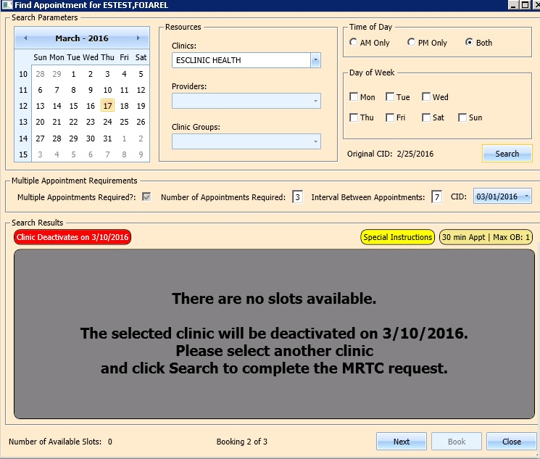

Figure 162: Future Clinic Inactivation Date

## Overbooking Appointments

Schedulers can overbook appointments based upon the following rules:

* The scheduler must have the Scheduling Overbook (SDOB) security key to overbook up to the clinic’s Maximum (Max) Overbook (OB) definition. Schedulers must have the Scheduling Master Overbook security key (SDMOB) security key to schedule beyond the clinic’s Max OB definition. Schedulers with both overbook security keys can overbook on any day that has availability defined regardless of the clinic’s Max OB definition. Schedulers cannot overbook if they are not assigned an overbooking security key.
* The Clinic must have availability defined for the day in question. If there is no availability defined, then schedulers will not be able to overbook appointments on that day regardless of the security key assigned to them.
* Appointments cannot be overbooked prior to the start of the day’s clinic availability.

### Overbooking Appointments with SDMOB Security Key

Schedulers assigned the SDMOB security key can overbook anytime outside of the clinic’s availability from the clinic’s start time to 11:59 p.m. even if the Max Overbook Limit defined for a clinic has been reached.

**To overbook an appointment with the SDMOB security key:**

1. Log into VS GUI as a Scheduler.
2. From the **Tasks** tab, in the **Search** text box, type the patient’s last name or the patient’s first initial of the last name and last four of the SSN (e.g. S1234). Click **Search**, and select the requested patient’s name. Click **Search**.
3. In the **Request Type** dialog box, select **APPT**, and then click **OK** to create a new request or click **Cancel** for the existing request.

**Note:** Refer to Section 5.1.2 Adding Appointment Request for steps on adding a new APPT Request.



Figure : Request Type

1. In the Request Management Grid select the **APPT** request.

The Clinic Schedule Grid displays the clinic’s schedule based upon the CID/Preferred date of request. For past dates, the clinic schedule opens to the default CID/Preferred date as Day 1 + six days. For the current date (or the CID/Preferred date less than three days in the future), the clinic schedule displays the current default date as Day 1 + six Days. For future dates, the clinic schedule displays -/+ three days of CID/Preferred date.

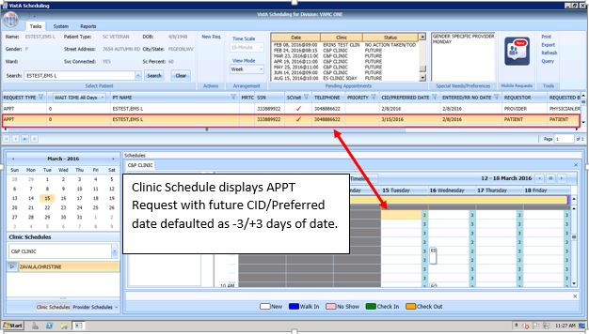

Figure : Clinic Schedule Display – APPT Request Future CID/Preferred Date

**Note:** For a newly created APPT request, the system automatically highlights the APPT request and the Clinic Schedule displays.

In the Clinic Schedule Grid, select the time slot in gray that is within the clinic’s hours, from the clinic’s start time to 11:59, or a date/time slot that has existing overbookings.

**Note:** The Clinic Max Overbook limit displays in the Clinic Day Event notes.

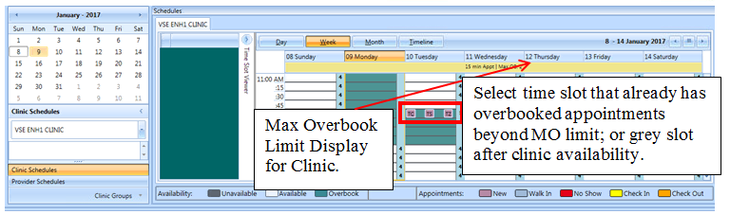

Figure : Max Overbook Limit

1. Right-click in the time slot.

The **Add Appointment** option displays.

**Note:** The **Create Walk In Appointment** option is only available for selection on the current date. It is not available for past or future CID/Preferred dates.

**Note:** Right-click options do not display if the selected time slot is for a day that has no availability defined or is prior to the clinic’s start time.



Figure : Appointment Right-click Options – Add Appointment

1. Select Add Appointment.

The Overbook message displays.

1. Click OK.

The View Appointment dialog box displays as well as the Patient Eligibility dialog box.

* **The Appointments Tab:**
* **Patient Information Section displays** Name, DOB, SSN, SVC Connected, SC Percent, GAF (read only), and Svc Related check box**.**
* **Appointment** information section displays Start Time, Appt Type, Duration, Clinic and Notes (Appointment Start Time; Duration on for appointments to VL Clinics; and Notes are editable fields).
* **Appointment Conflicts** section displays any appointments already scheduled that conflict with an appointment being added.

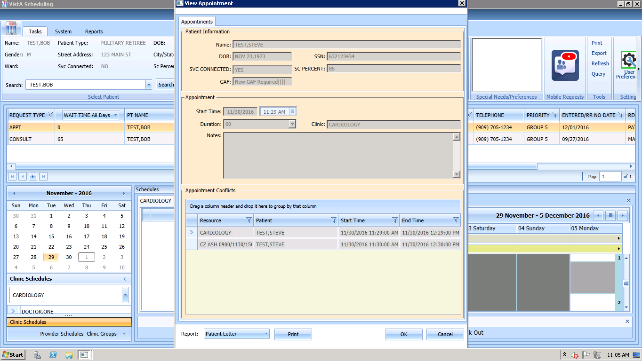

Figure : View Appointment Dialog – Appointments

1. Add any applicable Notes to the appointment. Click **OK**.

The Print Letter? Dialog displays.

1. Click **OK** to print the Letter to the patient.

Click **Cancel** to not print letter.



Figure : Print Letter? Dialog

The Closing Request dialog box opens.

1. Click **OK**.



Figure : Closing Request Dialog

* The APPT Request is removed from the Patient Request Management Grid.
* The Next request for the patient is moved up and highlighted.
* The Clinic Schedule closes.
* The New appointment displays in the Pending Appointment Window on the Ribbon Bar.

1. Select an appointment from the Pending Appointment window to view it in the Clinic Schedule Grid.

* The clinic schedule opens.
* For past dates, the clinic schedule opens to the default appointment date.
* For the current date (or appointment date less than three days in future), the clinic schedule defaults to the current date.
* For future dates, the clinic schedule displays -/+ three days of the appointment date.
* The Overbook count increases in the Clinic Schedule time slot and in the Time Slot Viewer. If the appointment count has filled the time slot, hover over the window to show the slot count.

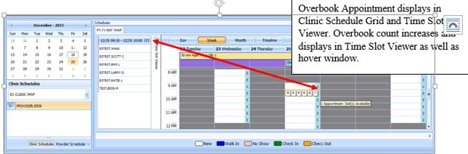

Figure : Clinic Schedule Display – Overbook Appointment

### Overbooking Appointments with SDOB Security Key

Schedulers who are assigned the SDOB security key can overbook outside of the clinic’s availability from the clinic start time to 11:59 p.m. Schedulers cannot overbook past the Max Overbook Limit defined for a clinic.

**To overbook an appointment with the SDOB security key:**

1. Log into VS GUI as a scheduler.
2. From the **Tasks** tab, in the **Search** text box, type the patient’s last name or the patient’s first initial of the last name and last four of the SSN (e.g. S1234). Click **Search**, and then select the requested patient’s name. Click **Search**.
3. In the **Request Type** dialog box, select **APPT** and then click **OK** to create a new request or click **Cancel** for the existing request.

**Note:** Refer to Section 5.1.2 Adding Appointment Request for steps on adding new APPT Request.



Figure : Request Type

1. Select APPT request in the Request Management Grid.

The Clinic Schedule Grid displays the clinic’s schedule based upon the CID/Preferred date of request. For a past date, the clinic’s schedule opens to the default CID/Preferred date as Day 1 + six days. For a current date (or CID/Preferred date less than three days in future), the clinic’s schedule displays the current default date as Day 1 + six days. For future dates, the clinic schedule displays -/+ three days of CID/Preferred date.

**Note:** For a newly created APPT request the system automatically highlights the APPT request and the Clinic Schedule displays.

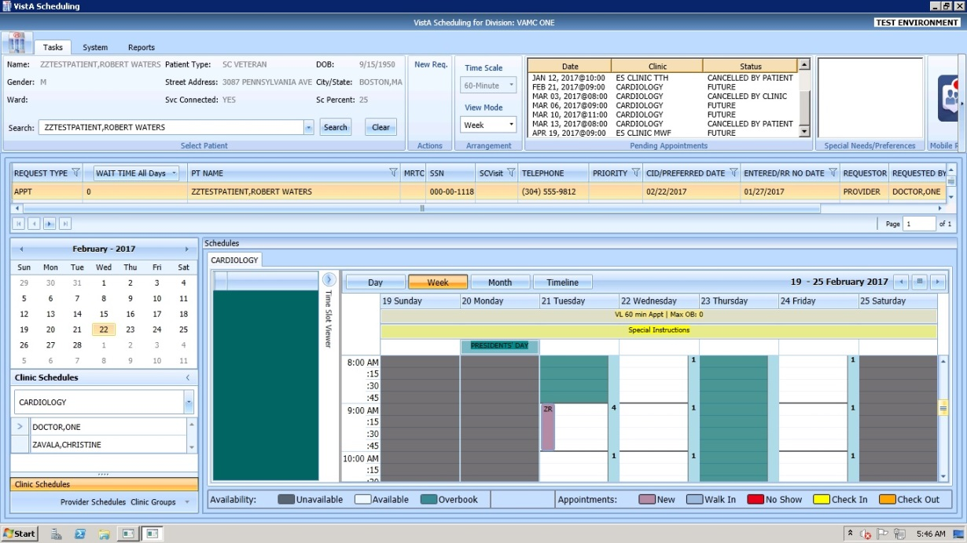

Figure : Clinic Schedule Display – APPT Request Future CID/Preferred Date

1. In the Clinic Schedule Grid, select the time slot colored in teal that is within the clinic’s hours, close of clinic hours to 11:59 p.m., or a date that does not already have existing overbooks.

**Note:** The Clinic Max Overbook limit displays in the Clinic Day Event notes.

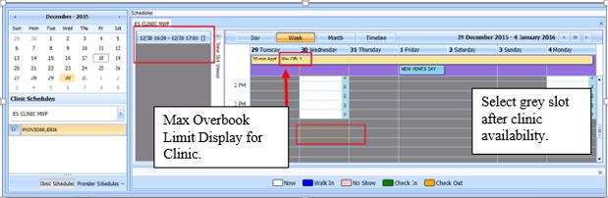

Figure : Overbook After Hours Time Slot

1. Right-click the time slot.

The Add Appointment option displays. The Create Walk In Appointment option is only available for selection on the current date. It is not available for past or future CID/Preferred dates.

**Note:** Right-click options do not display if the selected time slot is for a day that has no availability defined, is prior to the clinic’s start time, or the Max Overbook limit has been met for the day.



Figure : Appointment Right-click Options – Add Appointment

1. Select Add Appointment.

The Overbook message displays.

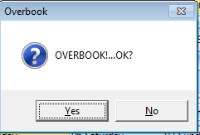

Figure : Overbook Confirmation Dialog

1. Click **OK**.

The New Appointment dialog box displays, as well as the Patient Eligibility dialog box.

* **Appointments Tab**:
* **Patient Information Section displays** Name, DOB, SSN, SVC Connected, SC Percent, GAF (read only), and Svc Related check box**.**
* **Appointment** information section displays Start Time, Appt Type, Duration, Clinic and Notes (Appointment Start Time; Duration on for appointments to VL Clinics; and Notes are editable fields).
* **Appointment Conflicts** section displays any appointments already scheduled that conflict with the appointment being added.



Figure : New Appointment Dialog

1. Add any applicable Notes to the appointment. Click **OK**.

The Print Letter? Dialog box displays.

1. Click **OK** to print the Patient Letter.
2. Click **Cancel** to exit the dialog box and not print the Patient Letter.



Figure : Print Letter? Dialog

The Closing Request dialog box opens.

1. Click **OK**.



Figure : Closing Request Dialog

The APPT Request is removed from the Patient Request Management Grid. The Next request for the patient is moved up and highlighted.

The Clinic Schedule closes.

The New appointment displays in the Pending Appointment window in Ribbon Bar.

1. Select an appointment from the Pending Appointment window to view it in the Clinic Schedule Grid.

The clinic schedule opens. For past dates, the clinic schedule opens to the default appointment date. For the current date (or appointment date less than three days in future), the clinic schedule displays the current default date. For future dates, the clinic schedule displays -/+ three days of appointment date.

The Overbook count increases in the clinic schedule time slot and in the Time Slot Viewer. If the appointment count has filled the time slot, hover over the window to display the slot count.

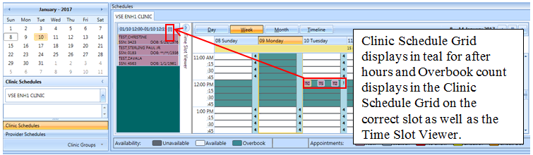

Figure : Clinic Schedule Display – Overbook Appointment After Hours

## Variable Length (VL) APPT

Scheduling appointments can typically be done in fixed length intervals based upon the clinic’s definitions. However, a clinic can be setup as a Variable Length (VL) clinic, which allows a user to schedule an appointment for an extended amount of time as needed rather than scheduling multiple appointments.

### IdentifyingaVLClinic**:**

To identify if a clinic is set up for VL scheduling:

1. Log on to VS GUI.
2. From the Clinic Schedules, type the clinic’s name (six-character minimum) or the clinic’s abbreviation (four-character minimum).

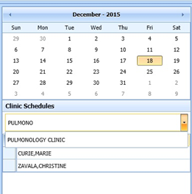

Figure : Clinic Schedules – Clinic Search

The selected clinic’s schedule displays the default, the current date as Day 1 + six days.

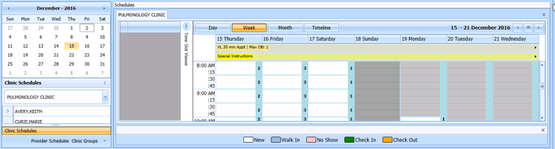

Figure : Clinic Schedule Grid

To confirm whether VL appointments can be booked at a clinic, view the All Day Event Bar in the Clinic Schedule Grid. The clinic’s defined appointment length and max overbooking limit are displayed. If the clinic is designated as a variable length clinic, the letters “VL” display before the appointment length.

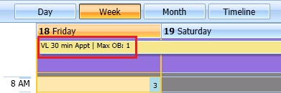

Figure : VL Indicator

### Add a VL APPT

**To add a VL APPT:**

1. In the clinic schedule, select the time slot that the APPT shall begin.
2. Right-click and select **Add Appointment**.

The New Appointment dialog box displays.

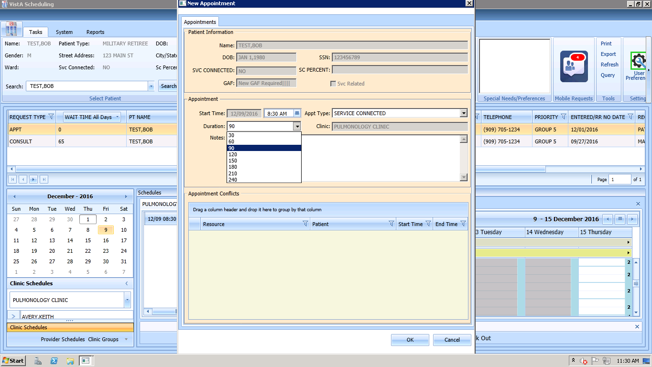

Figure : New Appointment Dialog

1. Select the appropriate duration of the APPT from the Duration list.

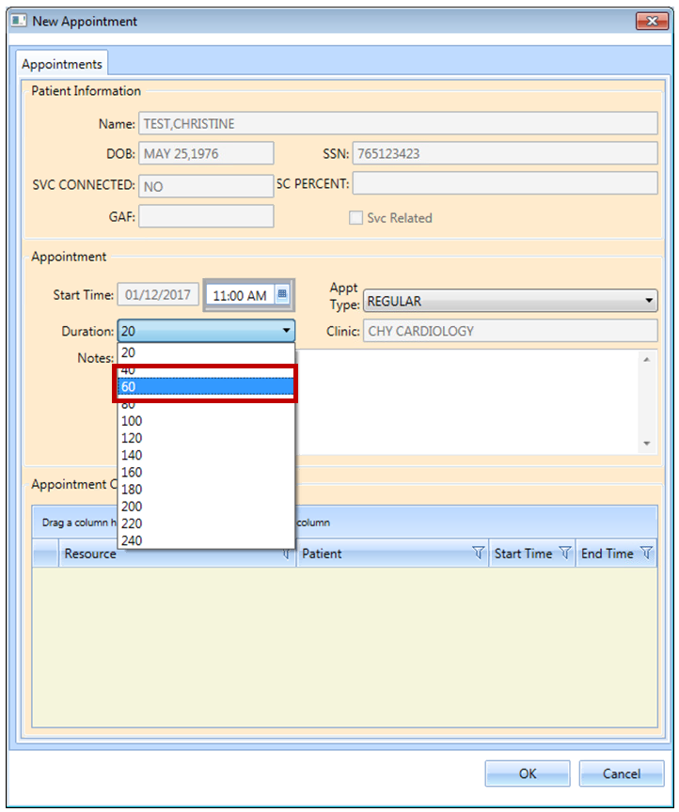

Figure : Clinic Schedule Display – Multiple Time Slot Selected

The New Appointment dialog box appears. Confirm that the appointment duration reflects the correct amount of time.

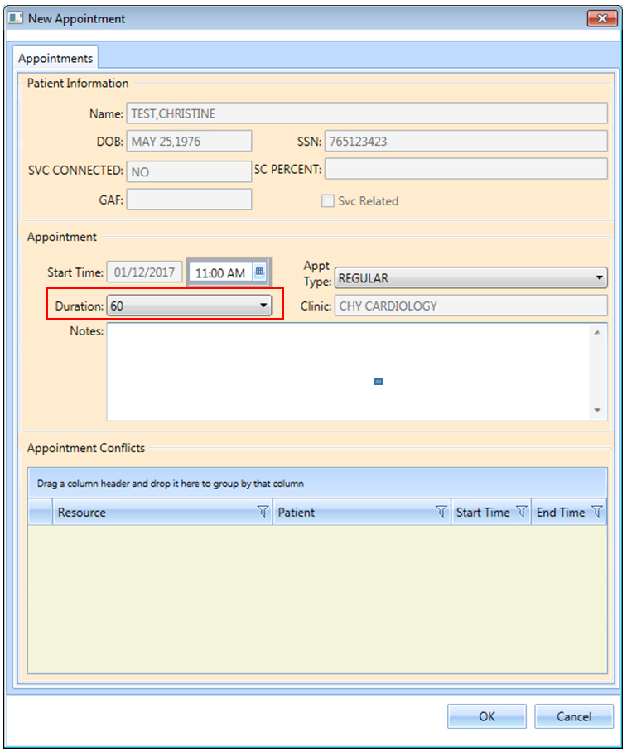

Figure : New Appointment Dialog – VL APPT Duration

1. Click **OK**.

The Print Letter? Dialog box opens.

1. Click **Cancel**.

The Closing Request dialog box displays a message “This request will be closed”.

1. Click **OK**.

The New APPT displays in the Pending Appointment window.

1. Select the APPT from the Pending Appointment window.

The Clinic Schedule displays the booked APPT spanning two time slots, which indicates a VL APPT.

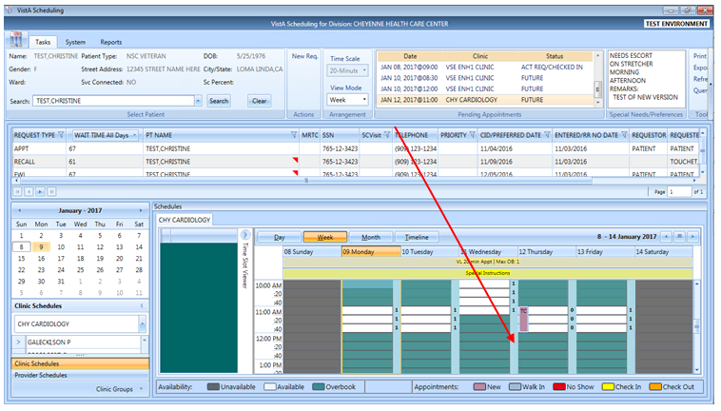

Figure : Clinic Schedule Display – Appointment Length Extended

## Compensation and Pension (C&P) APPTs

### Add a C&P APPT Request

1. Log into VS GUI.
2. From the Tasks tab, type the patient’s last name and the first name in the Search text box. Click **Search**, and then select the requested patient’s name from the list.
3. Select the APPT Request Type.
4. Complete the APPT Request dialog box.

Refer to Section 5.1.2 for instructions on completing APPT Request dialog.

1. Select the appropriate Clinic for the C&P appointment.
2. Enter the CID/Preferred Date.
3. In Appointment Type list, select C&P.
4. Click **OK**.

The APPT Request displays on the patient’s Request Management Grid.

### Add a C&P APPT for Pending 2507 Request NOT Previously Linked to Appointment

1. Log into VS GUI.
2. From the **Tasks** tab, in the **Search** text box, type the patient’s last name or the patient’s first initial of last name and last four of the SSN (e.g. S1234). Click **Search**, and then select the requested patient’s name.
3. In the Request Type click **Cancel**.
4. In the Request Management Grid, select pending C&P APPT Request.
5. In the Clinic Schedule Grid, click the open time slot.
6. Right-click, and then select **Add Appointment**

**Note:** The Create Walk-In Option is available if the current day is selected in the Clinic Schedule.

The New Appointment dialog box displays.

Confirm the Appointment Type is listed as C&P. If not, select the Appointment Type from the list.

Add any applicable APPT information to the Notes section.

1. Click **OK**.

The Dialog box displays:

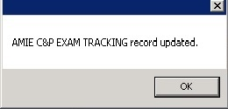

Figure : TRACKING Record Updated

**Note:** If the patient did NOT have a pending 2507 Request on file a dialog box opens:

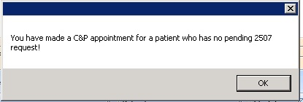

Figure : C&P Appointment for Patient with No Pending 2507 Request

1. Click **OK**.

The Print Letter? Dialog box displays.

1. Click **OK** to print the Patient Letter.

Click **Cancel** to exit the dialog box and not print the patient letter.

The Closing Request Dialog box displays a message - “This request will be closed.”

1. Click **OK**.

The New C&P APPT displays in the Pending Appointment window and the Automated Medical Information Exchange (AMIE) Tracking Link is updated.

### Add a C&P APPT for Pending 2507 Request Already Linked to APPT NOT Due to Cancellation

1. Log into VS GUI.
2. From the Tasks tab, type the patient’s last name and the first name in the Search text box. Click **Search**, and then select the patient’s name with the pending C&P APPT Request from the list.
3. In the Request Type window, click **Cancel**.
4. In the Request Management Grid, select pending C&P APPT Request.
5. In the Clinic Schedule Grid click an open time slot.
6. Right-click on open time slot, and then select **Add Appointment.**

**Note:** The Create Walk-In Option is available if the current day is selected in the Clinic Schedule.

The New Appointment dialog box opens.

1. Confirm the Appointment Type is listed as C&P. If not, select it from the list.
2. Click **OK**.

The C&P requests dialog box displays the following information:

* Name: Veteran’s name
* Request Date: Date 2507 Request created

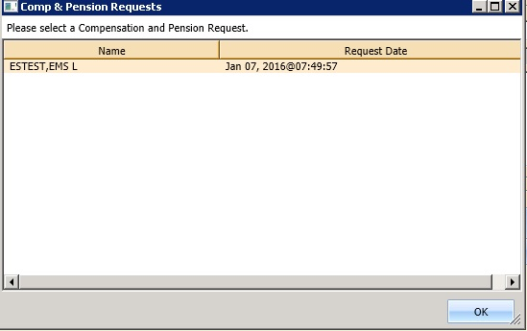

Figure : C&P Requests Dialog

1. Select the appropriate 2507 Request from the list.
2. Click **OK**.

The C&P Request dialog box displays an option to select Yes or No:

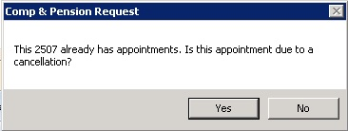

Figure : C&P Request Due to Cancellation Dialog

1. Click **No**.

A message update dialog box displays:



Figure : AMIE C&P EXAM TRACKING Record Updated

1. Click **OK**.

The Print Letter? Dialog box opens.

1. Click **OK** to print the Patient Letter.

Click **Cancel** to exit the dialog box and not print the Patient Letter.

The Closing Request dialog box displays the message: “This request will be closed.”

The New C&P Appointment displays in the Pending Appointment window, and shows the AMIE Tracking Link is updated.

### Add a C&P APPT for Pending 2507 Request due to Clinic Cancellation

1. Log into VS GUI.
2. From the **Tasks** tab, in the **Search** text box, type the patient’s last name or the patient’s first initial of the last name and last four of the SSN (e.g. S1234). Click **Search**, and then select the requested patient’s name. Click **Search**.
3. In the Request Type dialog box click **Cancel**.
4. In the Request Management Grid, select pending C&P APPT Request.
5. In the Clinic Schedule Grid, click the open time slot.
6. Right-click the time slot, and then select Add Appointment.

**Note:** The Create Walk-In Option is available if the current day is selected in the Clinic Schedule.

The New Appointment dialog box opens.

Confirm the Appointment Type is listed as C&P. If not, select the Appointment Type from the list.

1. Click **OK**.

The C&P Requests dialog box displays the following information:

* Name: Veteran’s name
* Request Date: Date 2507 Request created



Figure : C&P Requests Dialog

1. Select the appropriate 2507 Request from the list.
2. Click **OK**.

The C&P Request displays the option to select Yes or No:



Figure : C&P Request Due to Cancellation Dialog

1. Click **Yes**.

The C&P APPT Links dialog box displays the following information:

* Initial Appointment Date
* ClockStop Appointment Date
* Current Appointment Date
* Clinic Name

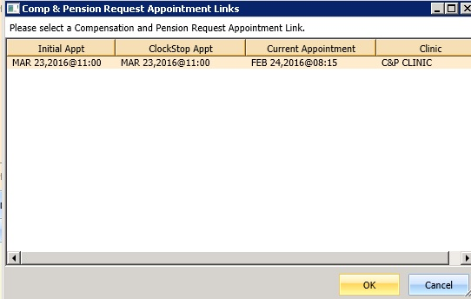

Figure : C&P Request APPT Links Dialog

1. Click **OK**.

**Note:** If the scheduler clicks **Cancel** , the following dialog box opens:

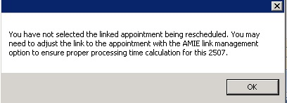

Figure : C&P APPT Links Due to Veteran Cancellation or No Show

The C&P APPT Links dialog box displays a message with the option to select Yes or No:

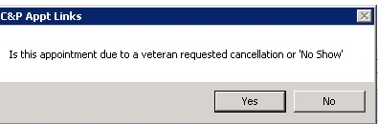

Figure : C&P APPT Links Due to Cancellation Dialog

1. Click **No**.

A Dialog box displays a message about the C&P appointment.

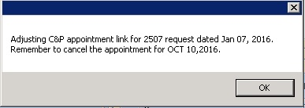

Figure : C&P APPT Links Adjustment Dialog

1. Click **OK**.

The Print Letter? Dialog opens.

1. Click **OK** to print the Patient Letter.

Click **Cancel** to exit the dialog box and not print the Patient Letter.

The Closing Request dialog box displays a message: “This request will be closed.”

The New C&P APPT displays in the Pending Appointment window and shows the AMIE Tracking Link is updated.

**Note:** The previous appointment linked to the 2507 Request must be manually dispositioned.

### Add C&P APPT for Pending 2507 Request due to Veteran Cancellation/No Show

1. Log into VS GUI.
2. From the **Tasks** tab, in the **Search** text box, type the patient’s last name or the patient’s first initial of the last name and last four of the SSN (e.g. S1234). Click **Search**, and then select the requested patient’s name. Click **Search**.
3. In the Request Type Dialog box click **Cancel**.
4. In the Request Management Grid, select pending C&P APPT Request.
5. In the Clinic Schedule Grid, click an open time slot.
6. Right-click the time slot, and then select **Add Appointment**.

**Note**: The Create Walk-In Option is available if the current day is selected in the Clinic Schedule.

The New Appointment dialog box opens.

1. Confirm the Appointment Type is listed as C&P. If not, select the Appointment Type from the list, and then click OK.

The C&P Requests dialog box displays the following information:

* Name: Veteran name
* Request Date: Date 2507 Request created



Figure : C&P Requests Dialog

1. Select the appropriate 2507 Request from the list.
2. Click **OK**.

The C&P Request dialog box displays information about the appointment and the option to select Yes or No:



Figure : C&P Request Due to Cancellation Dialog

1. Click **Yes**.

The Comp & Pension Appointment Links dialog box displays the following information:

* Initial Appointment Date
* ClockStop Appointment Date
* Current Appointment Date
* Clinic Name



Figure : C&P Request APPT Links Dialog

1. Click **OK**.

**Note:** If the scheduler clicks **Cancel** instead of OK, the following message displays:



Figure : C&P Canceled APPT Links Dialog Warning

The C&P Appt Links dialog box displays the option to select Yes or No:



Figure : C&P APPT Links Due to Veteran Cancellation or No Show

1. Click **Yes**.

A message update dialog box displays:



Figure : AMIE C&P EXAM TRACKING Record Updated

1. Click **OK**.

The Print Letter? Dialog box displays.

1. Click **OK** to print the Patient Letter.

Click **Cancel** to exit the dialog box and not print the Patient Letter.

The Closing Request dialog box displays a message: “This request will be closed.”

The New C&P APPT displays in the Pending Appointment window and Shows the AMIE Tracking Link is updated.

**Note:** The previous appointment linked to the 2507 Request must be manually dispositioned.

### Disposition APPT Linked to Pending 2507 Request

1. Log into VS GUI.
2. From the **Tasks** tab, in the **Search** text box, type the patient’s last name or the patient’s first initial of the last name and last four of the SSN (e.g. S1234). Click **Search**, and then select the requested patient’s name. Click **Search**.
3. In the Request type dialog box click **Cancel**.
4. In the Pending Appointment window, select the pending C&P APPT linked to the pending 2507 Request.
5. In the Clinic Schedule Grid, click the appointment.
6. Right-click the appointment and the following options are available to select:

* Edit Appointment
* View Appointment
* Cancel Appointment

1. Select Cancel Appointment.

The Cancel Appointment dialog box displays. See Section 0 for detailed instructions on completing the Cancel Appointment dialog.

1. Select Appointment Cancelled By.
2. Select Reason for Cancellation.

Edit CID/Preferred Date if applicable.

1. Enter Remarks.
2. Click **OK**.

A Dialog box displays an update message:

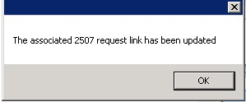

Figure : C&P Cancel APPT Associated 2507 Request Updated

**Note:** If the C&P APPT was NOT linked to the 2507 request, the following message displays in dialog box:

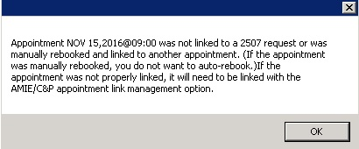

Figure : C&P Cancel APPT NOT Linked to Pending 2507 Request

1. Click **OK**.

The APPT status is updated in the Pending Appointment window. The APPT is removed from the Clinic Schedule and the AMIE Link is updated.

## VA Online Scheduling (formerly VAR)

**Note:** Note: VA Online Scheduling requests will NOT be processed in VS GUI at this time due to a number of enhancements that will be added at a later date. The SDECZREQUEST key is held in reserve until that time. If a user has the key on their VistA account now, it will give them an error each time they log in as the service cannot connect to the mobile request service.

VA Online Scheduling requests will eventually interface with VS GUI requests, including:

* Schedule an appointment requested in VA Online Scheduling through the VS GUI interface, fulfilling that request..
* View appointment requests within the GUI.
* Communicate or message the Veteran from within the GUI up to a limit of four times.
* Close out requests from within the GUI.

# Clinics

## Tasks Tab

### Viewing Clinic Schedule Availability

The VS GUI displays a consistent color visual indicator for a clinic’s workable hours including bookable holidays, non-workable hours including non-bookable holiday, clinic cancellation, and no availability as follows:

Table : Clinic Schedule Availability

|  |  |
| --- | --- |
| Appointment Availability Type | Color |
| Available Slots/Hours of Operation | White |
| Unavailable/ Non-workable hours during day with availability defined (i.e. clinic lunch breaks). | Teal |
| Cancelled Availability for Clinic—Partial and All Day Cancellation. | Teal + hash mark (\\) |
| Holiday but bookable | White |
| Holiday but NOT bookable | Gray |
| No availability defined for day (i.e. Saturday or Sunday). | Gray |
| No availability defined for the clinic | Gray |

**To search for a clinic and view the clinic schedule:**

1. From the **Tasks** tab, on the Clinic Schedules, enter a partial name of a clinic (six character minimum).

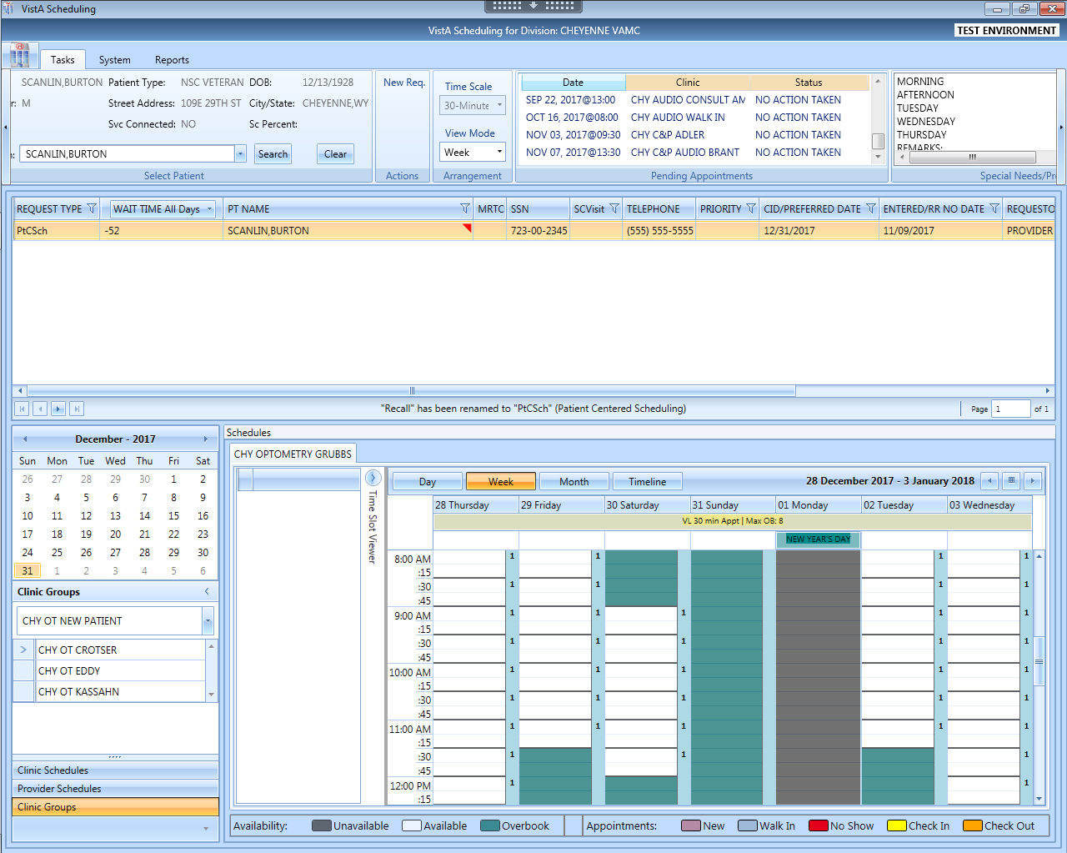

Figure : Clinic Schedules Search

1. Select the desired clinic from the returned list.

The selected clinic schedule displays.



AVAILABLE

UNAVAILABLE

Figure : Clinic Schedules Display – Available and Unavailable

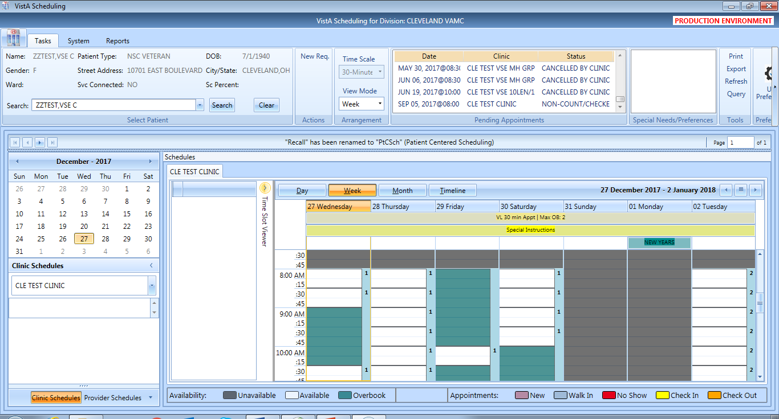

}

Hours of Operation

Figure : Clinic Schedules Display – Hours of Operation

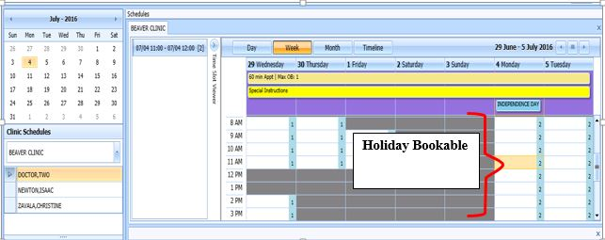

Figure : Clinic Schedules Display – Holiday Bookable



Figure : Clinic Schedules Display – Holiday Unbookable

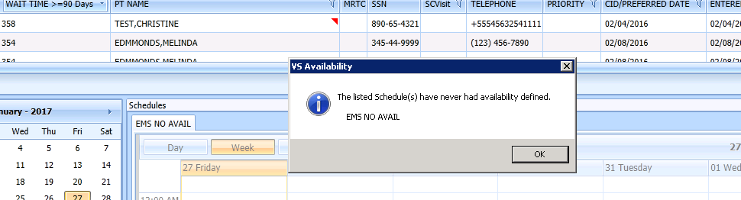

Figure : Clinic Schedule Display – No Availability Defined

### Viewing Clinic’s Availability Cancellation

The Clinic Schedule displays full or partial day cancellation in gray + \\ over the cancelled time slots.

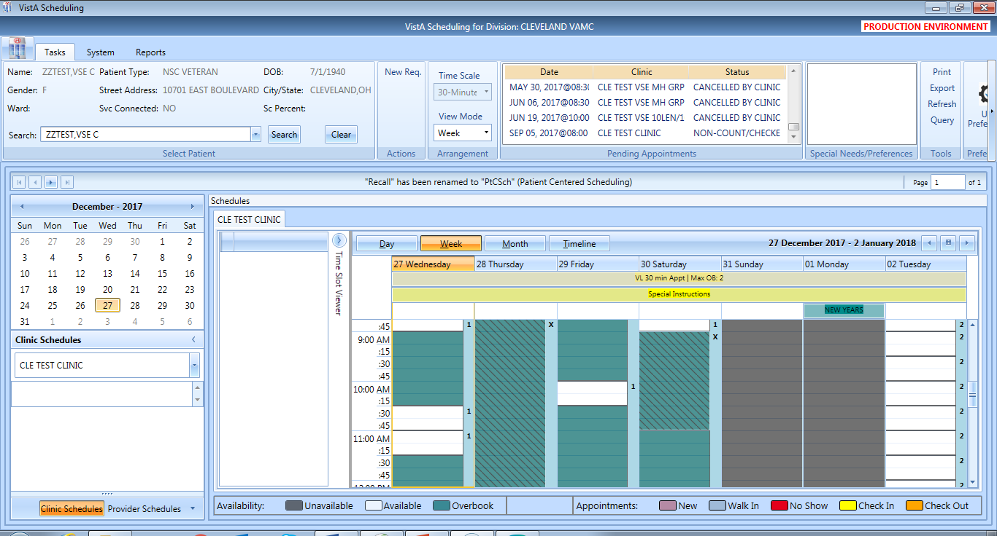

Figure : Clinic Schedule Display – Whole and Partial Day Cancel Availability

### Viewing the Clinic’s Length of APPT and Max OB

A label in the All Day Event Bar displays the Length of APP and Max OB values defined for the selected clinic.



Figure : APPT Length and Max OB Allowed

### Viewing the Clinic’s VL Indicator

For clinics defined as Variable Length, a flag “VL” displays before the Length of Appointment information in the All Day Event Bar in the Clinic Schedule Grid.

**Note:** Refer to Section 6.5.2 on How to Add VL APPT.



Figure : VL Indicator

### Viewing the Clinic’s Special Instructions

**To display a clinic’s special instructions:**

1. From the **Tasks** tab, on the Clinic Schedules, enter a partial name of a clinic (six characters minimum).
2. Select the desired clinic from the returned list.

The selected clinic schedule displays and the Special Instruction Indicator displays in the All Day Event Bar in the Clinic Schedule.

1. Click the **Special Instructions** indicator to display the Special Instructions.



Figure : Special Instructions Indicator

### Viewing Clinic’s Available Slots

The Time Slot Count for availability displays as follows:

* 0-9 and j-z –denote available slots where j=10,k=11…z=26.
* Upper Case Letters A-W denote overbooks, with A being the first slot to be overbooked and B being the second for that same time, etc.
* Special characters *,$,!,@,# denote overbooks or appointments that fall outside of a clinic’s regular hours.

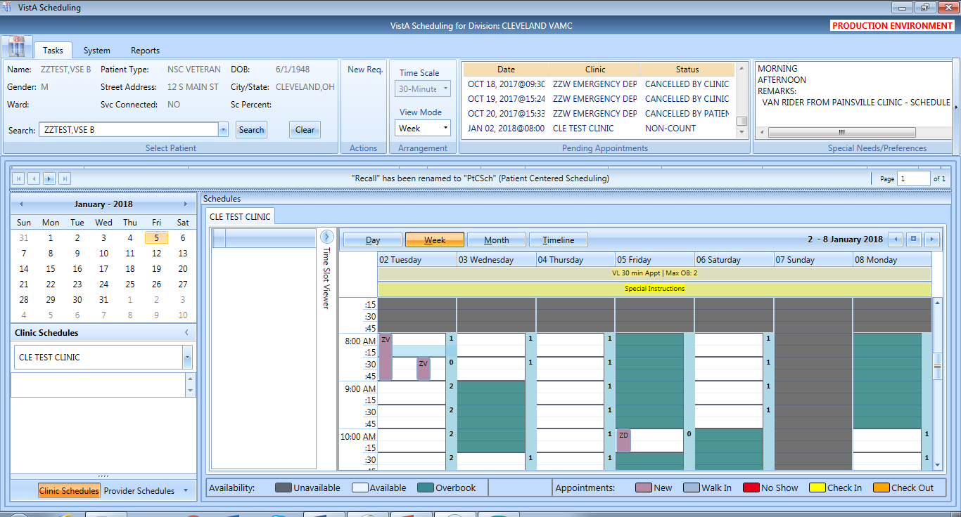

Figure : Time Slot Count

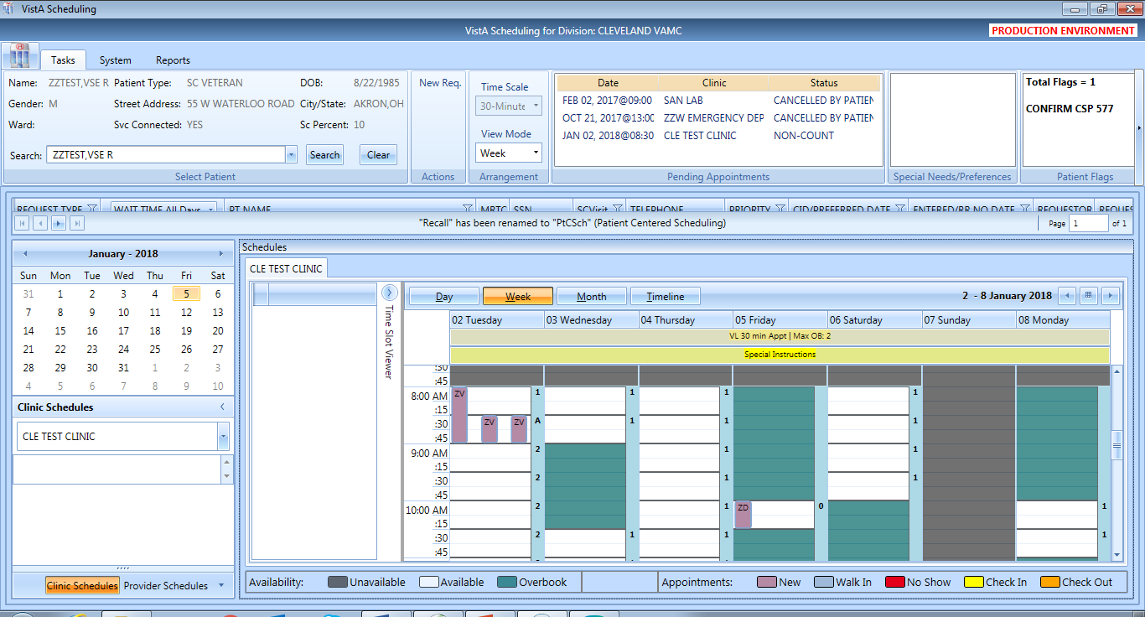

Figure : Overbook Time Slot Count

### The Time Slot Viewer

The Time Slot Viewer displays to the left of the Clinic Schedule Grid. It displays APPT information per selected time slot. For APPTs booked in the time slot, the full patient’s name displays in a list in the order they were added to the time slot.

1. From the **Tasks** Tab, on the Clinic Schedules, enter a partial name of a clinic (six-character minimum).
2. Select the desired clinic from the returned list.

The selected clinic schedule displays.

**Note:** Time Slot Viewer can be expanded or minimized in Clinic Schedule Grid.

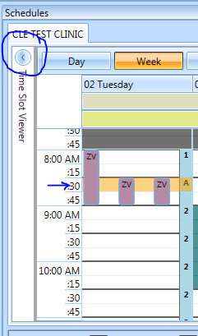

Figure : Minimized Time Slot Viewer

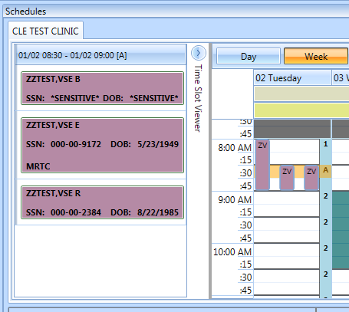

Figure : Expanded Time Slot Viewer

When you select a time slot from the Clinic Schedule it populates the Time Slot Viewer with the following information:

* Date/Time of the Time Slot.
* Available slot count left for the time slot.
* A list of patient names in the order they were booked, for any APPTs scheduled in the time slot.

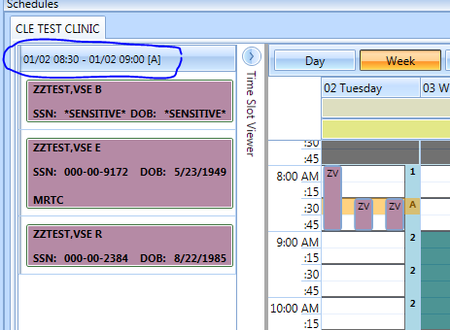

Figure : Time Slot Viewer Displays Slot Details

For booked APPTs, right-click to extend action options that are available from Time Slot Viewer, the same as in the Clinic Schedule Grid.

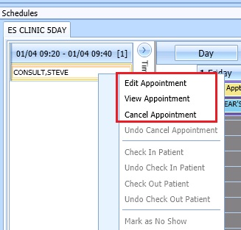

Figure : Time Slot Viewer Right-click–Edit, View, Cancel

The Check In Patient command from the Time Slot Viewer is the same as from the Clinic Schedule Grid.

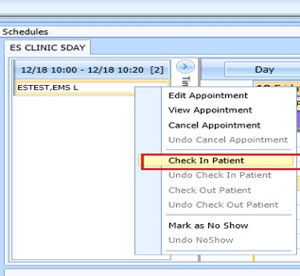

Figure : Time Slot Viewer – Check In Patient

The Check Out Patient command from the Time Slot Viewer is the same as from the Clinic Schedule Grid.

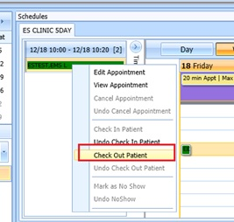

Figure : Time Slot Viewer – Check Out Patient

The Mark as No Show command from the Time Slot Viewer is the same as from the Clinic Schedule Grid.

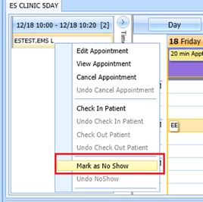

Figure : Time Slot Viewer – Mark as No Show

### Viewing Provider Availability

**To search for a provider and view the provider’s schedule.**

1. From the Tasks tab, under the Request grid calendar, select **Provider Schedules**.

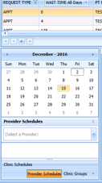

Figure : Provider Schedules

1. Enter a partial name of a provider (three characters minimum). Select the desired provider from the returned list.

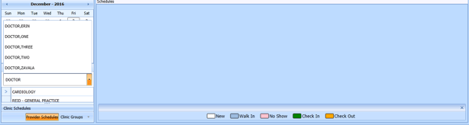

Figure : Provider Schedules Selection List

The selected provider schedule displays.

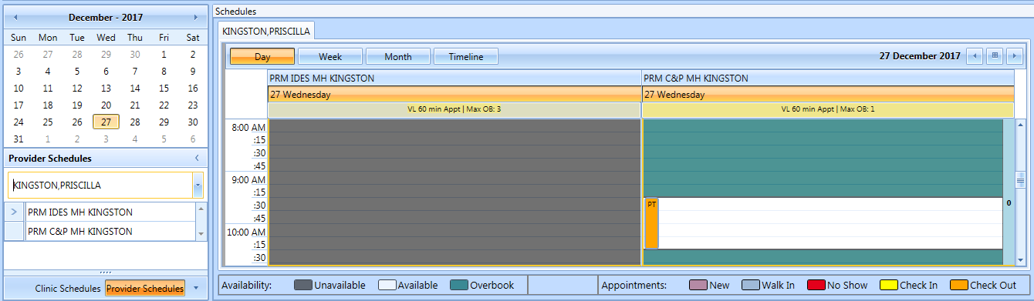

Figure : Provider Schedule Display

The provider’s availability displays across all clinics. If the provider has only one clinic, that clinic’s schedule and availability appear.



Figure : Provider Schedules Booked APPTs

Available APPT slots display as white space, which a scheduler can select to add an APPT.

The APPTs display with the name of the patient in a specific Clinic Schedule time slot.

Time slots in the Clinic Schedule that appear dimmed indicate they are not available therefore, schedulers are unable to add APPTs for those specific slots.

**Note:** Refer to Section 6 for APPT Management instructions on how to Add, Check-In, Checkout, and Cancel APPTs.

### Viewing Clinic Group Availability

**To search for a clinic group and view the clinic group’s schedule:**

1. On the Tasks tab, point to the calendar of the Request grid, and then select **Clinic Groups**.

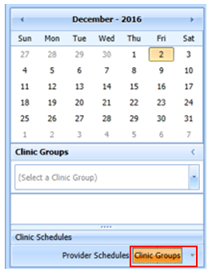

Figure : Clinic Groups

1. Enter a partial name of a clinic group (six-character minimum).
2. Select the desired Clinic Group from the returned list.

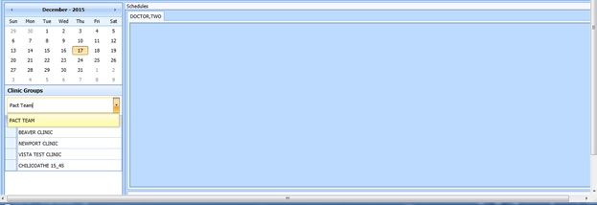

Figure : Clinic Groups Search Result List

The selected clinic group schedule(s) displays, starting with today’s date in the Day view.

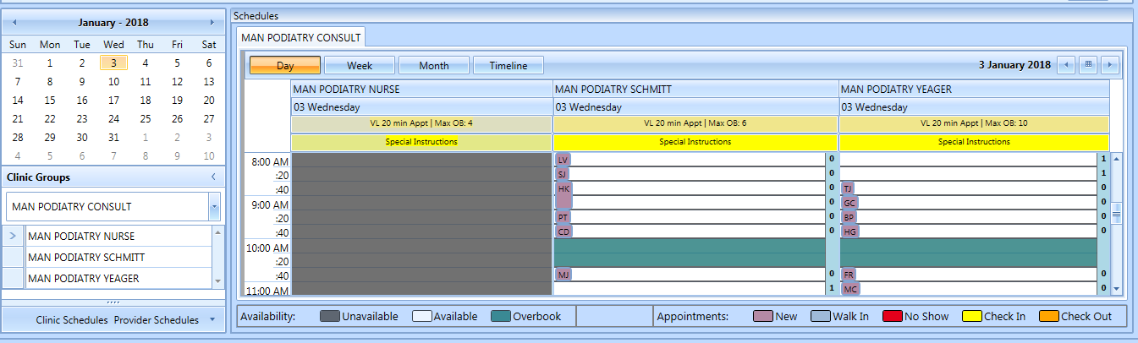

Figure : Clinic Groups Schedule Display

**Note:** Refer to Section 6 for the APPTs Management instructions on how to Add, Check-In, Checkout, and Cancel APPTs.

## System Tab

The **System** tab requires the SDECZMGR security key to access the tab.

### Viewing Clinic Availability Information

Clinic availability cannot be modified from the VS GUI.

**To quickly search for clinic availability:**

1. From the System tab, click Availability in the Resource Schedules section.
2. In the **Availability Selection** dialog box, type the desired clinic’s name.
3. Select the desired clinic and click **OK**.

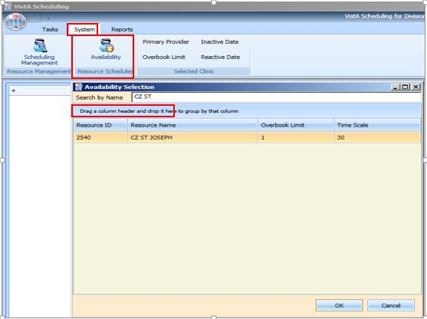

Figure : Clinic Availability Search

* The Schedule displays for the selected clinic. Primary Provider, Overbook Limit, Inactive Date, and Reactive Date, as applicable, also display in the **Selected Clinic** section.
* The **Schedule** also displays the number of APPTs per slot and the number of slots total per APPT length (in minutes and total number of bookable minutes).
* The **Schedule** uses the same visual coloration as the **Clinic Schedule** for workable hours, non-workable hours, and no availability.

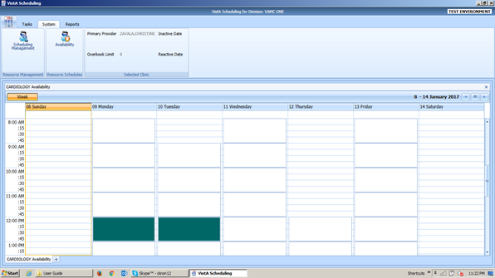

Figure : Clinic Availability

### Adding and Removing Privileged Users

#### Add A Privileged User

**To add a privileged user to a prohibited clinic:**

1. On the System tab, click **Scheduling Management**.
2. In the **Prohibited Clinic** search box, type a partial or full name of the clinic (minimum six characters).
3. Click **Find**.

A list of prohibited clinics displays.

1. Select the appropriate prohibited clinic.

A list of privileged users for the selected clinic displays.

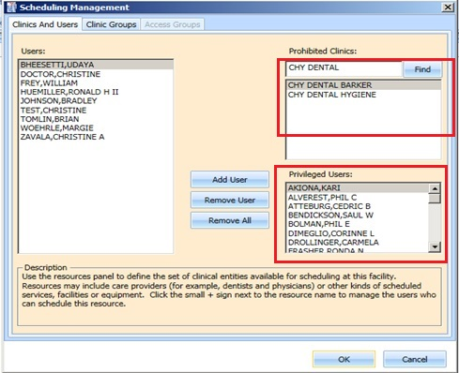

Figure : Clinics and Users

1. Select a user from the Users pane on the left side of the open window, and then click **Add User**.

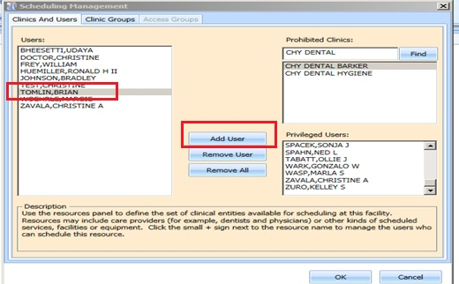

Figure : Add Privileged User

1. Click **OK** to add the user to the list of Privileged Users.
2. Please note: Only users with the VistA key SDECZMENU will show in the user list.

#### Remove Privileged User

**To remove a privileged user from a prohibited clinic:**

1. On the System tab, click **Scheduling Management**.
2. In the **Prohibited Clinic** search box, type a partial or full name of the clinic (minimum six characters).
3. Click **Find**.

A list of prohibited clinics displays.

1. Select the appropriate prohibited clinic.

A list of privileged users for the selected clinic displays.

1. Select a user from the **Privileged User** list for the selected prohibited clinic, and then click **Remove User.**

If all privileged users need to be removed, click **Remove All.**

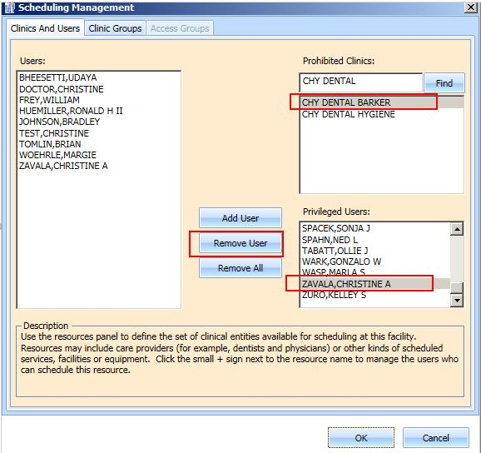

Figure : Remove Privileged User

### Creating Clinic Groups

**To create a Clinic Group:**

1. On the System tab, click **Scheduling Management**.
2. Select the **Clinic Groups** tab.
3. Click New Group.
4. Enter a name in the **Clinic Group Name** text box.

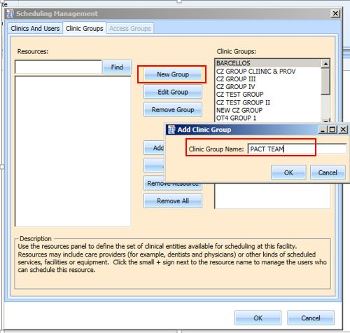

Figure : Create New Clinic Group

1. Click **OK**.
2. Select the newly added **Clinic Group**.
3. Enter a partial name search for a **Resource**,and then click **Find.**

A resource can be a clinic or a provider that is active with an active person class.

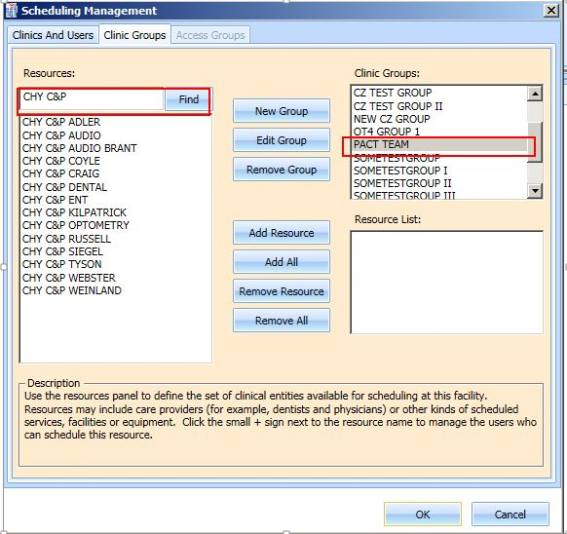

Figure : Find Resource

1. Select the appropriate resource to add to the Clinic Group, and then click **Add Resource**.

If all of the resources listed from the search need to be added, click **Add All**.

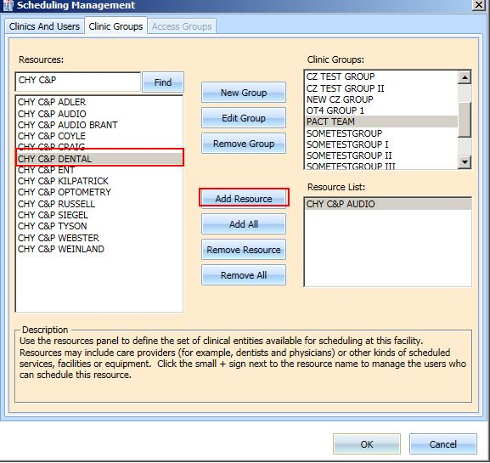

Figure : Add Resource to Clinic Group

1. Click **OK** to add the clinic group to the list.

### Removing a Resource from a Clinic Group

**To remove a resource from a Clinic Group:**

1. On the System tab, click **Scheduling Management**.
2. Select the **Clinic Groups** tab.
3. Select a clinic group to be edited from the **Clinic Groups** list.

Resources defined for the Clinic Group are displayed in the **Resource List** box.

1. Select a resource to remove, and then click **Remove Resource**.

If all resources need to be removed, click **Remove All**.

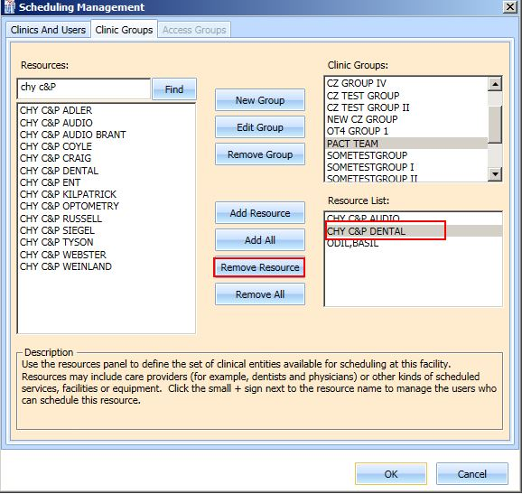

Figure : Remove Resource from Clinic Group

# Reports

The **Reports** tab allows you to view and print various reports. The Reports tab requires the SDECZMGR manager security key to access the tab. The following selections and reports are available:

* Audit Activity
* Clinics

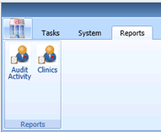

Figure : Reports Tab Selections

## The Audit Activity Report – UPDATE: Working as designed in v2.0.0.14

### Generating an Audit Activity Report for an Individual Scheduler

**To view Audit Activity for an individual scheduler:**

1. From the **Reports** tab, select **Audit Activity**.

The Audit Activity dialog displays.

1. Select the individual s**cheduler’s** name from the list.
2. Select **Start** **Date** and **End** **Date**. You can type the date or select it from the calendar.

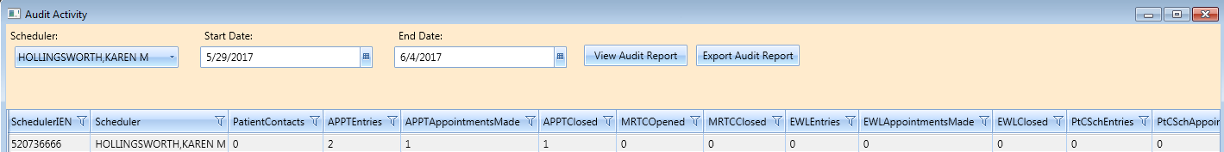

Figure : Audit Activity Report – Individual Scheduler

The following columns display data for the selected scheduler, based upon the time frame specified:

* SchedulerIEN (New Person File)
* SchedulerName
* PatientContacts
* APPTEntries
* APPTAppointmentsMade
* APPTClosed
* EWLEntries
* EWLAppointmentsMade
* EWLClosed
* Patient-Centered SchedulingAppointmentsMade
* ConsultAppointmentsMade
* AppointmentsCancelled
* TotalActions

1. Click **Close** to exit the Audit Activity report dialog box.

### Generating an Audit Activity Report for All Schedulers

1. From the Reports tab select **Audit Activity**.

The Audit Activity dialog displays.

1. From the **Scheduler** list select **All**.
2. Enter the **Start Date** and the **End Date** for the audit report.
3. Click View Audit Report.

The following columns display data for All Schedulers based upon the time frame specified:

* SchedulerIEN (Internal Entry Number – New Person File)
* SchedulerName
* PatientContacts
* APPTEntries
* APPTAppointmentsMade
* APPTClosed
* EWLEntries
* EWLAppointmentsMade
* EWLClosed
* Patient-Centered SchedulingAppointmentsMade
* ConsultAppointmentsMade
* AppointmentsCancelled
* TotalActions

Note: APPT columns include actions on RTC requests.

1. Click **Close** to exit the Audit Activity report dialog box.

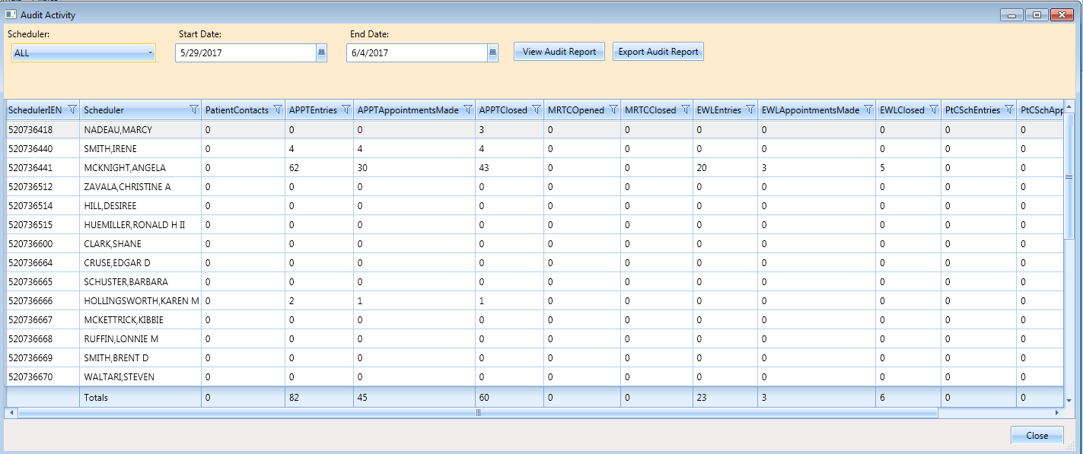

Figure : Audit Activity Report – All Schedulers

### Working with Audit Activity Report Data

#### Sorting by Column Header

1. Log into VS GUI.
2. Select the **Reports** tab.
3. Select **Audit Activity** from the Reports section.

The Audit Activity dialog box displays for all schedulers defined in the New Person file (#200).

The following data displays on the screen for the selected scheduler:

* SchedulerIEN (New Person File)
* SchedulerName
* PatientContacts
* APPTEntries
* APPTAppointmentsMade
* APPTClosed
* EWLEntries
* EWLAppointmentsMade
* EWLClosed
* Patient-Centered SchedulingAppointmentsMade
* ConsultAppointmentsMade
* AppointmentsCancelled
* TotalActions

1. Select the applicable column header to change the sort order for the report by data specified in a different column.

* To sort data in the specified column in ascending order, click the column header.
* To sort data in the specified column in descending order, click the column header a second time.

1. Click **Close** to exit the Audit Activity Report dialog box.

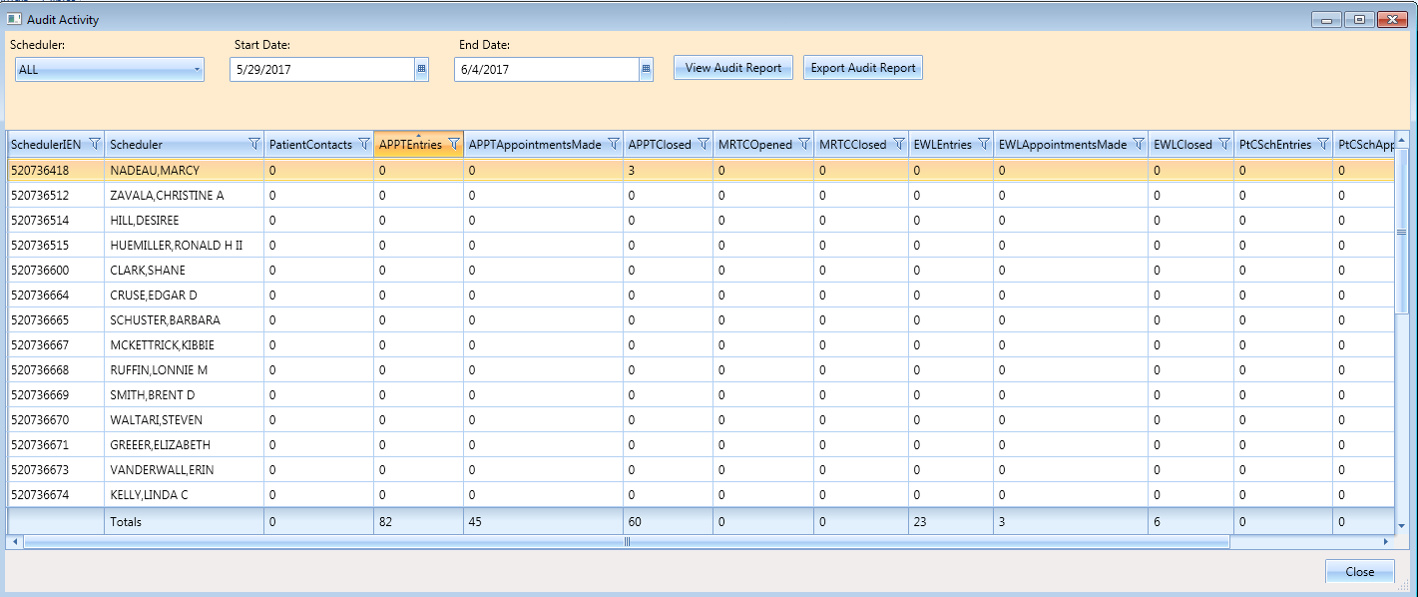

Figure : Audit Activity Sort – Ascending

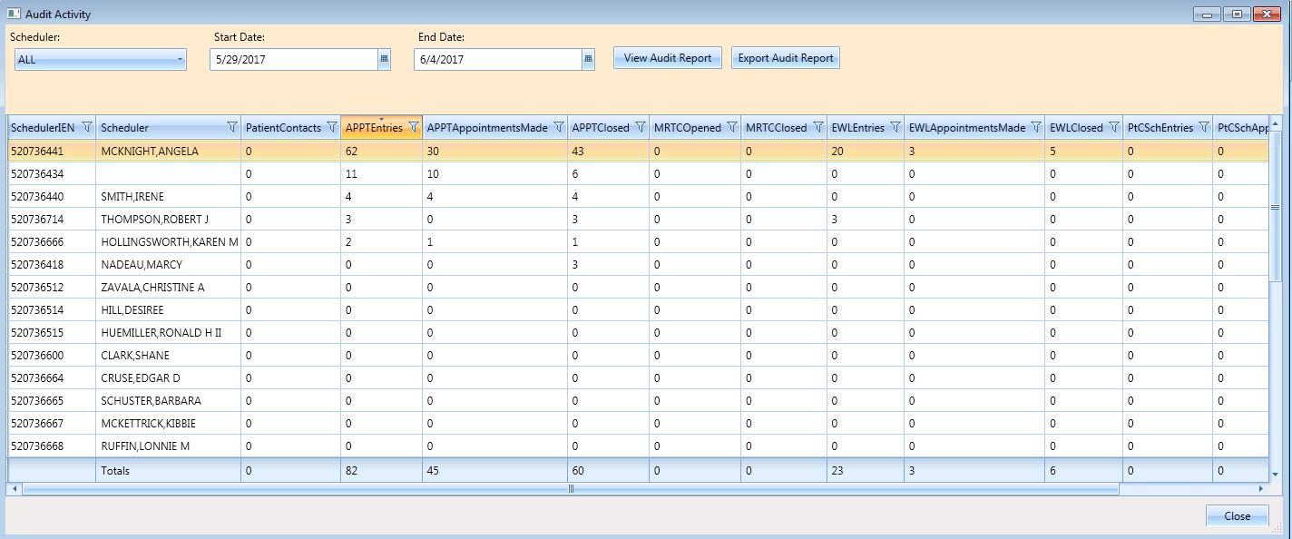

Figure : Audit Activity Sort – Descending

#### Filtering by Column Data

1. Select a filter option from each column header to filter data in the Audit Activity report.

**Note**: All schedulers who have greater than or equal to 10 APPT Appointments Made in the selected date range.

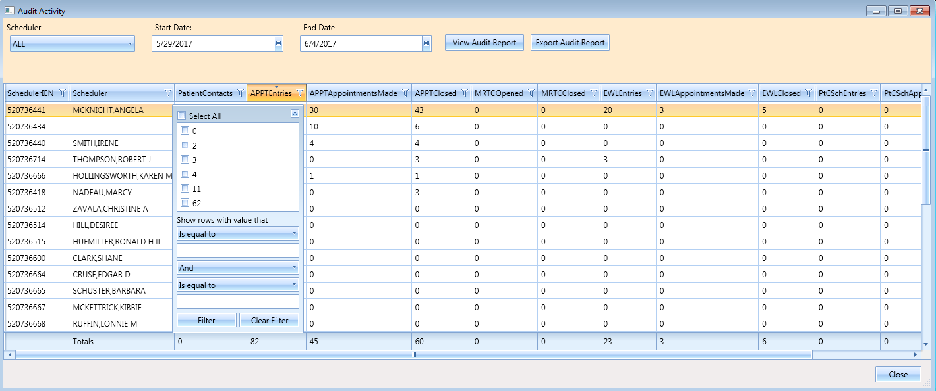

Figure : Audit Activity Report – Filtered

Multiple filters can be selected to refine results (i.e., All schedulers who have greater than or equal to 10 APPT Entries but less than or equal to 30 APPT Closed for the selected date range).

Selected filters are highlighted in column headers.

To remove filters, select the filter option in a column header, and then click **Clear Filter**.

1. Click **Close** to exit the Audit Activity report dialog box.

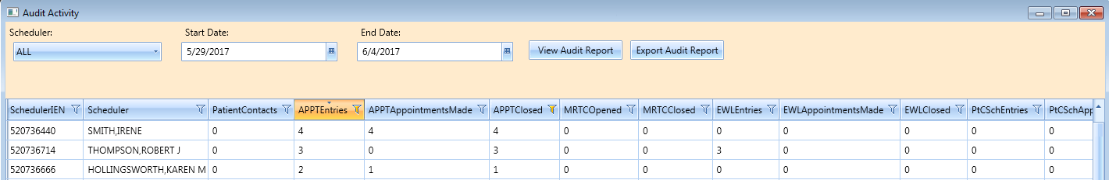

Figure : Audit Activity Report – Multiple Filters

### Export an Audit Activity Report for Individual or All Schedulers

The data displayed on the screen can be exported to an Excel spreadsheet.

1. To export the audit report, click **Export Audit Report**.

The Save As dialog box opens.

1. Select the location to save the report file.

The default File name is “Audit Report”. You can edit if necessary.

Confirm the “Save As Type” is Excel.

1. Click **Save**.

The Report is generated. It contains data displayed on the screen in the Audit Activity dialog box and it is saved to the location specified in the Save As dialog box.

1. Click **Close** to exit the Audit Activity report dialog box.

## Clinics Report

The Clinic Report is accessed from the **Reports** tab by selecting **Clinics** from the Reports section. The report displays clinic activity for all clinics, defined in the Hospital Location file as the default.

### Clinic Activity Report – Individual Clinic

The Clinic Report can be limited to individual clinics.

1. Log into VS GUI.
2. Select **Reports** tab.
3. From the Reports section, click **Clinics**.
4. In the Clinic Activity dialog box, enter the clinic’s name (six-character minimum) that is defined in the Hospital Location file.
5. Click **Search**.

The following data displays on the screen for the selected clinic:

* Clinic name
* Division
* Stop Code
* Service
* CreateDT
* InactiveDT
* ReactiveDT
* AppType
* DefaultProv
* AdditionalProv
* ApptLength
* Variable
* MaxDays

1. Click the **Clear** button to remove the search criteria and return to the Clinic Activity report for all clinics.
2. Click **Exit** to close the Clinic Activity Report dialog box.

### Working with the Clinic Activity Report

#### Sorting by Column Headers

1. Log into VS GUI.
2. Select the **Reports** tab.
3. Select **Clinics** from the Reports section.

The Clinic Activity dialog box displays for all clinics defined in the Hospital Location file (File #44).

The following data displays on the screen for the selected clinic:

* Clinic name
* Division
* Stop Code
* Service
* CreateDT
* InactiveDT
* ReactiveDT
* AppType
* DefaultProv
* AdditionalProv
* ApptLength
* Variable
* MaxDays

**Note:** The sort defaults in alphabetical order by the Clinic’s name.

1. To change the sort order for the report by data specified in a different column, select the applicable column header.
2. Click once on the column header to sorts the data in ascending order.
3. Click a second time on the column header to sort the data in descending order.
4. Click **Exit** to close the Clinic Activity Report dialog box.

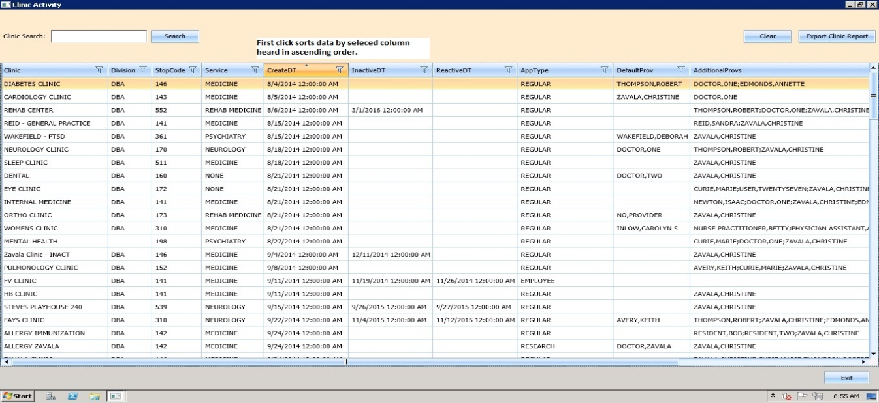

Figure : Clinic Activity Report Sort – Ascending Order

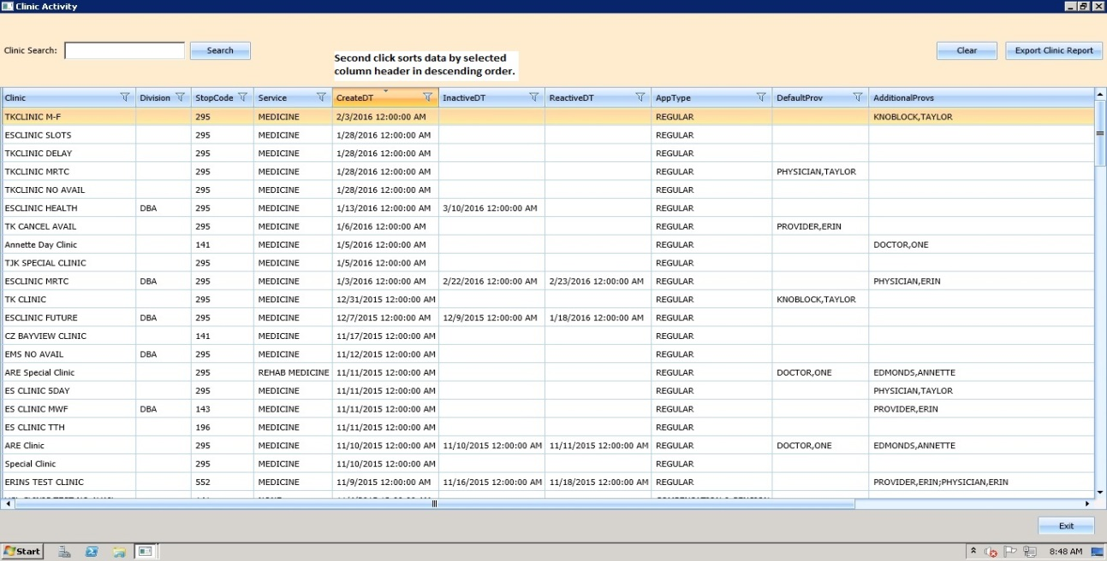

Figure : Clinic Activity Report Sort – Descending Order

#### Filtering Data by Column

Data in the Clinic’s Activity report can be filtered as follows:

1. Select the filter option in each column header (e.g., Clinic Activity data can be filtered by all Clinics with a defined Service of Rehab Medicine).

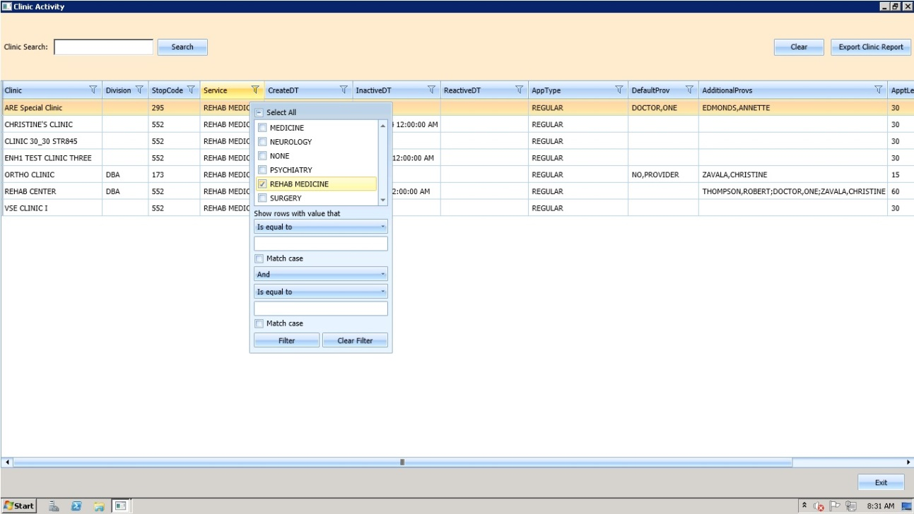

Figure : Clinic Activity Report – Filtered

Multiple filters can be selected to refine results (e.g., Clinic Activity data can be filtered by all Clinics with a defined Service of Rehab Medicine that also have no DefaultProv defined).

Selected filters are highlighted in column headers.

**To remove filters:**

1. Select a filter option in the column header, and then click **Clear Filter**.
2. Click **Exit** to close the Clinic Activity report dialog box.

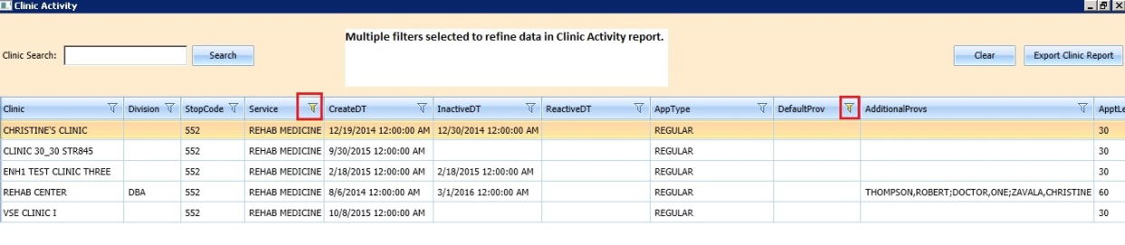

Figure : Clinic Activity Report – Multiple Filters

### Exporting a Clinic Report

**To export a Clinic Report:**

1. From the **Reports** tab, in the **Reports** section, select **Clinics.**

The **Clinic Activity** dialog box opens, displaying the report.

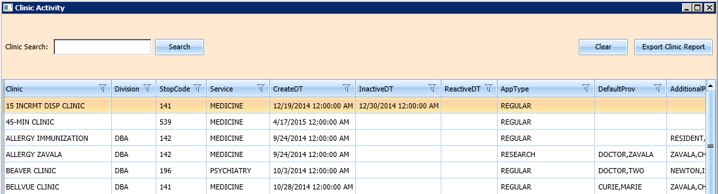

Figure : Clinic Activity

If applicable, search for a specific clinic in the Clinic Search field. Click **Search**. If no specific clinic is used, ensure the full list is downloaded by scrolling down on the right several times until the last clinic on the list is the same when scroll to the bottom.

1. Click Export Clinic Report.

A Save **As** dialog box opens.

1. Select the location to save the report.

Confirm the file name. The default is “Clinic Report”.

Confirm the Save as Type is Excel.

1. Click **Save**.

Data displayed on the screen is exported to the file and saved to the specified location with the defined name.

1. Click **Exit** to close the Clinic Activity report dialog box.

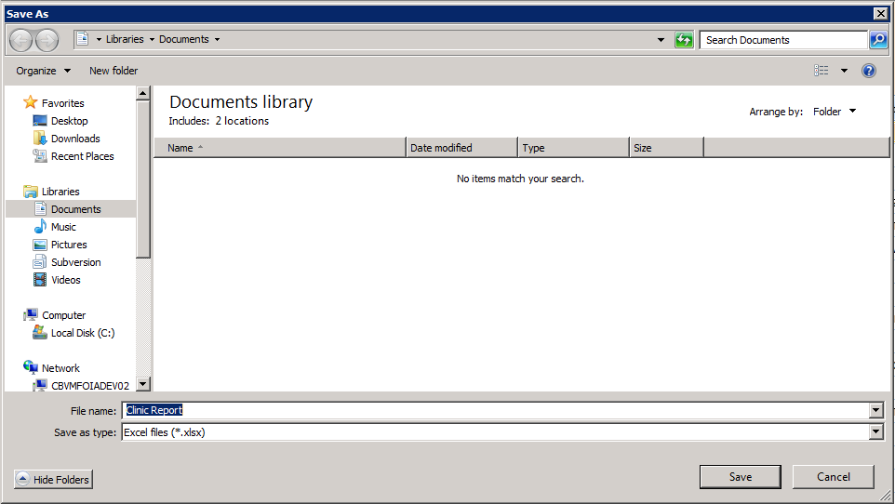

Figure : Save As

# Trash Queue Cleanup

**WARNING: ONLY USE THIS OPTION IF DIRECTED BY HEALTH PRODUCT SUPPORT ADMIN TEAM. PLACE A TICKET IF YOUR SITE THINKS THIS MAY BE NEEDED.**

During initial set-up of VS GUI, administrators who need to identify and purge unresolved requests, a task can be run to identify open appointment requests or duplicate appointment requests, close them, and produce a report for administrators. This excludes VAR requests which are called Veteran or Mobile requests, all stored in the SDEC APPT REQUEST file.

## Compile List of Re-Opened REQUEST Records that Can Be Closed

During initial set-up of VS GUI, the following dialog allows the user to find open appointment requests or duplicate appointment requests to produce a report for administrators to review/review verify.

The SDEC Initial Cleanup Utility will allow the Closing of Re-Opened SDEC APPT REQUEST records, which have resulted from a cancellation in VistA of a corresponding SDEC APPOINTMENT.

1. Log on to the VistA Legacy System.
2. Select VS GUI Initial Cleanup Utility [SDEC INITIAL CLEANUP UTILITY]
3. Select Compile List of Re-Opened REQUEST records that can be closed

**To Compile a List of Re-Opened REQUEST records that can be closed:**

1. Enter a list of Clinics (one by one) to EXCLUDE from Compilation.
2. Enter the Clinic to Exclude.
3. Press Enter to not exclude any Clinic.

A dialog box displays “You did not choose any Clinics to Exclude”.

Are you sure you want to run Cleanup for all clinics? Yes or No?

1. Click Yes to continue.
2. Click No to abort.
3. Select one of the following to print the results:

* VistA Print Device
* Spooler
* VistA Email
* Screen with capture

1. Review the list to ensure these are all extraneous open requests that should be auto-closed.

**To Compile for all Clinics excluding the following:**



Select Option: SDEC INITIAL CLEANUP UTILITY VS GUI Initial Cleanup Utility

The following Utility will allow the Closing of Re-Opened SDEC APPT REQUEST

records which have resulted from a Cancellation in VistA of a corresponding

SDEC APPOINTMENT.

* 1. Select one of the following Compile List of Re-Opened REQUEST records that can be Closed

2 Commit Records to Be Closed from Compiled List

What Would You like to Do?: **1 Compile List of Re-Opened REQUEST records that can be Closed**

Please enter in, one by one, a list of Clinics to EXCLUDE from Compilation.

Enter CLINIC to EXCLUDE: <Hit **Enter** to not exclude any Clinics>

You did not choose any Clinics to Exclude.

Are you sure you want to run cleanup for ALL clinics? (Y OR N):? NO// y YES

Compiling for all Clinics excluding the following:

DEVICE: HOME// HOME (CRT)

(You may enter a device that prints to a file, a printer, email message, or you may print on the screen.)

*** Open SDEC APPT REQUESTs List run Jan 09, 2017@02:48:47 ***

LAST 4 APPT REQ IEN

CLINIC PATIENT SSN APPT IEN CID DA==

VSE ENH1 CLINIC FAULCON,GONZALO J 2916 1747 ; 1985 12/27/2016

VSE ENH1 CLINIC TEST,STERLING PAUL JR 0183 1752 ; 1988 12/27/2016

## Commit Records to Be Closed from Compiled List

During initial set up of VS GUI, to commit Records to Be Closed from the Compiled List created via SDEC INITIAL CLEANUP UTILITY:

1. Log on to the VistA Legacy System.
2. Select VS GUI Initial Cleanup Utility [SDEC INITIAL CLEANUP UTILITY]
3. Select Commit Records to Be Closed from Compiled List

A dialog box displays “What Would You like to Do?”

**To Commit Records to Be Closed from the Compiled List:**

1. Open SDEC APPT REQUEST Compilation Lists to choose from:

The batch list displays records.

1. Enter the Batch # previously reviewed above. There may be several batches in the list from past compile jobs.

A message displays “Committing Open records for Batch # to Closed…. Done”

After the task is completed, the Current Status changes to “Closed” and the Disposition fields in the SDEC APPT REQUEST file are set accordingly.

**To verify the record has been closed:**

1. Go to VA FileMan
2. Inquire to view the SDEC APPT REQUEST File (#409.85)

View the following fields:

* CURRENT STATUS
* DATE DISPOSITIONED
* DISPOSITIONED BY
* DISPOSITION
* DISPOSITION CLOSED BY CLEANUP

Select Option: SDEC INITIAL CLEANUP UTILITY VS GUI Initial Cleanup Utility

The following Utility will allow the Closing of Re-Opened SDEC APPT REQUEST

records which have resulted from a Cancellation in VistA of a corresponding

SDEC APPOINTMENT.

* 1. Select one of the following Compile List of Re-Opened REQUEST records that can be Closed

2 Commit Records to Be Closed from Compiled List

What Would You like to Do?: **2 Commit Records to Be Closed from Compiled List**

Open SDEC APPT REQUEST Compilation Lists to Choose From:

Batch # Run User Start Date Finish Da==

1 STUCK,ERIN Dec 14, 2016@07:41:56 Dec 14, 2016@07:41:56

2 KRON,CAROLYN S Dec 16, 2016@23:54:52 Dec 16, 2016@23:54:53

3 KRON,CAROLYN S Dec 22, 2016@11:47:18 Dec 22, 2016@11:47:19

4 KRON,CAROLYN S Jan 09, 2017@02:34:05 Jan 09, 2017@02:34:05

5 KRON,CAROLYN S Jan 09, 2017@02:48:47 Jan 09, 2017@02:48:47

Enter Batch #:**5**

Committing Open records for Batch # 5 to Closed...Done

Once the task completes, the CURRENT STATUS is changed to “CLOSED” and the DISPOSITION fields in the SDEC APPT REQUEST file are set accordingly.

To verify the record has been closed, go to VA FileMan and Inquire to view the SDEC APPT REQUEST File (#409.85). View the following fields:

* CURRENT STATUS
* DATE DISPOSITIONED
* DISPOSITIONED BY
* DISPOSITION
* DISPOSITION CLOSED BY CLEANUP

#### Systems Manager

1. Navigate to Fileman Record INQUIRY [RTZ INQ-FM-INQUIRY], either through the programmer prompts or through the site’s local fileman prompts.
2. Select Inquire to File Entries [DIINQUIRE]
3. Inquire to File Entries

Output from What File: SDEC APPT REQUEST//

1. Select SDEC APPT REQUEST PATIENT:
2. Press Return

To see more

To exit

OR

Choose a number from the list

Select Systems Manager Menu Option: fm VA FileMan

VA FileMan Version 22.0

Enter or Edit File Entries

Print File Entries

Search File Entries

Modify File Attributes

Inquire to File Entries

Utility Functions ...

Data Dictionary Utilities ...

Transfer Entries

Other Options ...

Select VA FileMan Option: inquire to File Entries

OUTPUT FROM WHAT FILE: SDEC APPT REQUEST//

Select SDEC APPT REQUEST PATIENT: TEST,STERLING PAUL JR

* 1. TEST,STERLING PAUL JR

2 TEST,STERLING PAUL JR

3 TEST,STERLING PAUL JR

4 TEST,STERLING PAUL JR

* 1. TEST,STERLING PAUL JR

Press <RETURN> to see mor‘,’’^’ to exit this list, OR

CHOOSE 1-5:

Press <RETURN> to see mor‘,’’^’ to exit this list, OR

CHOOSE 10-15:

16 TEST,STERLING PAUL JR

17 TEST,STERLING PAUL JR

18 TEST,STERLING PAUL JR

19 TEST,STERLING PAUL JR

20 TEST,STERLING PAUL JR

Press <RETURN> to see mor‘,’’^’ to exit this list, OR

CHOOSE 1-20: 16 TEST,STERLING PAUL JR

ANOTHER ONE:

STANDARD CAPTIONED OUTPUT? Yes// (Yes)

Include COMPUTED fields: (N/Y/R/B): NO// b BOTH Computed Fields and Record Num

ber (IEN)

DISPLAY AUDIT TRAIL? No// y YES

NUMBER: 1752 PATIENT: TEST,STERLING PAUL JR

CREATE DATE: DEC 23, 2016 INSTITUTION: CHEYENNE VAMC

REQUEST TYPE: APPOINTMENT

REQ APPOINTMENT TYPE: REGULAR

Created on Dec 23, 2016@14:37:43 by User #520736464 (SDECRPC Option)

PATIENT STATUS: NEW

Created on Dec 23, 2016@14:37:43 by User #520736464 (SDECRPC Option)

REQ SPECIFIC CLINIC: VSE ENH1 CLINIC

Created on Dec 23, 2016@14:37:43 by User #520736464 (SDECRPC Option)

ORIGINATING USER: KRON,CAROLYN S PRIORITY: FUTURE

REQUESTED BY: PATIENT

Created on Dec 23, 2016@14:37:43 by User #520736464 (SDECRPC Option)

CID/PREFERRED DATE OF APPT: DEC 27, 2016

Created on Dec 23, 2016@14:37:43 by User #520736464 (SDECRPC Option)

**CURRENT STATUS: CLOSED**

**Changed from “OPEN” on Jan 09, 2017@02:49:09 by User #520736464**

**(SDEC INITIAL CLEANUP UTILITY Option)**

Changed from “CLOSED” on Dec 23, 2016@14:47:01 by User #520736464

(SDCANCEL Option)

Changed from “OPEN” on Dec 23, 2016@14:38:10 by User #520736464

(SDECRPC Option)

Enter RETURN to continue ‘r’’^’ to exit:

Created on Dec 23, 2016@14:37:43 by User #520736464 (SDECRPC Option)

COMMENTS: TEST

Created on Dec 23, 2016@14:37:43 by User #520736464 (SDECRPC Option)

ENROLLMENT PRIORITY: GROUP 8 MULTIPLE APPOINTMENT RTC: NO

DATE/TIME ENTERED: DEC 23, 2016@13:37

DATE EDITED: DEC 23, 2016@14:37 EDITED BY: KRON,CAROLYN S

REQ SPECIFIC CLINIC: VSE ENH1 CLINIC

**DATE DISPOSITIONED: JAN 09, 2017 DISPOSITIONED BY: KRON,CAROLYN S**

**DISPOSITION: ENTERED IN ERROR DISPOSITION CLOSED BY CLEANUP: YES**

SERVICE CONNECTED PERCENTAGE: 0 SERVICE CONNECTED PRIORITY: NO

## View Unresolved APPT Requests Reopened by the SDCANCEL Option

A user who has access to the VS GUI Requests Reopened by Cancel Availability [SDEC REQ REOPENED BY SDCANCEL] can view unresolved appointment requests. This is helpful after clinic availability has been canceled on a day with a lot of patients scheduled. If the user runs this report, it is a guide to which patients still have an open request sitting in VS GUI ready to be rescheduled.

**To view unresolved appointment requests:**

1. Go to the **Outputs** option under the Scheduling Manager’s Menu.
2. Select VS GUI Requests Reopened by Cancel Availability [SDEC REQ REOPENED BY SDCANCEL].
3. Select CLINIC:

Follow the steps shown below.

Select Scheduling Manager’s Menu Option: outputs

AQK Encounter Activity Report

AQK2 ACRP Stop Code Report

CAAR Clinic Appointment Availability Report

Appointment List

Appointment Management Report

Cancelled Clinic Report

Clinic Assignment Listing

Clinic List (Day of Week)

Clinic Next Available Appt. Monitoring Report

Clinic Profile

Display Clinic Availability Report

Enrollments > X Days

File Room List

Future Appointments for Inpatients

Inpatient Appointment List

Management Report for Ambulatory Procedures

No-Show Report

Patient Profile MAS

PCMM Main Menu ...

Print Scheduling Letters

Provider/Diagnosis Report

Radiology Pull List

Routing Slips

Visit Rpt by Transmitted OPT Encounter

VS GUI Requests Reopened by Cancel Availability

Workload Report

Select Outputs Option: **a**

2 VSE ENH1 CLINIC ONE ZAVALA,CHRISTINE A

3 VSE ENH1 CLINIC TWO

CHOOSE 1-3: **1 VSE ENH1 CLINIC**

Select CLINIC:

DEVICE: HOME// HOME (CRT)

VS GUI Requests Re-Opened by Cancel Availability (SDCANCEL) Option

for clinics: VSE ENH1 CLINIC

PATIENT SSN TELEPHONE CID/PREF DATE

TEST,CHRISTINE 000-12-1234 (555)123-1234 JAN 12,2017

# VistA Scheduling 508 Compliance

The following section outlines the process for executing the VistA Scheduling Application functionality using the keyboard. Many keyboard shortcuts have been added for ease of use. A consolidated list of all keyboard shortcuts is provided in Section 13.

## The Tasks Tab

**Ctrl + T** is the keyboard shortcut to navigate to the **Tasks Tab**.

### The Ribbon Bar

1. Log on to VS GUI as a scheduler.

The Search field is highlighted and the cursor is blinking.

1. Press the **Tab** key to advance through the Ribbon Bar.
2. Beginning at the **Patient Search** field, move from left to right.

If the controls in each section listed below are enabled, when you press the tab key each one will be highlighted accordingly:

* Patient Search Field
* Search Button
* Clear Button
* Actions
* Arrangement
* Pending Appointments
* Special Needs/Preferences
* Mobile Requests
* Tools
* Print
  + Export
  + Refresh
  + Query

After leaving the **Tools** section, you will be redirected to the **Patient Search** field.

Table : Keyboard Shortcuts for Ribbon Bar Components

|  |  |
| --- | --- |
| Ribbon Bar Component | Keyboard Shortcut |
| Patient Search Field | ALT + S |
| Action | ALT + A |
| Arrangement | ALT + G |
| Pending Appointment Window | ALT + P |
| Special Needs/Preferences | ALT + N |
| Mobile Requests | ALT + M |
| Tools | ALT + T |

### Request Type Dialog

Using the Tab key**:**

1. From the **Actions Pane**, with the **New Req.** highlighted, press **Enter**.

The **Request Type** dialog box displays.

Focus is **OK**.

1. Press the Tab key to move to **CLEAR**.
2. Press the Tab key to move to **APPT Request Type**.
3. Press the Tab key to move to PATIENT-CENTERED SCHEDULING Request Type.
4. To select a **Request Type**, press the tab key to highlight, and then press the **Space Bar** key to select.
5. Press the Tab key to move to **OK**, and then press **Enter**.

**Note:** The arrow keys can also be used to navigate to the Request Type dialog box.

Table : Keyboard Shortcuts for Request Type

|  |  |
| --- | --- |
| Component | Keyboard Shortcut |
| OK | ALT + O |
| Clear | ALT + C |

### Appointment Request

**Using the Tab key**:

The **Appointment** Request **Dialog** opens with **OK** highlighted.

Use the Tab key to move to **CLEAR** and the **Svc Related** check box.

1. Press the **Space Bar** to select.

Use the Tab key to move to **Clinic** (default) and **Service/Specialty**.

1. Press the **Space Bar** to select.
2. Press the Tab key to move to the **Clinic** field, and then enter the **Clinic Name** (four-character minimum).
3. Press the Tab key to move to the **CID/Preferred Date** field, and once highlighted press **Enter** to display **Calendar** control.
4. Use the up arrow and the down arrow to navigate the dates in the calendar, and then press **Enter** to select the date.
5. Press the Tab key to move to **Appointment Type**, and then use the arrow keys to select **Appointment Type**.
6. Press the Tab key to move to the **Requested By** field, and then use the arrow keys to select **Requested By**.
7. Press the Tab key to move to the **Provider** field (if applicable), and then enter the **Provider** name (three-character minimum).
8. Press the Tab key to move to the **Multiple Appointments Required** check box, and then press the **Space Bar** to select.
9. Press the Tab key to move to the **Number of Appointments Required** field, and then use the arrow keys to select the number of appointments required.
10. Press the Tab key to move to the **Interval Between Appointments** field, and then use the arrow keys to select the number of days between appointments.
11. Press the Tab key to move to the **Comments** field, and then enter your text.
12. Press the Tab key to move to **OK**, and then press Enter to select and create the APPT Request and exit the dialog box.

Table : Keyboard shortcuts for the Appointment Request

|  |  |
| --- | --- |
| Component | Keyboard shortcut |
| OK | ALT + O |
| Clear | ALT + C |

**Query**

The **Query Dialog** box opens with the **Patient** field highlighted.

1. Enter the patient’s **Last Name**, **First Name** or thelast initial and last four of the SSN.
2. Press the Tab key to move to **Find**, and then press **Enter**.

Use the **Down Arrow** to highlight names in the **Patient** list.

1. Press the **Enter** key to select patients from the list to include in the query.
2. Press the Tab key to move to the **Patients** column.

Use the **Down Arrow** to highlight the names listed.

1. To remove names from the selection press **Enter**.

Use the Tab key to move to the **Request Type Filter**.

1. Press **Enter** to open the **Request Types** dialog box.

Use the arrow keys to navigate to the **Request Type** selection grid.

1. Press the **Space Bar** to select the highlighted **Request Type**.

Use the Tab key to move to **OK** to confirm the selection.

Use the Tab key to **Cancel** the selection and exit the dialog box.

**The Clinic/Service Filter**

Use the Tab key to move to the **Clinic/Service Filter**.

1. Press **Enter** to open the **Clinics** dialog box.
2. Enter the **Clinic/Service** name in the blank field (four-character minimum).

Use the Tab key to move to **Find** and the **Select All** check box.

1. Press the Space Bar to **Select All**.

Use the Tab key to move to **Clinics** or **Services**.

**Clinics** is the default.

1. Press the Space Bar to select the **Services** button.

Use the arrow keys to navigate up and down the **Clinics/Service Grid**.

Use the **Space Bar** to select/deselect from the list.

1. Press the Tab key to move to **OK,** and then press **Enter** to confirm the selections for the query.

OR use the Tab key to **Cancel**

1. Press **Enter** to quit the selection and exit the dialog box.

**The Priority Group Filter**

1. Press the Tab key to move to the **Priority Group Filter** and then press **Enter** to display the **Priority Group** dialog box.

Use the Tab key to move to the **Select All** check box.

1. Press the **Space Bar** to select (if applicable).
2. Press the Tab key to move to the **Priority Group** grid.

Use the up or down arrow to navigate up and down the list.

Use the **Space Bar** to select/deselect the **Priority Group** options.

1. Press the Tab key to move to **OK,** and then press **Enter** to confirm the selections for the query.

OR use the Tab key to **Cancel**

1. Press **Enter** to quit the selection and exit the dialog box.

**Wait Time**

1. Press the Tab key to move to the following:

* Wait Time list.
* **SC Visit?** List
* **Connected?** list

Use the arrow keys to navigate the options for the query selections.

1. Press the Tab key to move to the **Origination Date** field/**CID/Preferred Date** field.
2. Enter the date for the query selection as applicable.
3. Press the Tab key to move to the **Urgency** field (Applicable to Consult Requests only)/**Change Sort** field.

Use the arrow keys to navigate to the list for query selection.

1. Press the Tab key to move to the **Clear** button, and then press **Enter**.

The **Clear Filter** dialog box displays.

1. Press the Tab key to move to **OK,** and then press **Enter** to clear the **Request Query** dialog box of all filter selections and start the query selection process again.
2. Press the Tab key to move to **Cancel** and then press **Enter** to **Cancel Clear** Filter selection and exit the dialog box.

**Note:** Selecting **Cancel** will keep the current **Request Query** filter selections for the query.

1. Press the Tab key to move to the **Submit** button, and then press **Enter**.

The Request Query Confirmation dialog box opens.

1. Press the Tab key to move to **OK**, and then press **Enter**.

The query results display in the **Request Management Grid**.

**To Cancel the action:**

1. Press the Tab key to **Cancel**.
2. Press the **Enter** key to abort the query results and return to the **Request Query** dialog box.
3. Press the Tab key to move to **Close**, and then press **Enter** to close the **Request Query** dialog box.

## Systems Tab

To access the **Systems Tab**, press **CTRL+Y**.

### ****Systems Tab Ribbon Bar****

1. Press the Tab key to move to Scheduling Management.
2. Press **Enter** to display the **Scheduling Management** dialog box.
3. Press the Tab key to move to **Availability**, and then press **Enter** to open the **Availability Selection** dialog box.

Table : Keyboard Shortcuts for the Systems Tab Ribbon Bar

| Ribbon Bar Component | Keyboard Shortcut |
| --- | --- |
| Systems Tab | CTRL + Y |
| Scheduling Management | ALT + M |
| Availability | ALT + H |
| Selected Clinic | ALT + L |

### Scheduling Management

#### Clinics and Users Tab

The **Scheduling Management Dialog** box opens on the **Clinics** and **Users** tab with the **OK** button highlighted. Focus is on **OK** button.

1. Press the Tab key to move to the **Users Selection List**.

Use the **Down** **Arrow** to highlight the **First Name** in the **Users List**.

1. Press **Enter** to select the **User Name**, and then press the Tab key to move to the **Prohibited Clinic** field.
2. Enter the **Clinic Name**.
3. Press the Tab key to move to the **Find b**utton, and then press **Enter**.

The Prohibited Clinic List is displayed.

Use the arrow keys to navigate up and down the list.

1. Press the Tab key to move to the **Privileged Users List** for users who are assigned to the selected clinic.

Use the Tab key to move to the **Add User** button, the **Remove User** button or the **Remove All** button.

Table : Keyboard Shortcuts for Scheduling Management

| Component | Keyboard Shortcut |
| --- | --- |
| Add User | ALT + A |
| Remove User | ALT + R |
| Remove All | ALT + E |
| Find | ALT + F |
| OK | ALT + O |
| Cancel | ALT + C |

#### Clinic Groups Tab

When the user accesses the Clinic Group tab, the OK button is highlighted.

1. Press the Tab key to move to Resources.
2. Enter the Clinic Schedule Resource criteria

* User name, Clinic Name, Clinic Group

1. Press the Tab key to move to the Find button, and then press Enter.

Use the down arrow to highlight the first name in the Resource List.

1. Press the Tab key to move to the following:

* New Group
* Edit Group
* Remove Group
* Clinic Groups List
* Add Resource
* Add All
* Remove Resource
* Remove All

Table : Keyboard Shortcuts for the Clinic Groups Tab

| Component | Keyboard Shortcut |
| --- | --- |
| New Group | ALT + N |
| Edit Group | ALT + E |
| Remove Group | ALT + R |
| Add Resource | ALT + S |
| Add All | ALT + L |
| Remove Resource | ALT + D |
| Remove All | ALT + X |
| OK | ALT + O |
| Cancel | ALT + C |

### Availability Selection

The **Availability Selection Dialog** box opens with the **OK** button highlighted.

1. Press the Tab key to move to the **Cancel** button.
2. Press the Tab key to move to the **Search by** Name field.
3. Enter the **Clinic Name** (four-character minimum).
4. Press the Tab key to move to the Resource **List Grid**.

Use the arrow keys to navigate up and down the **Resource List**.

1. Press **Enter** to select the highlighted **Resource**.

The Select Clinic Availability displays.

Table : Keyboard Shortcuts for the Availability Selection

| Component | Keyboard Shortcut |
| --- | --- |
| Search Field | ALT + S |
| First Row of Results Grid | ALT + G |
| OK | ALT + O |
| Cancel | ALT + C |

## The Reports Tab

To access the **Reports Tab** press **CTRL+R**.

### Reports Tab Ribbon Bar

1. Press the Tab key to move to Audit Activity.
2. Press the Tab key to move to **Clinics**.
3. Press the Tab key to move to Management Reports.

Table : Keyboard Shortcuts for the Reports Tab Ribbon Bar

| Ribbon Bar Component | Keyboard Shortcut |
| --- | --- |
| Reports Tab | Ctrl + R |
| Reports | Alt + R |

### Audit Activity

The **Audit Activity** dialog box opens with the Close button highlighted.

1. Press the Tab key to move to the **Scheduler** list.

The default is **All**.

Use the **Down** **Arrow** to select a user’s name (listed in alphabetical order).

1. Enter the user’s name (last name, first name) to go directly to the specific user.
2. Press the Tab key to move to the **Start** **Date** field, and then press **Enter** to select the **Calendar**.

Use the arrow keys to select the date.

1. Press the Tab key to move to the **End Date** field, and then press **Enter** to select the **Calendar**.

Use the arrow keys to select the date.

1. Press the Tab key to move to the View Audit Report, and then press **Enter** to display the **Audit Report in Grid**.
2. Press the Tab key to move to the Export Audit Report, and then press **Enter** to open the **Save As** dialog box.

**Note:** Only data displayed on the screen will appear in the exported **Audit Report**.

You can use the Tab key to navigate the **Audit Report Grid**.

Table : Keyboard Shortcuts for Audit Activity

| Component | Keyboard Shortcut |
| --- | --- |
| Scheduler drop down | ALT + S |
| Audit Report | ALT + V |
| Export Report | ALT + E |
| Close | ALT + C |

### Clinic Activity

The **Clinic Activity** dialog box opens with the **Exit** button highlighted.

1. Press the Tab key to move to the **Clinic Search** field, and then enter the **Clinic Name** (six-character minimum).
2. Press the Tab key to move to the **Search** button, and then press **Enter**.
3. Press the Tab key to move to the Clinic Results Grid.

Use the Tab key to navigate through the Clinic Results Grid including the Column Headers and Filters.

Table Keyboard Shortcuts for Clinic Activity

| Component | Keyboard Shortcut |
| --- | --- |
| Search Button | ALT + S |
| Clear | ALT + C |
| Export | ALT + E |
| Exit | ALT + X |

# Troubleshooting

Contact the Enterprise Service Desk (ESD), formally the National Service Desk (NSD), and open a ticket for any VS GUI related issues. At the time of publishing, the phone number is 855-673-HELP (4357).

VSE Pulse page resources and training aids:

* Frequently Asked Questions/Known Issues document: <https://www.vapulse.net/docs/DOC-107042>
* Scheduler: <https://www.vapulse.net/community/vista-scheduling-enhancements-vse>
* Super User: <https://www.vapulse.net/groups/vse-super-users>
* National Return to Clinic Order Implementation: <https://www.vapulse.net/groups/return-to-clinic-rtc>

## **Changing User ID and Password**

Contact your supervisor or System Administrator for User ID or Password changes.

## Special Instructions for Error Correction

Some potential warning messages are listed here.

Table : Warning Messages

| Reason for Message | Message | Action | Result |
| --- | --- | --- | --- |
| Sensitive Information Warning | Warning displays to the user:  ***WARNING***  ***RESTRICTED RECORD*** | Click **OK** | User is able to log into the Security Log Audit Trail |
| Warning for similar names and SSN | Similar Names dialog displays  System lit patients with similar name and same last four digits of SS# | Click **OK** | User is able to continue |
| Accessing deceased patient’s record | This patient died on <Date of Death>  Do you wish to continue? | Click **OK** | User is able to perform action such as Disposition, Cancel Appointments |
| Accessing own record at selection | Security regulations prohibit computer access to your own medical record. | Click **OK** | User is unable to perform any activity/actions |

# Acronyms and Abbreviations

| Term | Description |
| --- | --- |
| Access Block | A color-coded representation of the amount of time allotted for a specific Access Type (or appointment). |
| Access Groups | Categories of Access Types. Assigning Access Types to Access Groups makes it easier to schedule and search for certain types of appointments. |
| Access Types | The variety of different appointment types available in the Legacy VistA Scheduling package. Each type of appointment, such as routine physical, dental, walk-in, or other specific appointment type is an Access Type. |
| AMIE | Automated Medical Information Exchange |
| API | Application Program Interface |
| APPT | Appointment: A scheduled or unscheduled meeting between patient and healthcare professional.; an appointment can include several encounters with providers or clinics for tests, procedures, etc. |
| CID | Clinically Indicated Date |
| Clinic | A medical center location where patients receive care by a doctor or authorized provider. |
| CPRS | Computerized Patient Record System |
| Enh | Enhancement |
| EWL | Electronic Wait List |
| GUI | Graphical User Interface |
| MUMPS | Massachusetts General Hospital Utility Multi-Programming System |
| MRTC | Multiple Return To Clinic |
| NSR | New Service Request |
| OI&T | Office of Information and Technology |
| OOS | Occasion of Service |
| OT3 | Optional Task #3 |
| OT4 | Optional Task #4 |
| OVAC | Office For Veterans Access to Care |
| PACT | Patient-Aligned Care Teams |
| PII | Personally Identifiable Information |
| PIMS | Patient Information Management System |
| POC | Point of Contact |
| PRF | Patient Record Flag |
| Provider | A doctor or other authorized provider in the medical center who provides patient care. |
| PT | Patient |
| PWS | Performance Work Statement |
| RM Grid | Request Management Grid |
| RTC | Return to Clinic |
| SDMOB | Scheduling Master Overbook |
| SDOB | Scheduling Overbook |
| Slot | Number of appointments per defined appointment length that have been previously set up in VistA Scheduling. For example, if “Slots = 4” and the clinic (resource) appointment length is 30 minutes, then there are four available appointments for every 30 minutes. |
| SSN | Social Security Number |
| T4 | Transformation Twenty-One Total Technology |
| TAC | Technology Acquisition Center |
| TCP/IP | Transmission Control Protocol/Internet Protocol |
| VA | Department of Veterans Affairs |
| VAR | Veteran Appointment Request |
| VCL | Veterans Crisis Line |
| VHA | Veterans Health Administration |
| VistA | Veterans Health Information Systems and Technology Architecture |
| VL | Variable Length |
| VS | VistA Scheduling |
| VSE | VistA Scheduling Enhancements |

# Keyboard Shortcuts Quick List

Patient demographic information can be displayed and edited at any point in the process by entering **CTRL + P** to open the Patient Info screen.

Ribbon Bar Components

|  |  |
| --- | --- |
| Ribbon Bar Component | Keyboard Shortcut |
| Patient Search Field | ALT + S |
| Action | ALT + A |
| Arrangement | ALT + G |
| Pending Appointment Window | ALT + P |
| Special Needs/Preferences | ALT + N |
| Mobile Requests | ALT + M |
| Tools | ALT + T |

Request Type

|  |  |
| --- | --- |
| Component | Keyboard Shortcut |
| OK | ALT + O |
| Clear | ALT + C |

Appointment Request

|  |  |
| --- | --- |
| Component | Keyboard Shortcut |
| OK | ALT + O |
| Clear | ALT + C |

Systems Tab Ribbon Bar

| Ribbon Bar Component | Keyboard Shortcut |
| --- | --- |
| Systems Tab | CTRL + Y |
| Scheduling Management | ALT + M |
| Availability | ALT + H |
| Selected Clinic | ALT + L |

Scheduling Management

| Component | Keyboard Shortcut |
| --- | --- |
| Add User | ALT + A |
| Remove User | ALT + R |
| Remove All | ALT + E |
| Find | ALT + F |
| OK | ALT + O |
| Cancel | ALT + C |

Clinic Groups Tab

| Component | Keyboard Shortcut |
| --- | --- |
| New Group | ALT + N |
| Edit Group | ALT + E |
| Remove Group | ALT + R |
| Add Resource | ALT + S |
| Add All | ALT + L |
| Remove Resource | ALT + D |
| Remove All | ALT + X |
| OK | ALT + O |
| Cancel | ALT + C |

Availability Selection

| Component | Keyboard Shortcut |
| --- | --- |
| Search Field | ALT + S |
| First Row of Results Grid | ALT + G |
| OK | ALT + O |
| Cancel | ALT + C |

Reports Tab Ribbon Bar

| Ribbon Bar Component | Keyboard Shortcut |
| --- | --- |
| Reports Tab | CTRL + R |
| Reports | ALT + R |

Audit Activity

| Component | Keyboard Shortcut |
| --- | --- |
| Scheduler list | ALT + S |
| Audit Report | ALT + V |
| Export Report | ALT + E |
| Close | ALT + C |

Clinic Activity

| Component | Keyboard Shortcut |
| --- | --- |
| Search Button | ALT + S |
| Clear | ALT + C |
| Export | ALT + E |
| Exit | ALT + X |